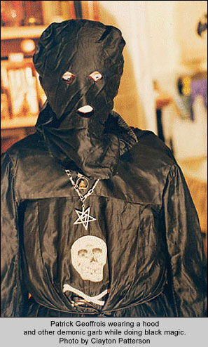
Patrick Geoffrois (Prithu Putra Swami) wearing a hood and
other demonic garb while doing black magic. [/media-credit]
The Iskcon GBC and its Satanic Past
To: Padmagarbha <padmagarbha.das@gmail.com>
Date: Wed, Feb 14, 2018
Subject: Some Research Ive been digging up regarding GBC and its Satanic Past.
(VERY important/Comprehensive)
Hare Krishna Kamsahanta Prabhu,
please accept my obeisances, all glories to Srila Prabhupada!
Somehow or other I havent heard from you in a while, you said you were going to call a while back but you must have forgotten. The only way i can take calls is if i know you are going to call on a certain day, i will wait with my phone in hand so that I do not miss your call.
In any case, I have been reading a bit and compiling some information on Malati (Melani Nagel), her ex husband Patrick Geoffrois (Prithu Putra, ex swami) In this letter there is compiled information by myself and another devotee who wishes to remain anonymous.
This is a news article of a murder in New York. the guy on the right is Malati's husband, Prithu Putra das (ex swami), who ran a satan worship cult among drug addicts in the lower east side he was the guru of the satan worshipers there, and they killed some people in rituals and fed the meat to the homeless in soup this same satan worshipping guy (Patrick Geoffrois) was with Prabhupada in the last two years as part of his entourage.
Here is a letter in folio that confirms it:
Letter to: Shri Kulabidhusingh – March 5, 1976 "The following is the complete list of devotees who will be coming and you can kindly disregard all previous lists of names which have been previously cited:" "Name Passport A.C. Bhaktivedanta Swami (Indian - K001044) Gopal Khanna (Canadian - RX 176156) Milan Kumar Talukdar (Indian - J780145) Paul Howard Dossick (U.S.A. - Z 2269551) Denis Harrison (U.K. - P 606464) Nityananda Das (Indian - no passport). Patrick Geoffrois (French - 149/72).
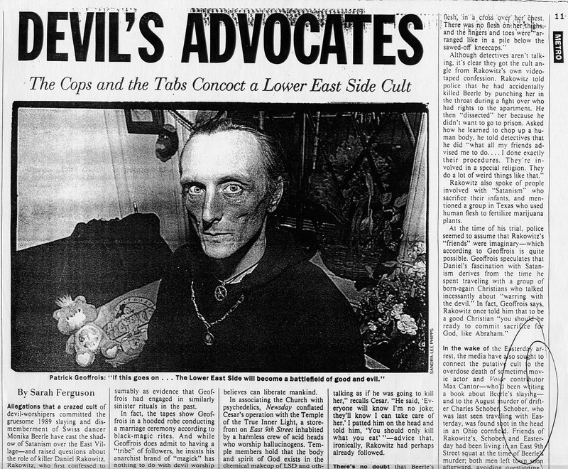
Part II of newspaper article here
Also there was a devotee witness who said Prithu Putra Swami was in Vrindavan when Prabhupada passed away, and then as soon as it was over he came back to france, disconected form ISKCON and then went back to his old ways of Satan worship. [see below]
It appears to me he becomes a prime suspect, or at least an accomplice in the poisoning of Prabhupada. How can a Satan worshipper have gotten so close to the inside circle of Prabhupada's group. and then he mysteriously disappears just days after Prabhupada leaves his body and he instantly goes back to Satan worship as though he was never a part of iskcon.
Here is a picture of him in his Satanic robes.... [Photo here] (note he was just with Prabhupada when he passed...then immediately went back to his satanic robes)
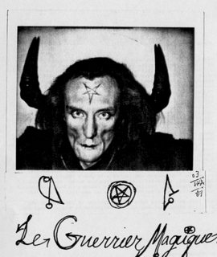
Patrick Geoffrois (Prithu Putra Swami)

This is the woman he had murdered, and chopped her up into soup to feed to homeless people-
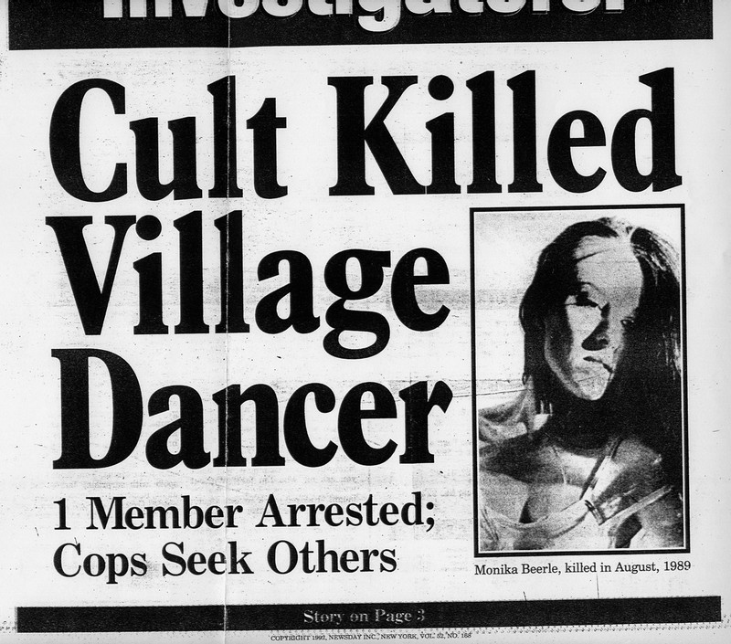
Girl killed in satanic rituals and the meat fed to the homeless in soup
All this time when he is running this satan cult and murdering people, Malati is his wife and together in this satan worship then I stumbled upon an archive of his satan worship manual: http://pissierarchives.canalblog.com/archives/2007/06/29/5460851.html -

Patrick Geoffrois [Prithu-Putra Swami], NYC, circa 1988.
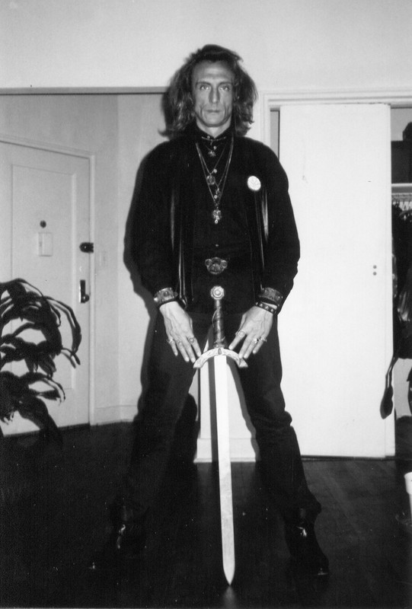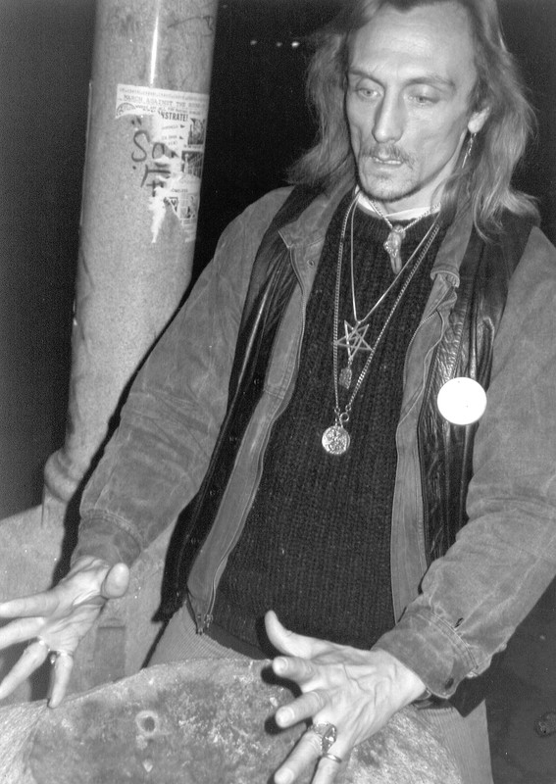
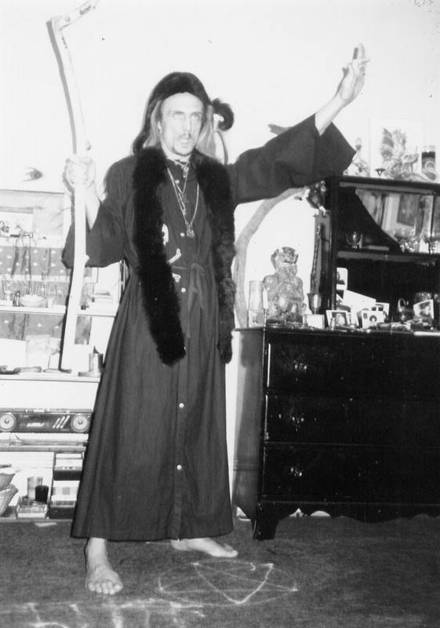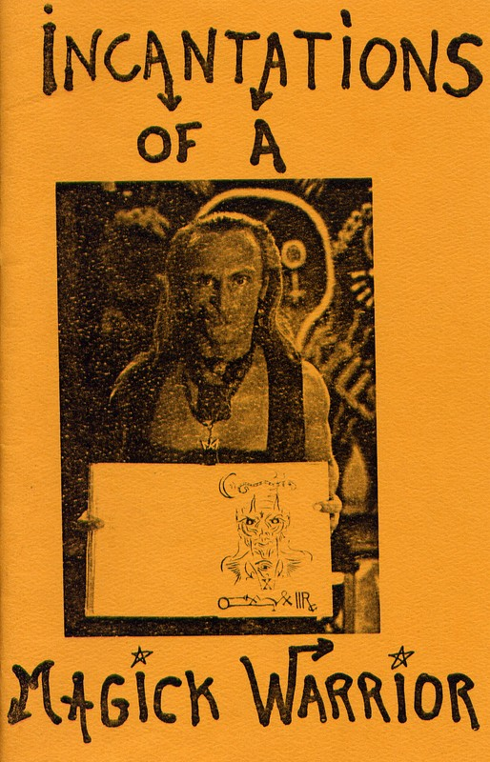
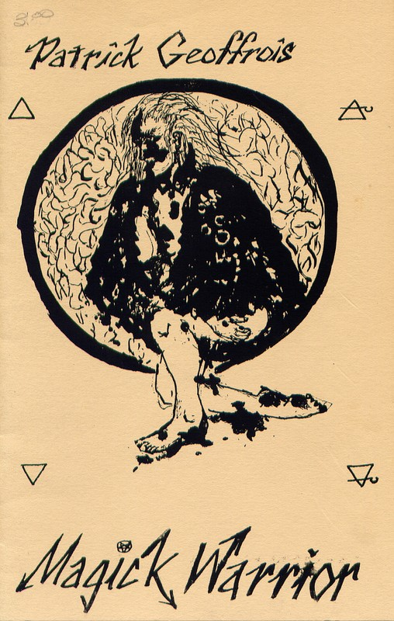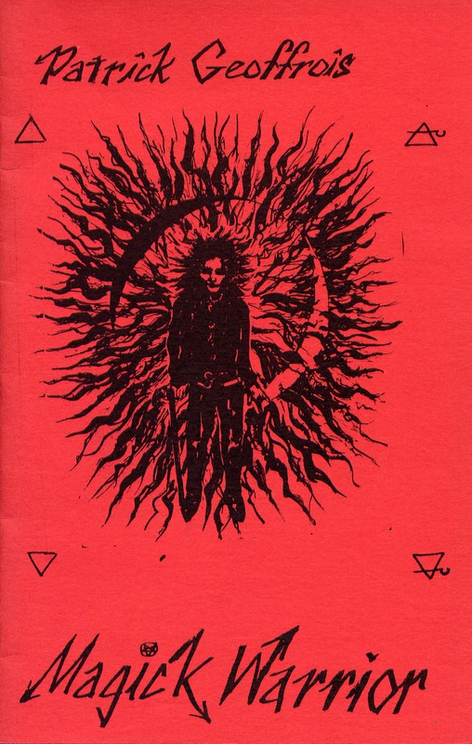
INCANTATIONS OF A INCANTATIONS OF A
MAGICK WARRIOR, Vol. I, MAGICK WARRIOR, Vol. II,
Patrick Geoffrois, [Prithu Putra] Electric Press, New-York/Paris, 1987
INCANTATIONS OF A MAGICK WARRIOR Début des années 90.
- and inside the booklet it credits Malati as the artist -
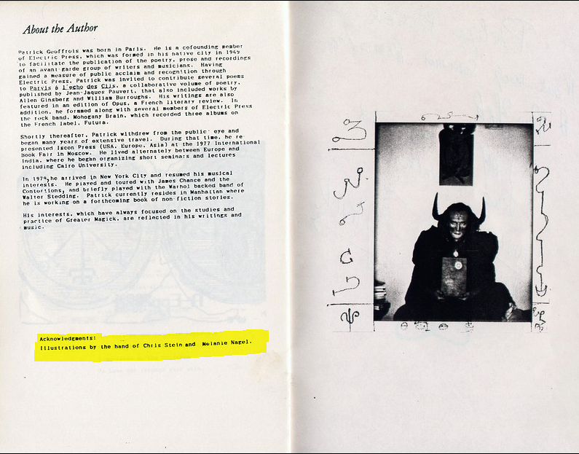
Illustrations by Melanie Nagel, who is non other than Malati Dasi!
Multiple editions of the satan worship manual credit Melanie Nagel [Malati Dasi] as the artist.
They will try to say she left in the 80's, but here is a letter from him (Patrick/Prithu Putra Swami) where he gives the return address including Melanie Nagel's name in1993 so they were together even as late as 1993 doing satan worship
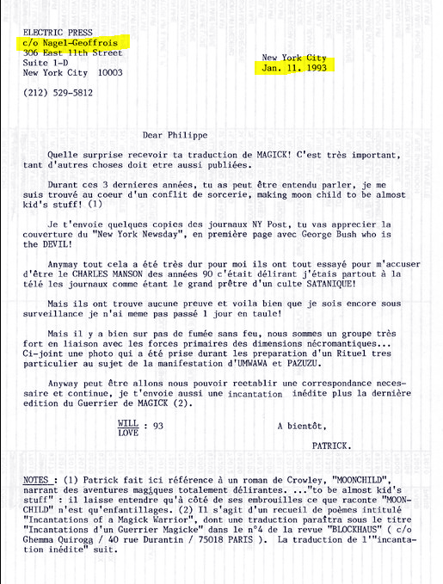
And when you search the phone number or address that they used at the time, you can see a list of past tenants, one of whom is Melanie Nagel, and if you click her name it shows her present address which is New Vrindavan.
So what this all tells us is that Malati was doing Satan Worship along with Prithu Putra even as late as 1993 just a short time before being reinstated in ISKCON as a GBC. How do you go from satan worship, human sacrifice, etc., to immediately being appointed as a leader of ISKCON???
There is one more suspicious thing about Prabhupada's departure: Adi Keshava Swami was the son of a CIA officer--- Adi Keshava Swami was put in charge of getting Prabhupada's "medicine" in the final days. He was having the ayurvedic medicine made by a person named Chandra Swami, who today is infamous as a criminal, arms smuggler, tantric, "godman", etc. He was put in jail at some point, and was previously an advisor to various prime ministers of India.He was also accused in the assasination of Rajeev Gandhi, former prime minister of India. So how does Adi Keshava Swami, son of a CIA officer, have connections with this godman Chandra Swami, who was a big shot even at that time, advising prime ministers and politicians? Is it possible for some random american to show up in India and have contacts with famous people?
Adi Keshava Swami was having Prabhupada's medicine made by a person who has now been accused in the assassination of Rajeev Gandhi. Doesn't that seem just a tad bit strange?
Also this Chandra Swami was just 26 years old when Prabhupada died. How is a 26 year old a master of Ayurvedic medicine? Why would they go to this person instead of an aged ayurvedic doctor who has had a life time of experience in treating diseases?
Here is an article on the recent passing away of Chandra Swami: https://www.hindustantimes.com/india-news/chandraswami-the-godman-mired-in-controversy-is-dead/story-gfFWyRJn84L8jrGX68BBSN.html
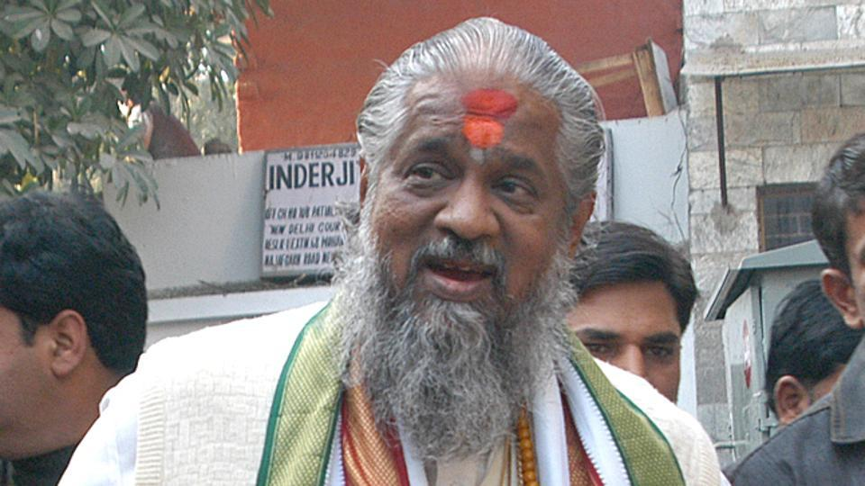
www.hindustantimes.com: Chandraswami, the godman mired in controversy, is dead ...
Controversial godman Chandraswami — said to be a close friend of then Prime Minister PV Narasimha Rao and allegedly involved in the assassination of former Prime ..
Here is from Vedabase Prabhupada speaking of this Chandra Swami, who would later be used to make his medicine in the last days
Girirāja: No, another one. Not Sukla. And this Sharma is saying that he has personal experience that this is a bona fide movement and that the American public in general may not know, but A.C. Bhaktivedanta Swami is one of the renowned writers of translations of Vedic translations and commentaries of Vedic literature. [break] And then Ādi-Keśava Mahārāja is going with a swami? Chandra Swami, some Indian swami in America. He's going with Ādi-Keśava Mahārāja to meet the new President of the United States on January 27th.
Prabhupāda: He's going to see?
Girirāja: Yes, Jimmy Carter. On January 20th he will become the next President. So Ādi-Keśava Mahārāja and this one Indian sannyāsī, they are going to make a representation to the new President.
Prabhupāda: Who is that Indian swami?
Śrutaśrava: His name is Chandra Swami.
Prabhupāda: Chandra Swami? So why...?
Guest (4): He's a young man.
Prabhupāda: He must be Māyāvādī. He's taking advantage of this. He's a Māyāvādī.
Guest (4): He's a man who is following Tantric.
Prabhupāda: So what is this nonsense. This should not be... He should not accompany. He's taking advantage of it.
Guest (4): He's also directly associated with the Prime Minister, this young man. Chandra Swami.
Adi Keshava was taking this Chandra Swami on a tour to the US back in 1976. How is it possible? Where did they get the money from? Imagine back then when ISKCON was just starting out, who could imagine they would take some Swami on a tour of the United States. And he appears to have been the only māyāvādī Swami to ever have been given a free tour of the united states by an ISKCON swami. Looks like they took him to the CIA for plotting to poison Prabhupāda.
And look at this connection of Chandra Swami:
"Chandra Swami faced charges of repeated violation of the Foreign Exchange Regulation Act. An income-tax raid on his ashram is reported to have uncovered original drafts of payments to Adnan Khashoggi of $11 million. Khashoggi was allegedly involved in the “Iran-Contra affair” as a key middleman in the arms-for-hostages exchange along with Iranian arms dealer Manucher Ghorbanifar.
The “Iran-Contra affair” was a political scandal in the US during the second term of Ronald Reagan as President. Senior Reagan Administration officials had secretly facilitated the sale of arms to Iran, which was the subject of an arms embargo."
There is no way he isn't CIA if he is getting payments from someone the CIA used in the Iran Contra affair. Rather it appears he was paying money to Adnan Khashoggi, but prinicple is same. Why would he be having financial transactions with a CIA middleman? Now look back at Adikeshava Swami, son of a CIA officer, taking Chandra Swami for a tour to the USA in 1976. It all makes sense that they were all in the CIA. And this CIA asset was then commissioned to make the "Ayurvedic medicine" for Prabhupāda to take in the final days.
Now read this conversation about the medicine made by Chandra Swami in 1977, keeping in mind the background and their connections to the CIA
Bhavānanda: Yes. (devotees chant japa) [break] Srīla Prabhupāda? Śatadhanya Mahārāja has come.
Śatadhanya: I have brought the makara-dhvaja from the kavirāja in Delhi. This kavirāja, he's not Rāmānuja-sampradāya, but many people say in Delhi that he's the foremost kavirāja in India. He treats the Prime Minister, Morarji Desai, and all the ministers also. So many people trusted him, and he mixed this medicine... He was mixing it for some other person, but when he heard that you were ill, he gave it to us.
Bhavānanda: What kind of makara-dhvaja?
Śatadhanya: There's different kinds of makara-dhvaja, six kinds. This is the most potent kind. This is called siddha makara-dhvaja. This contains gold and pearl and musk and mica and many other ingredients.
Bhavānanda: And what are the other ingredients you have to take it with?
Śatadhanya: You can take it with either honey or milk. But he recommended that for Prabhupāda's particular condition he take it with honey.
Prabhupāda: That's all right. What did he charge?
Tamāla Kṛṣṇa: What did he charge?
Śatadhanya: Nothing. We got it for free because we got it through one influential man named Chandra Swami.
Prabhupāda: Oh.
Tamāla Kṛṣṇa: Oh, Chandra Swami. That's that person Ādi-keSava was always working with.
Prabhupāda: That means he's honest. That's all.
Tamāla Kṛṣṇa: You met Chandra Swami?
Śatadhanya: No, he's in Madras. This is forty-eight doses, two doses a day. That means this is twenty-four days' medicine makara-dhvaja. Two doses per day.
Prabhupāda: So do it carefully. Tamāla?
Tamāla Kṛṣṇa: Yes, Srīla Prabhupāda.
Prabhupāda: You take care.
Tamāla Kṛṣṇa: All right. I'll keep it locked up.
Prabhupāda: They charged nothing. Then he is honest.
Tamāla Kṛṣṇa: Did he say what the charge would normally have been?
Śatadhanya: No. But he did say that what the other kavirājas said about dosage was very wrong, and that if that dose was taken it would have been detrimental.
Tamāla Kṛṣṇa: Which dose?
Śatadhanya: One tolā. He said that's not sane.
Bhavānanda: Did he say anything about length of time involved for the efficacy of the medicine?
Śatadhanya: No. He just said it's very powerful medicine.
Tamāla Kṛṣṇa: What time should it be taken? Morning and night?
Śatadhanya: Morning and evening.
Tamāla Kṛṣṇa: Any particular time in the morning?
Śatadhanya: No.
Bhavānanda: Srīla Prabhupāda, would you like to take some now?
Prabhupāda: Yes. Why not? Huh? Tamāla?
Tamāla Kṛṣṇa: Yes.
Prabhupāda: Simply with honey.
Tamāla Kṛṣṇa: Is it in the form of powder? So it's mixed...
Śatadhanya: It's already mixed and separated into separate doses.
Tamāla Kṛṣṇa: And it's put in a spoon of honey?
Śatadhanya: It's mixed with honey.
Bhavānanda: About ten drops of honey.
Tamāla Kṛṣṇa: It's already with honey?
Śatadhanya: No, you have to mix it with honey.
Bhavānanda: How much honey?
Śatadhanya: He said just some honey.
Tamāla Kṛṣṇa: Just so it becomes palatable.
Bhavānanda: So Bhakti-caru Mahārāja will take charge of mixing that?
Prabhupāda: Where he is?
Tamāla Kṛṣṇa: Bhakti-caru? He's here.
Prabhupāda: (Bengali)
Tamāla Kṛṣṇa: I'll keep it locked in the almirah, and I will give one dose at a time to Bhakti-caru.
Prabhupāda: Yes.
Tamāla Kṛṣṇa: And he will mix it with honey and give to you.
Prabhupāda: Yes.
Bhavānanda: Very good. So let's mix a little...
Prabhupāda: What is date today?
Tamāla Kṛṣṇa: Today is the 25th. It's an inauspicious day. So it's the proper day to begin taking it.
Prabhupāda: So let us begin tomorrow morning.
Tamāla Kṛṣṇa: Begin tomorrow morning, on an auspicious day.
Prabhupāda: Ha.
Bhavānanda: Of course, you... Srīla Prabhupāda, you've said when an auspicious thing comes along, it's best to act on it immediately. However, if you feel that you want to start in the morning...
Prabhupāda: You decide.
Trivikrama: You should take it now.
Pañca-draviḍa: Yes.
Prabhupāda: All right.
Pañca-draviḍa: If something's auspicious, why wait for tomorrow?
So the medicine is given free from Chandra Swami, and carried by Satadhanya. Look up the background of Satadhanya.
In Iskcon there is a tendency for devotees to make careers out of their presence with Prabhupada in the final days, some writing half a dozen books on it, using that link for their fame and prestige and maintenance... and thereby get a lot of respect and position in ISKCON.
So when you find someone who was very intimately involved in the procurement of Prabhupada's medicine, but they hide the fact that they were with Prabhupada in the last days and conceal their involvement - that tells us they want to remain inconspicuous for a reason.
After Srila Prabhupada's departure, Adi Keshava Swami disappeared from the face of the earth, never to be heard of in ISKCON again.
Satadhanya was made the official lawyer of ISKCON in India and has been protected in Mayapur for the last 40+ years despite a lot of things.
Satadhanya, Bhavananda and Nitai Chand were three homosexual child molesters in Mayapur. They were protected for 40 years, one kid was raped so bad by Satadhanya that he had to have his anus stitched in the hospital.
Yet no one was every charged with a crime and they were kept on Iskcon payroll for 40 years.
Why doesn’t he mention he was with Prabhupada in the last months when he was the one bringing the medicine and helping to "care for Prabhupada"?
The only reason a devotee would not tell everyone how close he was to Prabhupada and how he was with Prabhupada helping him, is if he didn’t want it to be known because he knew there was a crime involved.
----------------------

Who is Prithu Putra Swami? And Malati dd?
Prithu Putra is Patrick Geoffroy [Geoffrois] and Malati is Melanie Nagel (a lesbian)
Malati dasi’s karmi name is Melanie Nagel (a lesbian), and her satanic boyfriend is Patrick Geoffrois, spiritual name Prithu-putra
ISKCON GBC member, Malati and her ex-swami friend, Prithu Putra Swami where beating Krishna-kirtana dasi in front of Notre Dama Cathedral on Christmas Eve, because Krishna-kirtana dasi was distributing Srila Prabhupada's books.
Mar 03, 2012 — VRINDAVAN DHAM, INDIA (SUN) —
Wasn't Patrick Geoffroy [Geoffrois] the most infamous Prithu putra, former sannyasa and rogue in France in the late 1970's and beginning 80's? I remember Malati and him attacking us in front of Notre Dame Cathedral in Paris during our Christmas marathon, while we were distributing Srila Prabhupada's books. They beat us and stole all the money collection belonging to Srila Prabhupada, right in front of the people coming out of the Cathedral on that Christmas night. Big nightmare!
And when I saw her on the GBC, I realized you were right from the very beginning! The big gang club, the old boys and now girls! Such a shame! I felt like vomiting ISKCON!
I left the GBC authority behind and started exposing the impostors on the Net too, and around. We are now proceeding safely at Srila Prabhupada's lotus feet, from outside the GBC circle of influence! Thanks to all those who helped us, after having been kicked out of our local temple, where we had been serving steadily for more than 15 years, go back to University, get our degree, teach in French National Education, retire with a pension and gradually move to Vrindavan Dhama to end up our drama in good company at least, by the end of our life.
We thank you for being our real "watch dog" in Srila Prabhupada's Movement :) Thanks again for your determination in revealing the truth, no matter how unpleasant and shameful it may be.
Your servant,
Krishna-kirtana dasi
Pada: Malati (Melanie Nagel), a woman who had problems with lesbianism, and running off to have affairs with swamis like Prithu putra, also was made a big leader in the ex-Kirtanananda regime. Prithu Putra told his friend in France that Srila Prabhupada had been poisoned, and he knew who the culprits were. PrthuPutra and Malati left ISKCON together, (and got married) so its assumed he must have told Malati who did it. How come Malati is now a GBC-member, sitting in the seat of the GBC body? http://krishna1008.blogspot.de/2012/06/srila-prabhupada-poisoning-confirmation.html
Comment: Prithu Putra (Patrick Geoffroy) was the 1st French Isk'Con Sannyasi. He left KC some time after Srila Prabhupada's disappearance and reassumed the lifestyle he led before he joined - sex, drugs rock' n' roll and satanic worship. Some years later he contracted AIDS. As the disease progressed he ended up in hospital, and as it progressed further he was hooked on the machines which kept him alive. During his last days he was in coma and eventually died.
From: The Villager: Both Patrick and Melanie were H.I.V. positive. Melanie got down to around 80 pounds. She died in the hospital, but as one of the only modern miracles I know of, she came back to life. She recovered and once again became an active member of the Krishna movement. Patrick knew he was dying and played up being the Magick Warrior to the max. She and Patrick split. She lived and Patrick died.
Please also see:
http://thevillager.com/2012/03/01/cops-were-spellbound-by-idea-of-magician-as-killer/
http://patterson.no-art.info/writings/2012-03-01_patrick-geoffrois.html
INCANTATIONS OF A MAGICK WARRIOR
PATRICK GEOFFROIS – INCANTATIONS D’UN GUERRIER MAGIQUE

