CHAPTER 28:
GBC ABANDONS UNTESTED HAIR SAMPLES

“Every month I had the opportunity to shave Srila Prabhupada’s head with the electric clippers…I was very careful. By Krishna’s grace there was never a mishap… Many devotees were delighted when I distributed Srila Prabhupada’s hair.” What Is The Difficulty? by Srutikirti das, pg 66

NEED FOR NEW HAIR TESTS
The 1999 neutron activation analysis of Srila Prabhupada’s hair sample Q-1 by Dr. Steve Morris revealed 2.6 ppm arsenic content, and constituted a big step forward in the poisoning investigation. If further hair tests produced multiple confirmations of abnormally high levels of poisons such as arsenic, the proof of poisoning would be dramatically strengthened. We believed Srila Prabhupada when he said he was being poisoned; all we needed was proof for the non-believers.
Multiple confirmations would also exclude the suspicions of a small possibility of a fluke test result due to some unknown circumstance. There were perhaps dozens of devotees who had kept samples of Srila Prabhupada’s hair as sacred keepsakes. Therefore, to do further forensic hair tests, it was necessary to find more authenticated late-1976 and 1977 hair samples which would be available for testing. This was now a top priority for the private investigation.
After the Q-1 test, Balavanta das had sent Dr. Morris two more Srila Prabhupada hair samples from years previous to 1977, being the only samples he could locate. This was believed to be far before the time when Srila Prabhupada’s poisoning began. The dramatic downturn in Srila Prabhupada’s health on Feb. 26, 1977 seemed to be the beginning of the poisoning, so we focused on locating hair samples that had been cut in 1977, not earlier. The two hair samples were:
Sample 1A: Contributed by Sashikala devi dasi of Prabhupada Village in North Carolina. She received it from Yugadharma das, who received it from Upendra das shortly after it was cut from Srila Prabhupada’s head in mid-1975. It was 17 pieces of 1 cm in length.
Sample 1C: This one was from 1974, being only 2 pieces of 1 cm in length. Balavanta told Nityananda that he had gotten this sample from Sruta Kirti das, who later confirmed this.
Just before the Mayapur GBC meetings in early 2000, Balavanta das had told Nityananda das that he was reluctant to do further testing after Q-1 unless he could locate some 1977 samples. He thought his 1974 and 1975 samples could be useful for reference, to compare earlier periods with Q-1’s 1977 arsenic levels, ostensibly comparing the pre-poisoning to the post-poisoning periods. But he found no more 1977 samples, and besides, he was not prepared to pay the $6000 that Dr. Morris was now asking due to having been intimidated by the author of the GBC’s book (by demanding an unknown number of free tests.)
Little did Balavanta know that while he was working on the official GBC investigation, another secret operation was being organized by the primary suspects themselves, or that they had diverted two 1977 hair samples to their own program of orchestrated denials. It is interesting how the section of ISKCON leadership who was aware of only Balavanta’s efforts, awaiting his report, seamlessly and compliantly jumped to adopt the verdict of the secretive suspects’ report in Not That I Am Poisoned. Everyone was relieved by a salvationary dismissal of the poisoning “theory,” and that it was produced directly by the suspects themselves did not matter much to them, as they were apparently not concerned what was truth, but what was politically useful.
Balavanta left his two samples (1A and 1C) with Dr. Morris, who never heard from Balavanta again after 1999. Balavanta was disgusted with the March 2000 GBC cover-up and how he had been shoved aside without notice. He dropped all his investigative efforts, and after Someone Has Poisoned Me was published, all honest investigation into Srila Prabhupada’s poisoning had come to an end.
However, the quest for the truth should not be dependent on GBC funding or the honesty of the ISKCON leadership, so the private investigative committee decided to push forward in the search for other hair samples. This important business should not be left unfinished. The story continues, as related by Nityananda das himself.

By Nityananda das

GBC CANNOT ORGANIZE THEIR HAIR TESTS
In March 2000 I asked Dr. Morris for cost concessions on a new set of tests, guessing that I could locate at least a few more hair samples. He replied that he would “re-negotiate” the $6000 quote he gave Balavanta and the GBC’s Deva Gaurahari das. He expressed his concern that many “Hare Krishnas” would expect free tests and complicate his academic life, and thus he had felt it necessary to charge a commercial rate. I assured him that I would be his only client and that others would need to arrange their own work, which he was entitled to decline. He agreed, and I told him I would contact him later when I obtained further samples. I was thus encouraged to find them, with the testing arrangements now at the ready.
After putting out queries all around the Vaishnava world for 1976 or 1977 hair samples, we located only a few earlier-dated ones. We already had three pre-76 samples, namely 1A, 1C, and presumably my own hair relic (what remained of it). The search dragged on for a year and a half in vain. It was discouraging, especially when I found several 1977 hair samples that their caretakers were not willing to share or exchange. Yamuna dasi, Satyanarayan das (Library party), Hari Sauri das- their samples were inaccessible. Offering to trade a few pieces of their 1977 hair sample for my earlier dated hair, they wanted nothing to do with this controversial matter. They took me to be a troublemaker and politely declined to get involved in any way.
Then one day in late 2001, I was studying more closely Not That I Am Poisoned, becoming intrigued by what I read on pages 318-319:
“At this time (October 1999) we contacted Dr. Morris while trying to locate a lab to analyse a hair sample from Vrindaban… The devotee in charge of the archives in Vrindaban testified that this hair was originally ON the clippers but was removed with a brush and kept in this container… Dr. Morris agreed to do the analysis… he wanted US$6000 to do the work… It then had to be decided if it was justifiable to spend $6000 US of GBC funds… it was decided that, considering the circumstances, it was not justifiable…”
NTIAP continued:
“To allay any fears of a ‘cover-up’, the Ministry for the Protection of ISKCON extends an open invitation to anyone who would like to fund this analysis by Dr. Morris. We will fully cooperate by providing full details of the specimens, which are already at a lab in the US, and what were their origins.”
A glimmer of hope appeared in my mind’s eye. What if somehow these GBC hair samples could be tested? What if they produced further forensic evidence and confirmation of poisoning? Should I volunteer to pay for the tests? And had anyone already taken up this offer? Although I doubted anyone else had, I also wondered why the NTIAP author had even made such an offer? Was it just a bluff, something he said to convince couch-potato spectators, but which the GBC would never allow?

YUDHISTHIRA DAS BECOMES A DOUBLE AGENT
Although the GBC book offered to cooperate in the testing of their hair specimens, I doubted very much that they in fact would do so. Especially not with myself, who had published Someone Has Poisoned Me! Maybe they would take the money and control the tests themselves, but would never turn over the test results or the hair samples to anyone else. These hair samples might disappear once actual testing was discussed seriously. How could ISKCON or the suspects risk facilitating what results might come about beyond their direct control?
I learned that Hari Sauri das had arranged for the Vrindaban ISKCON temple’s clippers hair sample to be given to the NTIAP author for testing. The first step was to obtain from Hari Sauri or the NTIAP author, somehow or other, “full details of the specimens” and “what were their origins.” Was it actually the hair “originally ON the clippers” mentioned in the NTIAP? Was there more than one sample?
Hari Sauri das was firmly in the GBC “camp,” so obviously I could not approach him directly as myself. I was already persona non-grata number one in ISKCON, for publishing the Vedic Village Reviews (1988-1993) about the ritvik representative initiation system and, more recently, the book of evidence on Srila Prabhupada’s poisoning (1999). Tamal had called me, “Public enemy number one.” So instead, I initiated correspondence by email with him using the pseudonym Yudhisthira das, and posed myself as one who was very sympathetic to the GBC’s “no-poison” position. I wrote:
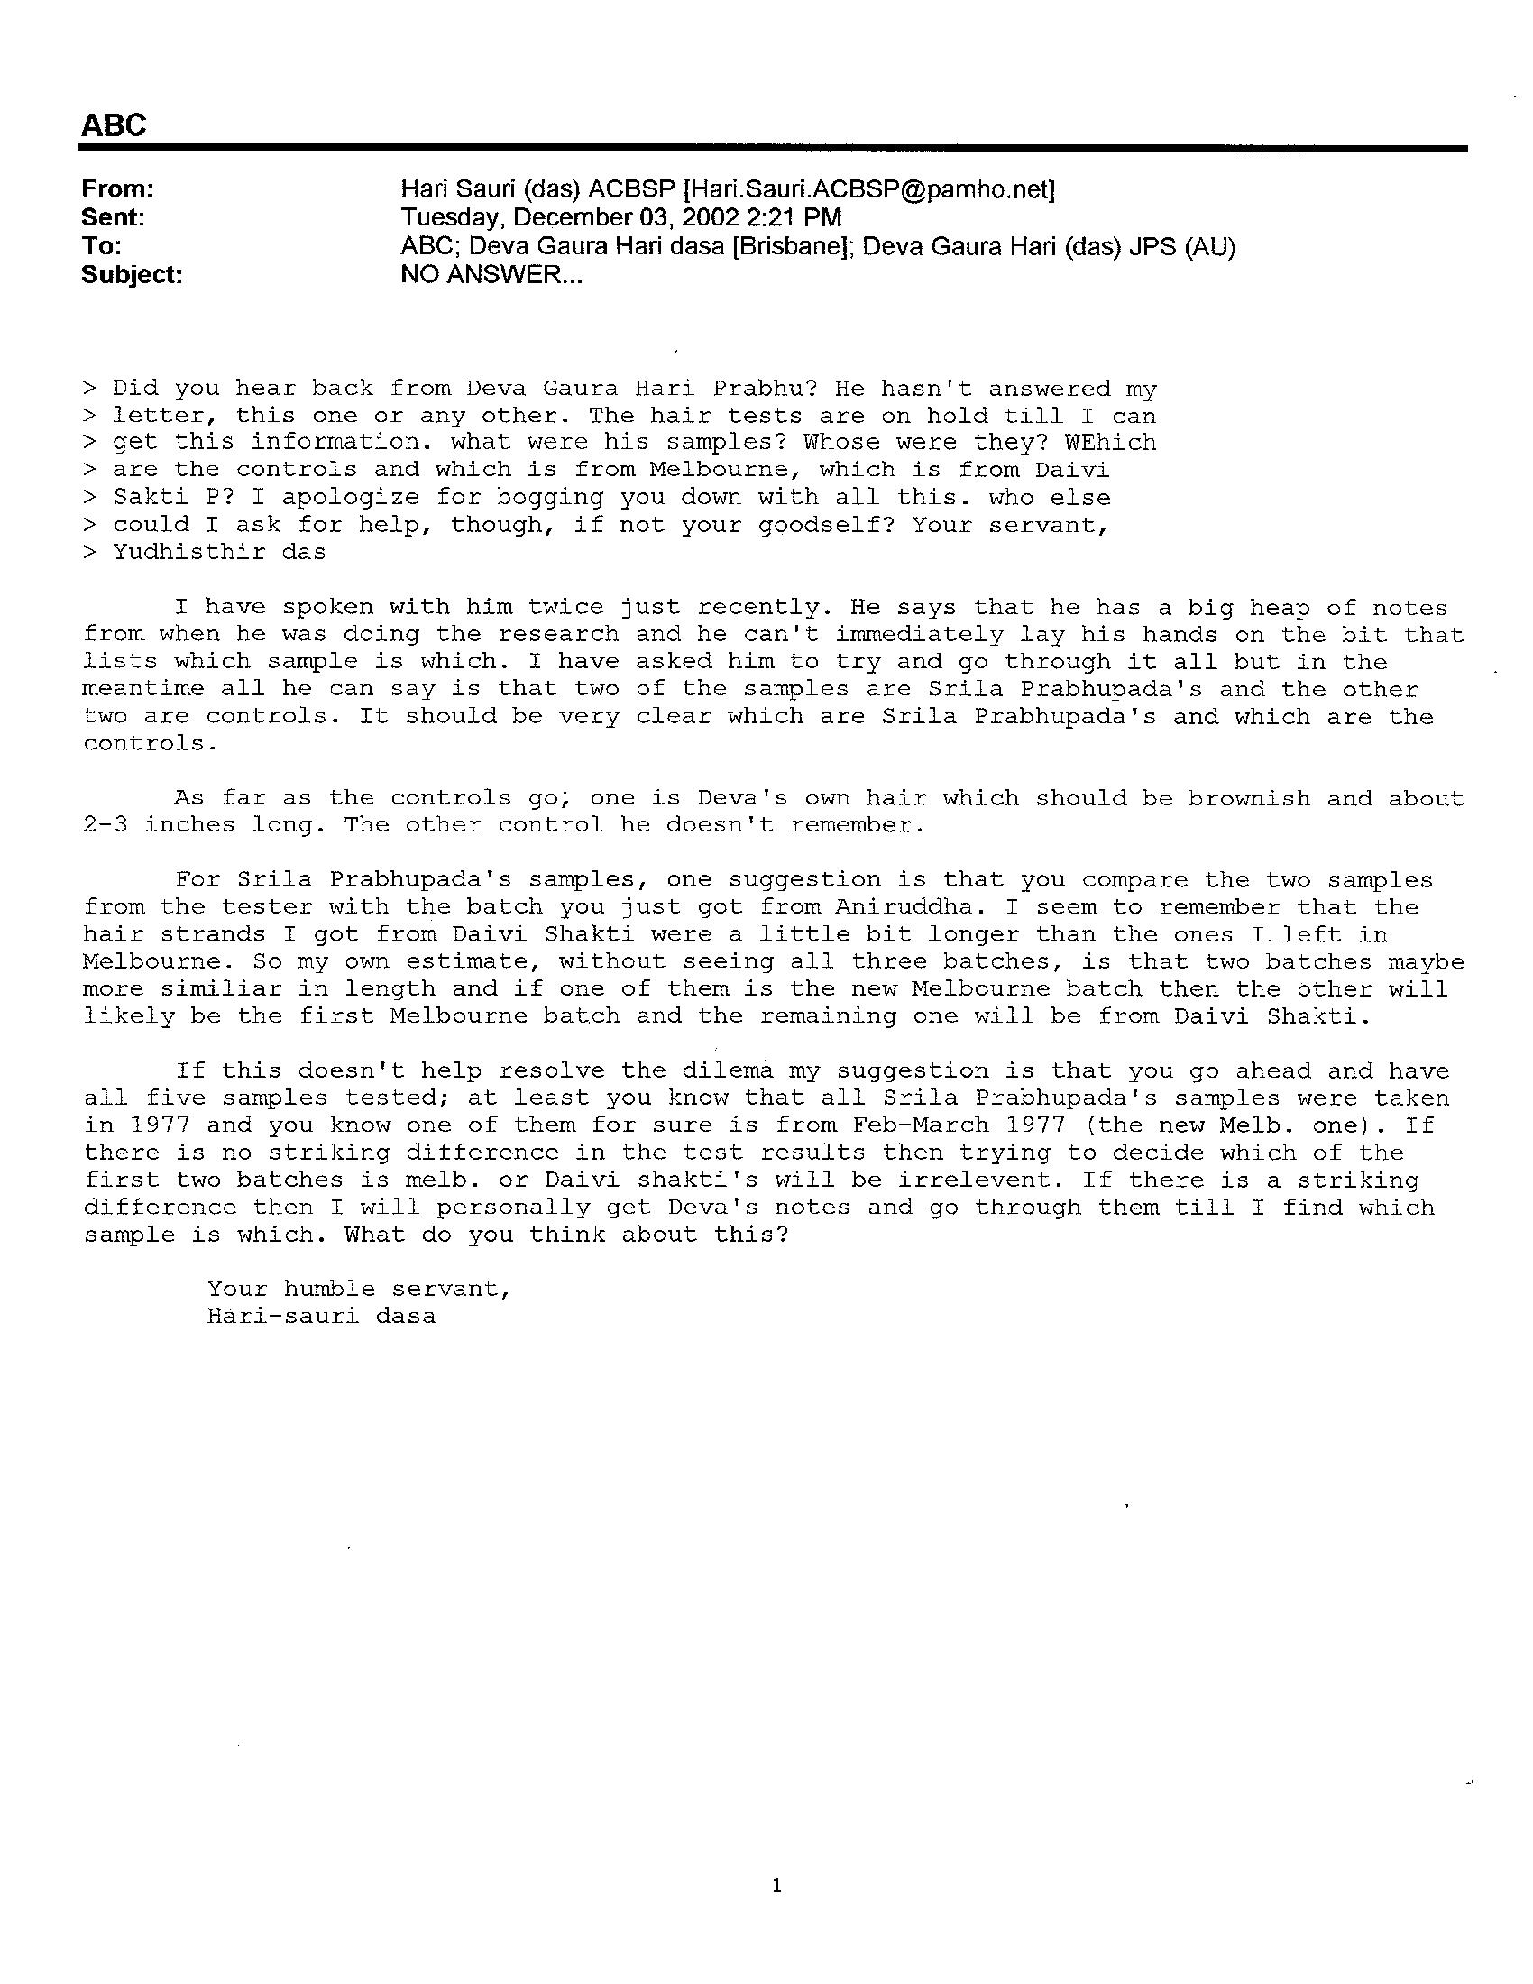
“Recently I was in Alachua and discussing the poison issue with devotees there. The dubious hair analysis done on Balavanta’s hair sample from the hairclippers...” Then I asked some questions about the hairclippers. Hari Sauri das replied, being the good English gentleman that he is, giving details which were hopeful, in an email on October 20, 2001:
“…a small batch of Srila Prabhupada’s hair was collected by Daivi Shakti after Prabhupada’s disappearance. She had cleaned off the clippers and put the hair in a box and kept it carefully. When Balavanta requested hair samples in 1998, I sent him the clippers without knowing about the batch of hair that Daivi Shakti had… The hair samples I got later on from Daivi Shakti, which were sent to America for testing independently of Balavanta’s investigation, were much bigger…
“There is no doubt that these samples were Srila Prabhupada’s hair and it is highly likely that they were the last batch of hair clippings from His Divine Grace. It’s also certain that they were clipped from his head in 1977 but the exact month is not clear.”
Hari Sauri also said that the last time he personally saw Srila Prabhupada’s hair being clipped was in early March 1977, as on March 13 he left Srila Prabhupada’s personal service in India to serve in the Australian temples, not returning to Srila Prabhupada bedside until October 1977. Hari Sauri thus would not know about the clippers’ use in his absence. But Tamal in his diary noted that Srila Prabhupada’s hair was last cut by razor-shaving on September 22, something that was confirmed by another devotee named Vrindaban das Parker. Also Tamal was quoted in 1999 (in NTIAP) as stating that the latest possible use of the clippers was early September 1977. That left about two or so months from September to November where apparently Srila Prabhupada’s hair growth had slowed dramatically due to illness, a normal occurrence with those who are very ill, and there were probably no hair cuttings in those months. These details were just background information which became useful later.
Hari Sauri das further informed me in the same e-mail: “I gave the sample of Daivi Shakti dd to Deva Gaura Hari prabhu in Brisbane… He did send it to a lab in the USA…”

HISTORY OF THE HAIRCLIPPERS AND SAMPLES
The hairclippers Hari Sauri das sent to Balavanta were directly removed from the Vrindaban ISKCON Prabhupada museum display cases, where they were labeled “Srila Prabhupada’s Last Hairclippers” and had been on display there for many years. There had been more than one hairclipper used through the years in Srila Prabhupada’s service, but this one was the last one. We do not know about earlier hairclippers.
In the same October 20, 2001 email, Hari Sauri answered my further questions about the history of the hairclippers that he earlier sent to Balavanta in late 1997. He wrote:
“As far as the hairclippers go, they were only ever used on Srila Prabhupada and no one else. They were sent as replacements for a clipper machine I had in late 1976 that burnt out in Vrindaban. They were brand new and being Prabhupada’s personal clippers they could not have been used by anyone else. I don’t remember the exact date that we received these new ones but it would have been in either very late 1976, around mid-November when Alex Kulik brought some things over from LA or they would have been sent over with devotees coming in early 1977. When Balavanta requested hair samples I sent him the clippers…”
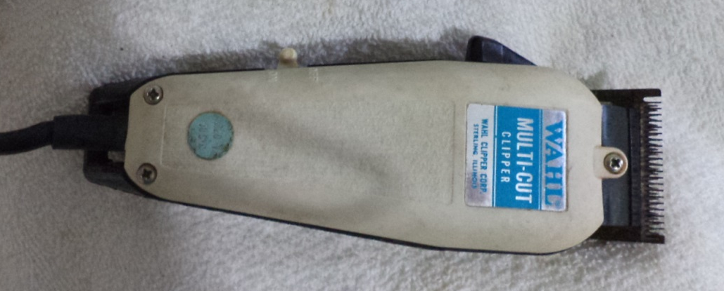
Srila Prabhupada’s last hairclippers, now in the Fiji Prabhupada Museum

Thus, based on the statements from Hari Sauri and Tamal, these clippers were used to cut Srila Prabhupada’s hair from maybe mid-November 1976 and continuing until as late as late August 1977, as there was a razor cutting on Sept. 22. This was at most 10 months, and it can be estimated that these clippers cut Srila Prabhupada’s hair about 6 to 8 times, since Srila Prabhupada would shave about once a month. Of course, during his illness, his hair grew slower and thus there would be expected to have been less cuttings.
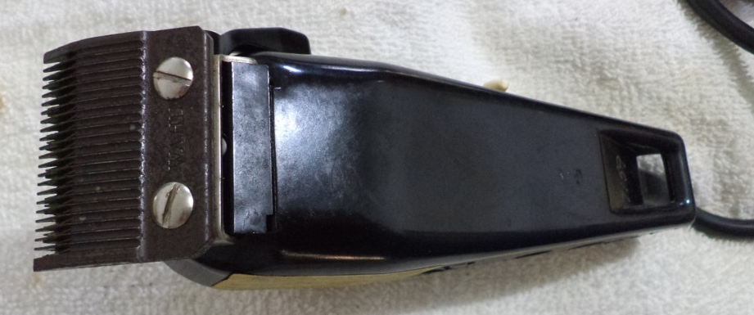
Therefore it can be confidently concluded that the little container of hair collected from the clippers with Daivi Shakti’s brush is a MIXTURE from various hair clippings representing up to ten months from November 1976/ February 1977 until September 1977, the same exact time period during which Srila Prabhupada’s health fell into a rapid decline. Each subsequent clipping during these months would contribute some more hairs which stuck on the blades, as some also fell off. They stuck there due to the clipper’s lubricant oil. Daivi Shakti dasi brushed off a collection of hairs from various haircuttings during this time of Nov. ‘76/Feb. ’77 util September 1977.
In other words, if any poisonous elements were to be found in Daivi Shakti’s sample- they would represent roughly an average of this six to ten months time period.
Balavanta’s Q-1 hair sample (composed of only 0.0013 grams) had been washed off the same clippers by Dr. Morris in 1998 because Daivi Shakti dasi had not removed all the hairs, some 20 years earlier.

HUNTING DOWN THE GBC’S PRABHUPADA HAIR SAMPLES
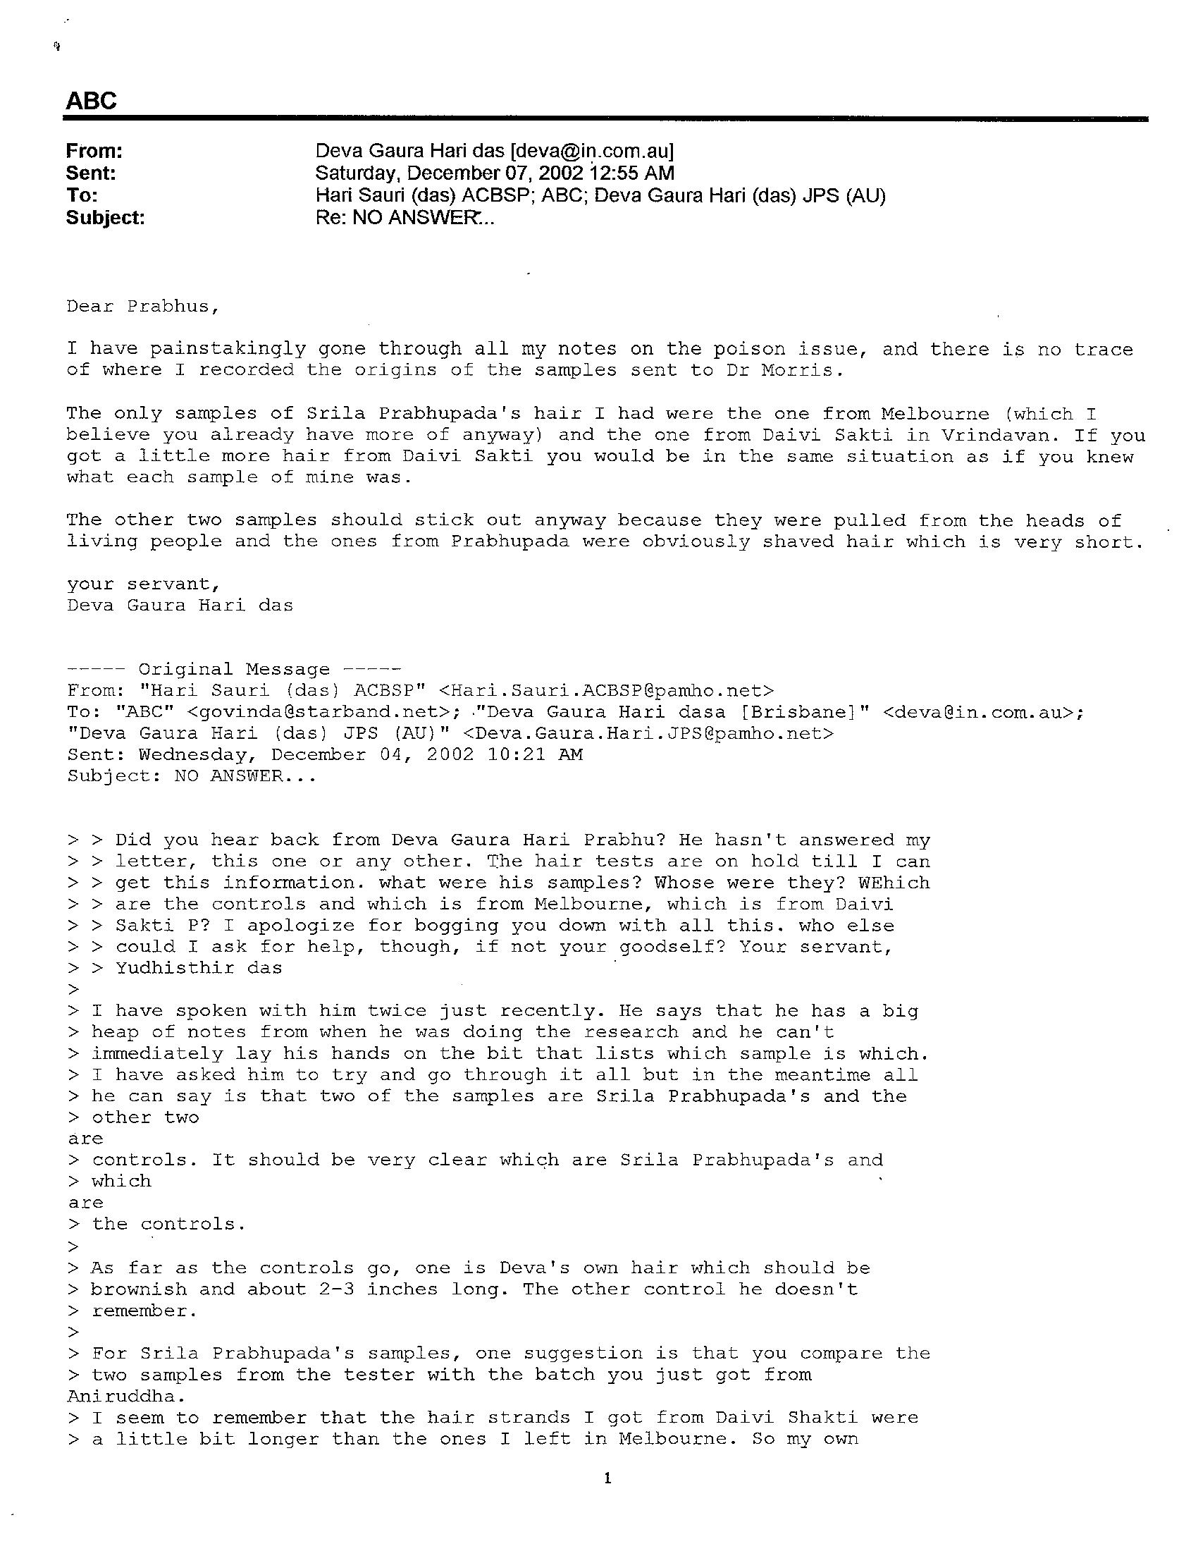
But where was this Daivi Shakti 1977 hair sample now? Which lab was it sent to? I suspected that just as Balavanta had dropped his investigative efforts and abandoned his 1974 and 1975 hair samples with Dr. Morris, maybe the GBC author had left other hair samples at some USA lab, intending to test them, but never did. According to page 37 of NTIAP, the GBC author “contacted various laboratories across the US regarding possible testing of a hair sample from Srila Prabhupada.” NTIAP mentions finding Larry Kovar of General Activation Analysis in California, and relates this:
“After Larry found that his facility didn’t have the required reactor time to perform the tests, he contacted Dr. Richard Cashwell at the University of Wisconsin about performing the analysis.”
Putting it all together, it appeared that Daivi Shakti’s hair sample, a Hari Sauri and GBC authenticated Srila Prabhupada hair sample from 1977, and exactly what we had been trying to locate, might still be sitting for two years at either Kovar’s lab or at the University of Wisconsin. Perhaps it had been abandoned by the GBC author, who referred to “specimens,” meaning more than just Daivi Shakti’s one sample. I suspected that after he sent the samples to the USA for testing, but failed to find an appropriate facility or affordable option, he then just gave up, especially because their publishing deadline was looming. Actually, NTIAP hinted at that, “which are already at a lab in the US.” Once his book NTIAP was published, he might have lost interest in those hair samples and simply forgot about them.
I wrote to Larry Kovar, inquiring whether he still had these hair samples in his possession, leading him to think that I knew they were sent to him. Kovar confirmed that he did receive the hair samples from the GBC author, but that he had determined he could not test such small quantities with his inadequate equipment. He had then sent the samples to Dr. Richard Cashwell at the University of Wisconsin, where he hoped the tests could be performed if they had the proper facilities.
Now I was excited. More than one of Srila Prabhupada’s hair samples, including Daivi Shakti’s 1977 clippers sample, had been sent to Wisconsin in late 1999. Were they still there two years later in 2001?
NO COOPERATION FROM THE GBC AUTHOR
Meanwhile, I emailed the GBC author, at the address provided in NTIAP, as Yudhisthira das and presented myself as very interested in disproving the poison theory by funding the tests on his samples. I inquired about his samples’ history and details, but, as I suspected, there was no reply.
A second and third copy of my letter and offer over a long period bore no results. Obviously it would be a risk for the GBC to test the hair; after getting close to actually doing the tests, the NTIAP mastermind Tamal must have thought twice about actually doing them, and he would have used the $6000 expense as a reason to not do them. (“It then had to be decided if it was justifiable to spend $6000 US of GBC funds… it was decided that, considering the circumstances, it was not justifiable…” NTIAP)
“We will fully cooperate by providing full details of the specimens, which are already at a lab in the US, and what were their origins.” (NTIAP)
Fully cooperate? Well, no help coming from there; it was just a bluff.

LOCATING THE GBC SAMPLES IN WISCONSIN
I suspected that Dr. Cashwell also could not perform the test due to the small quantities involved, otherwise why did the GBC author at one point approach Dr. Morris for testing his samples in addition to Balavanta’s samples? Mustering my nerve, I tried by phone to contact Dr. Cashwell directly at the University of Wisconsin. However, he had retired a year earlier.
Amazingly, his replacement, Dr. Robert Agasie, knew of the case, saying that their equipment was inadequate to test such small hair samples, as I had suspected. While I held the phone, he went looking around on his office shelves, and returning, blithely confirmed that the samples were still there! Shocked, I advised that I would call back soon with further instructions.
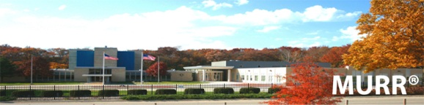
Mustering more nerve, the following week I boldly requested Dr. Agasie to send the hair samples to Dr. Steven Morris for testing at the University of Missouri (MURR), giving the address and instructions how to charge the freight costs to my FEDEX account. I posed as a colleague of those who had sent him the hair samples, and Dr. Agasie duly and promptly packaged up the GBC hair samples and sent them overnight to Dr. Morris. I kept the Fedex invoice showing that the samples had gone directly from Dr. Agasie to Dr. Morris. No one would be able to say that maybe I had tampered with them, as I never saw or handled them. This chain of custody was important to document for future reference.
Shortly, Dr. Morris confirmed that four hair samples from Wisconsin were delivered to him on November 1, 2001. I was elated at the successful recovery of these hair samples which could very well turn out to be of extreme import. How could the GBC just forget about them there in Wisconsin? Had they no esteem for Srila Prabhupada tadiya or sacred relics? They also never thought to retrieve the hairclippers that Balavanta das had sent to Dr. Morris, which I was fortunate enough to receive from Dr. Morris four years later.

THE LOST AND NOW RECOVERED EVIDENCE
At this point I negotiated with Dr. Morris and pleaded for leniency in a quotation on neutron activation analysis of these four and probably other hair samples. He quoted a cost of $2500 minimum for up to five samples, and $500 for each additional sample thereafter. Mandapa das, Yasodanandan das, and Mahatma das contributed generously, and I made up the rest, sending Dr. Morris $3500 in advance for a total of seven tests. We also agreed that I would be the only client from this project that he would work with, and in this way his fears of being obliged to other Hare Krishnas and their possible future demands for free hair tests was allayed. Fortunately Dr. Morris never heard from any other Hare Krishnas besides myself again.
BELOW: Third party Fedex shipping invoice, Wisconsin to Dr. Morris directly
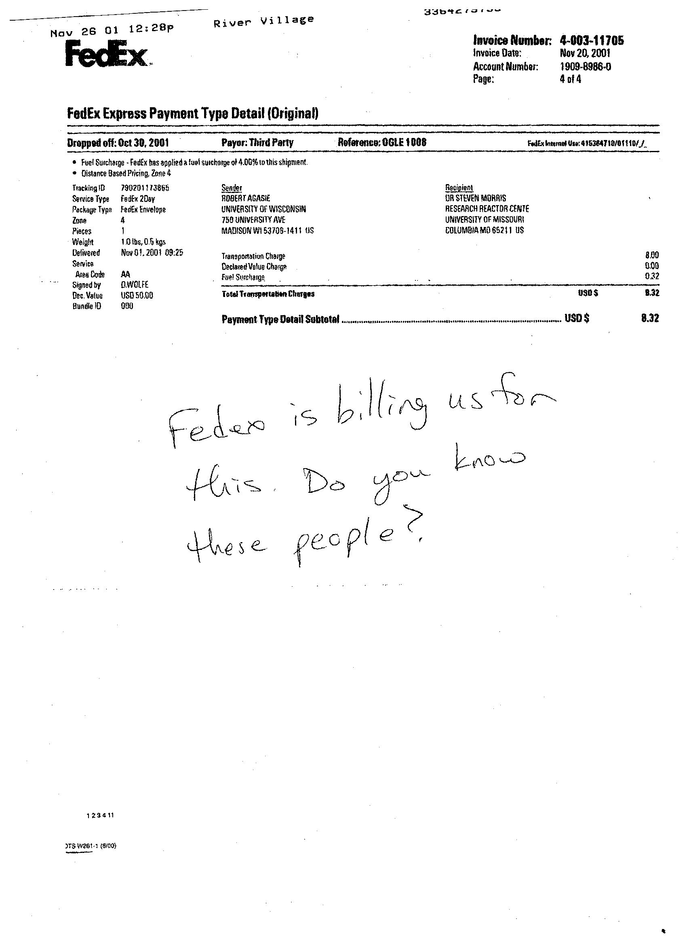

BELOW: LETTERS TO DR. MORRIS & DR. CASHWELL ARRANGING RESCUE OF HAIR SAMPLES

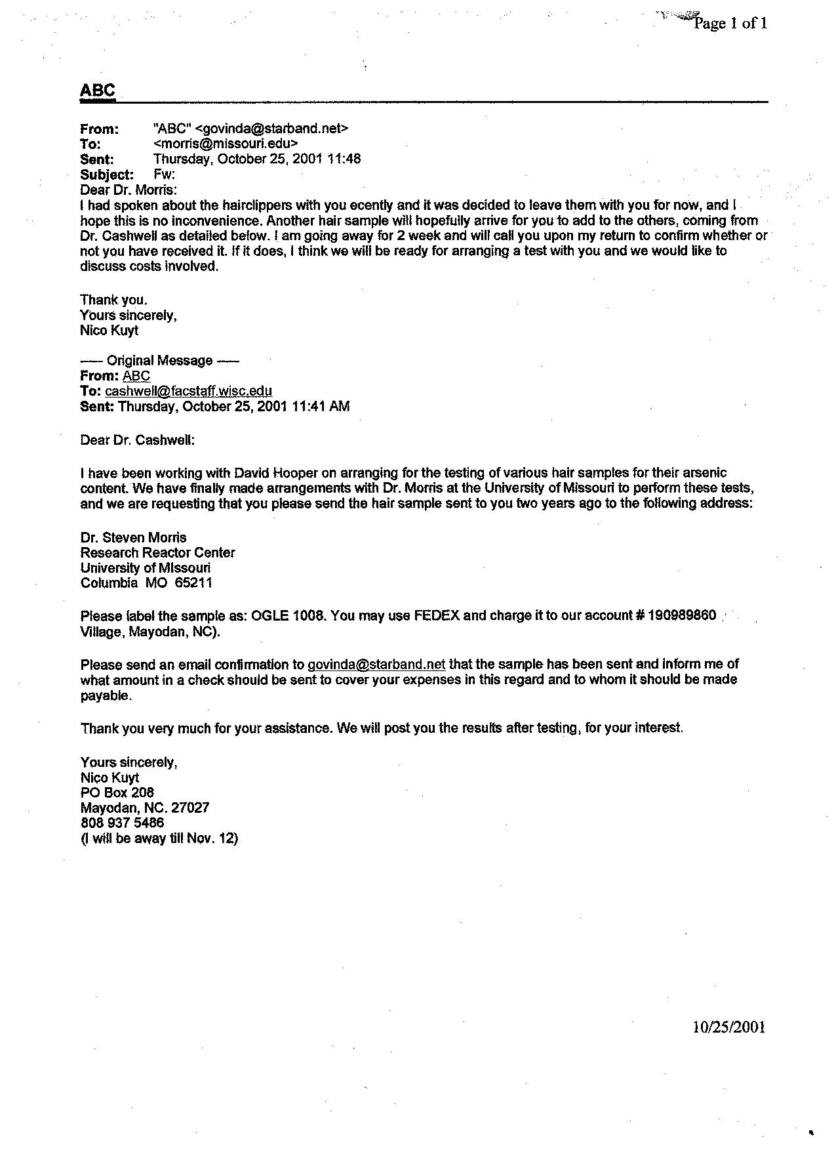

EXAMINING THE FOUR HAIR SAMPLES
Dr. Morris described by phone the four samples from Wisconsin which the GBC author had labeled as samples A, B, D, and E. He then wrote me on January 3, 2002:
“Sample A: Several grey and several dark hairs mixed and approximately 1 to 2 cm in length. Labelled as having a mass of 1.09 mg.”
“Sample B: Mostly light-colored hairs of various lengths ranging from approximately 1 to 5 cm. Labelled as having a mass of 2.5 mg.”
“Sample D: Mostly short hairs, maybe facial hair, approximately 0.5 cm in length. No mass indicated but likely will be 1 to 2 mg.”
“Sample E: Large sample of light reddish-brown hair. Length appears to be approximately 5 cm. No mass given but is likely 100 mg or more.”
Samples B and E obviously were from persons other than Srila Prabhupada, having the wrong color for being Srila Prabhupada’s hair, undoubtedly intended as “controls,” for comparison sake. Of the four, only samples A and D appeared to be Srila Prabhupada’s hair, but we needed to be sure, we needed some positive identification before proceeding with tests. We wanted to know for sure whose hair we were testing.
I was stumped as to what to do next. A few weeks earlier, on December 7, 2001, I was able to elicit a response from the GBC author by employing Hari Sauri as a go-between for “Yudhisthira das.” The GBC author wrote to Hari Sauri, who then copied it on to Yudhisthira:
“The only samples of Srila Prabhupada’s hair I had were the one from Melbourne and the one from Daivi Shakti in Vrindaban… The other two samples should stick out anyway because they were pulled from the heads of living people, and the ones from Prabhupada were obviously shaved hair which is very short.”
A few days earlier on December 4, 2001, Hari Sauri wrote of his contact with the GBC author:
“I have spoken to him twice just recently… all he can say is that two of the samples are Srila Prabhupada’s and the other two are controls. It should be very clear which are Srila Prabhupada’s and which are the controls. As far as the controls go, one is Deva’s own hair which should be brownish and about 2-3 inches long. The other control he doesn’t remember.”
The color and lengths of samples B and E indicated they were not Srila Prabhupada’s hair and obviously were the controls. Sample E was from the GBC author’s head. Srila Prabhupada’s hair was mixed clear-grey-black and under 2 cm, not light colored or brown or 2-3 inches long.
But, in discussions with various parties, it was clear that the best control samples would be from Srila Prabhupada himself, namely samples from an earlier, pre-poisoning time period to compare with a post-poisoning time period. Thus it made no sense to test either samples B or E, and we eventually tested some pre-1977 Srila Prabhupada hair samples to compare to his 1977 ones.

A IS FOR DAIVI SHAKTI, D IS FOR MELBOURNE
Therefore I decided to test only samples A and D- one of which was Daivi Shakti’s- and the other was “from Melbourne.” Later in 2002, Hari Sauri confirmed with Yudhisthira that Sample D was from the Melbourne ISKCON temple, to whom he had personally given some hair that he cut from Srila Prabhupada’s head just before March 13 1977, when he left Prabhupada’s service to go to Australia. It had been kept in Srila Prabhupada’s Melbourne ISKCON personal quarters all those years since then as a sacred relic. In 1999 Hari Sauri had retrieved some of his donated sample from Melbourne ISKCON and given it to the GBC author for testing, and it eventually reached Wisconsin and then Dr. Morris.
How did we identify samples A and D, which was Daivi Shakti’s and which was Melbourne’s? Further correspondence with Hari Sauri shed light on the matter.
“For Srila Prabhupada’s samples… the hair strands I got from Daivi Shakti were a little bit longer than the ones I left in Melbourne.”
Sample A (1-2 cm) consisted of longer hairs than Sample D (1/2 cm). Sample A was therefore Daivi Shakti’s Vrindaban museum exhibit, brushed off the hairclippers. Also, Sample A was in an Indian-style tiny plastic container, as described by Hari Sauri. Thus it was concluded that the shorter hairs in Sample D was Srila Prabhupada’s hair cut by Hari Sauri just before March 13, 1977 and later donated by him to the Melbourne ISKCON temple.
Now the picture was clear: A was for Daivi Shakti, the hair brushed off the outside of Srila Prabhupada’s last hairclippers with a brush (shortly after SrilaPrabhupada’s departure) and saved in a tiny container in ISKCON Vrindaban’s Srila Prabhupada Museum display cases.
D was for Melbourne, the hair cut before March 13, 1977 by Hari Sauri, and later donated to the Melbourne ISKCON temple’s exhibits in Srila Prabhupada’s quarters there.

COUNTERING THE OBSTRUCTIVE GBC WITH SPECIAL TACTICS
Miraculously, we had rescued two 1977 samples of Srila Prabhupada’s hair that had been abandoned by the GBC, and now, testing by Dr. Morris had been arranged. There was no doubt in my mind (or Naveen Krishna’s, who was kept fully informed on all these developments) that if the GBC or their author found out what was going on, they would try to sabotage the tests or resume control of the results. It had been necessary to use special secretive tactics in our further investigation into the poisoning issue. As such, Yudhisthira das had been very useful. We were about to complete the GBC’s own tests on their abandoned, authenticated Srila Prabhupada hair samples, without ever taking possession of them.
What would be the results? Hari Sauri, Tamal, and the rest of the GBC were unaware of what was about to happen.

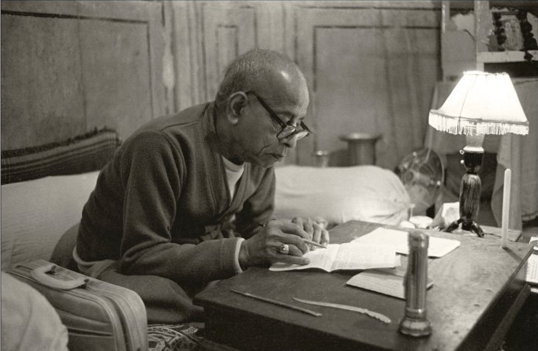
CHAPTER 29:
DISCOVERY OF THE PRIMARY POISON

By Nityananda das

DEVISING PARAMETERS TO TEST THE GBC HAIR SAMPLES
So far we had only one positive test result: Balavanta’s Q-1 with unusually high arsenic levels, but now we were embarking on a new series of tests. We would complete the GBC’s work that they had abandoned. This was exciting detective work; the greatest crime of many centuries could perhaps yet be further confirmed with forensics, 35 years after the fact. Dr. Morris sounded quite enthusiastic about the whole test program and he began preparing for the neutron activation testing regime.
I had been very impressed with Dr. Morris’s knowledge and I came to know that he had been involved in many previous hair tests for law enforcement agencies and court actions. He also had worked on numerous academic cases such as Incan and Aztec mummies. On January 7, 2002, I conferred with Dr. Morris again, deciding which hair sample we would first test, and the overall test strategy. We would start with GBC Sample D obtained from the University of Wisconsin, testing for arsenic.

Almost as an afterthought, I asked Dr. Morris if he would be able to test for more than one heavy metal with such small samples. I specifically asked about antimony and mercury in addition to arsenic. He said he would need to do substantial preparation work but agreed that it was wise to broaden our search “while we were at it.” Dr. Morris then also suggested cadmium because it fit well with the parameters used in measuring arsenic, antimony, and mercury. So the tests were geared for these four elements.
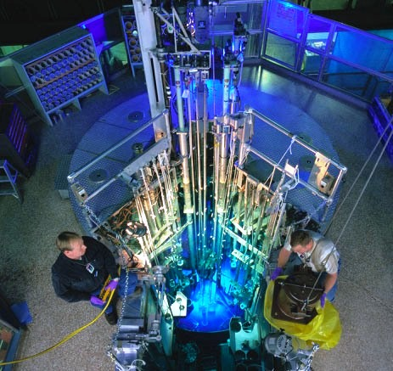
Dr. Morris explained later there was scientific reason as to why these four toxic heavy metals could be tested together: they had radioactive half-lives in the same range and had particular nuclear properties in common. They could thus be measured “in coincidence,” along with a number of other non-toxic elements which would serve as a benchmark for verification of any disproportionately high values of heavy metals. The non-toxic markers to be measured simultaneously would be bromine, sodium, zinc, gold, silver, europium, and uranium.
However, measurements of poisonous elements such as beryllium, thallium, lead, nickel, osmium and tin would require a separate and different nuclear activation parameter. Different activation regimes would enable the measurements of different elements. On such small samples, only one set of elements could be measured, therefore we chose the heavy metals commonly associated with poisoning. Arsenic was the most “popular” poison in history. Mercury had been mentioned in the conversations by the kaviraja Shastriji. High levels of antimony had also been found in Napoleon’s hair.
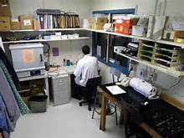
After massive nuclear activation, the resultant radioactivity of the sample is measured over five days. Each element has a different optimum time for measurement. First the arsenic is calculated, then the cadmium, then the mercury, and finally the antimony. This was how Dr. Morris explained his methodology.
Dr. Morris decided not to wash the samples before testing. Sample washing can have very serious effects in the compromising of results and was of limited value anyway, he explained. By powerful microscopic examination he had not found any significant amount of external debris on the hair samples; they did not show evidence of external contamination, such as oils, chemicals, or whatever. Also, he referred to scientific literature on hair analysis that had found hair very close to the scalp, as these samples were (the first half inch), was least likely to have been externally contaminated. Also another US study on the validity of hair mineral testing found that much of the variance in results was due to the washing steps used by some labs. This issue is further discussed elsewhere in Chapter 47, section on Exogenous or Endogenous?
Since our samples were very small, Dr. Morris wanted to refine his testing techniques to maximize the accuracy. He would increase the neutron activation by more radiation than normal, and measurement of results would be taken over five days. But he was concerned whether his test container would hold up or disintegrate under such heavy radiation.
A trial test of some ordinary construction nails in a special plastic capsule was submerged under 30 feet of water in the reactor’s testing tank and submitted to two full hours of intense neutron bombardment. The capsule held up fine, and preparations were made for Sample D to “be put to the test” thirty feet under.

AUTHENTICITY ISSUES AND FUTURE DNA TESTS
One critical element of any forensic hair tests would be the authenticity of the samples. Were they really Srila Prabhupada’s hair? My study of the Napoleon poisoning controversy had impressed upon me the need to do everything possible to preserve credibility and document authenticity of the samples being tested. I knew that by samples passing through my hands, critics could accuse me of tampering with them. Therefore I made sure to have no contact with any hair samples that Dr. Morris would be testing. The only exception was one from my own collection of Srila Prabhupada memorabilia, but all tests on it showed nothing unusual.
It also dawned on me that if we were to find unusual results in several or a series of samples, that it would be questioned whether all of them belonged to Srila Prabhupada. The usual deniers would claim that it was not sure that all the samples were in fact Srila Prabhupada’s hair. I discussed this anticipation with Dr. Morris, who agreed to test only about 90% of each sample, saving enough for possible future micro-DNA testing. This could verify whether our samples all came from the same person or not. Otherwise, without setting aside some of each sample, such intense radiation would scramble all DNA beyond recognition. (see Ch. 89: Authenticity of the Evidence)

THE UNEXPECTED FORENSIC BREAKTHROUGH

There were delays, and in early March 2002 while I was gone to the Fiji Islands searching properties for a varnashrama project in the South Pacific, I got word through a third party that Sample D had been tested, but that arsenic and antimony were rather normal.
Ten days later I was back in Hawaii and called Dr. Morris to discuss the test results on sample D. We reviewed the low levels of arsenic and antimony and I told him Sample A should be next. Then Dr. Morris surprised me.
“I wanted to talk to you when you returned from your trip. Checking some of the other elemental contents in sample D, and I checked the calculations several times to make very sure, there is a most unusual and strikingly high amount of cadmium… It has 23.6 parts per million of cadmium.”

“Oh, so, what does that mean?” I asked.
Dr. Morris then launched into a little dissertation on cadmium, an extremely toxic element in the same family with arsenic, mercury, lead and thallium. Cadmium’s effects are most well understood by its causing kidney disease, which was Srila Prabhupada’s primary health problem. The symptoms of long-term chronic cadmium poisoning, as Dr. Morris briefly described them, were definitely present in the history of Srila Prabhupada’s final year, as I remembered them from my readings.

CADMIUM LEVELS SKY HIGH ABOVE THE NORMAL AVERAGE
How could Srila Prabhupada have gotten these cadmium levels? I was stunned, shocked. We were focused on the arsenic, but we had stumbled upon such an unusual poison as cadmium! Online research revealed that normal average societal levels of cadmium are about 0.065 ppm, about half that of normal average arsenic levels. That is about one-sixteenth of one part per million.
So we were looking at cadmium levels several hundred times more than normal.

This was a dramatic development in the investigation. A breakthrough in forensic evidence was now in hand that would remove all doubts about Srila Prabhupada’s poisoning, even in the most diehard non-believers. Scientifically-minded persons wanted hard-core, indisputable forensic proof- and here it was.
There would always be doubters about the significance of 2.6 ppm arsenic, which was “only” about 20 times above normal, but no one would be able to dismiss these sky-high amounts of cadmium poisoning. Arsenic was now a distant and secondary consideration, and cadmium had been revealed as the primary poison. Somehow Krishna had led us to stumble upon the evidence that would complete the investigation into the question of Srila Prabhupada’s poisoning. Srila Prabhupada was poisoned, primarily with cadmium.

TAMAL DEPARTS THIS LIFE
Dr. Morris had ascertained the cadmium values on March 5, 2002. I learned about them on March 18. In between, on the 15th, the Ides of March, the primary person of interest in Srila Prabhupada’s poisoning was killed in a car crash in India. Tamal Krishna Goswami would never know of our discovery as to how Srila Prabhupada had been poisoned with cadmium, at least not that we could see. The timing of these two events somehow seemed coincidental. Why did Tamal have to depart just as the cadmium poisoning was uncovered?
My old college associate Satyanarayan das called me on March 16, and lamented how Tamal had perished. I was also dismayed, exclaiming, “Oh, that’s very bad… now we’ll never be able to interview him for the poison investigation!” He replied, “Is that all you can say!!?”

CADMIUM: A RARE AND EXOTIC POISON

On the first of April, I conferred with Dr. Morris again. He was back from Easter break and was scheduled to irradiate the GBC Sample A that week, including the container that the GBC samples arrived in. We exchanged notes on our understanding of cadmium poisoning, and I asked where one would be able to find cadmium with which to poison someone. He replied:
“Many high school chemistry labs have cadmium salts such as cadmium sulfate, oxide or chloride. You won’t find cadmium at the hardware or grocery store- one would need to know something about chemistry to know where to get it, such as a laboratory supplier. Cadmium is actually more poisonous than arsenic, and also is used as a poison.”
Although not as readily available as arsenic once was (as an ant killer), cadmium is nevertheless available by mail-order to those who are a little resourceful. In India cadmium could be extracted from nickel-cadmium batteries with brick cleaner (muriatic acid.) Cadmium is not a restricted material, unlike plutonium, mercury, anthrax or many chemicals. Cadmium is unusual, not a well-known element, but quite available pretty much anywhere in the world.
I asked Dr. Morris who would have knowledge of such an unusual and rarely used poison such as cadmium, and who would have the expertise to use it in proper dosages and timing so not to arouse suspicion? Amateurs seemed out of the question. Dr. Morris replied, “Someone with a very good knowledge of chemistry and poisons.” The recipe, doses, and application of a slow-acting cadmium poisoning was definitely beyond the ability or imagination of the average Joe.
My mind flashed: “This poisoning was carried out by professionals, those who do poisonings as a course of business, policy or profession.” I remembered Chandra Swami’s nefarious history (see Ch. 75) and the rumors of Indira Gandhi’s political prisoners developing a mysterious kidney disease, and Chandra Swami being very close to Indira Gandhi. I remembered as well his reputed connections with shady foreign intelligence agencies, the Israeli Mossad, the CIA and the Russian KGB, who were professionals in the assassination business. Their forward operations always needed hard cash, selling their techniques and secrets through discreet channels. How had the prescription for a cadmium poisoning been obtained?
Surely, I thought, Srila Prabhupada’s poisoners would have needed advice, guidance, or assistance from a professional source to have employed this esoteric poison.

RESULTS OF THE SECOND GBC HAIR SAMPLE A
On April 18, 2002, I received communication by email from Dr. Morris about the second test in the new series. GBC Sample A, which Daivi Shakti dasi had brushed directly off Srila Prabhupada’s Vrindaban hairclippers, had these results:

GBC SAMPLE A:
CADMIUM = 12.4 ppm (190 times the norm of 0.065 ppm)
ARSENIC = 0. 200 ppm (nearly normal)
ANTIMONY = 0.186 ppm (twice the normal)
MERCURY = 5.16 ppm (nearly normal)
Dr. Morris cryptically noted: “Again, the most striking finding in Sample A is the very high level of cadmium.”
Amazing! Now there was a double confirmation of cadmium poisoning, a confirmation strengthened by the fact that the two samples were fully authenticated as Srila Prabhupada’s hair and that they were from different sources and time periods. Samples A and D had fully vindicated our assertions in Someone Has Poisoned Me. Our research and efforts, by the grace of Srila Prabhupada and Lord Krishna, had now provided the irrefutable solid evidence that Srila Prabhupada was indeed maliciously poisoned. One hair test was powerful enough, but now there was double confirmation of cadmium. The email included Dr. Morris’s initial report on these first two hair tests.

BLANK CORRECTED REVISIONS AND CONTAINER TESTS
Dr. Morris’s report also explained how he had dealt with and eliminated two of the most likely of all possible scenarios for misleading distortions in the test results of the two GBC hair samples (D & A). By precision compensation for feedback from the test vials or “blanks,” he had made minor revisions to the test results on GBC Sample D. The final, more accurate results were adjusted slightly lower.

GBC SAMPLE D:
CADMIUM = 19.9 ppm (306 times the norm of 0.065 ppm)
ARSENIC = 0.640 ppm (5 times normal)
ANTIMONY = 0.661 ppm (10 times normal)
MERCURY = 3.72 ppm (nearly normal)

Dr. Morris detailed his work:
“As we have discussed previously, with such small samples the so-called analytical blank must be carefully determined so that one does not assign analytical signal to the sample that is actually associated with some other source. In this case there are two possibilities that could confound the hair analyses: external contamination and impurities in the small vials used to contain the hair specimens during the neutron activation analysis.
“External contamination cannot be completely ruled out without a detailed history of the sample; but one can search for possible sources of external contamination. In the instant case: I now have checked the containers the samples have been stored in and find no evidence of significant contamination sources for arsenic, cadmium, antimony, or mercury.
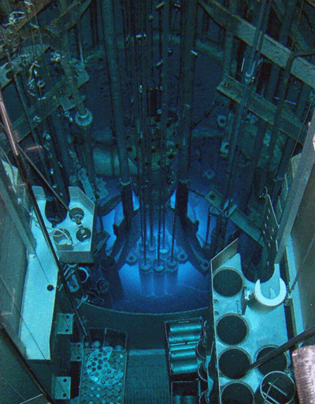
“I also carefully analyzed the high-purity vials (blanks) that I use in the NAA experiments and as expected there is a minute presence of the elements of interest in these vials. Keep in mind insofar as trace elements are concerned there is "everything in everything" if one has a technique sensitive enough to make the measurement. I have now made these sensitive measurements and have "blank-corrected" the results…”

The difference between 23.6 and 19.9 ppm cadmium in Sample A was 3.7 ppm and was due to the test vial being very slightly cadmium-positive but very much higher in mass than the hair. Dr. Morris clarified that the vial did not contain 3.7 ppm cadmium, but that a tiny fraction of one ppm multiplied by thousands of times in mass resulted in the difference.
Dr. Morris also described the container in which he received the four GBC samples from the University of Wisconsin. They were in a small pillbox with cardboard sides (D) and a translucent plastic bottom and top (A). He tested the pillbox and found “no evidence of significant contamination…” No one could claim that samples A had been tainted with cadmium by the container in which it had been stored by Daivi Shakti dasi for many years. The plastic pillbox also conformed to the descriptions of Daivi Shakti dasi’s hair container.

The Srila Prabhupada hair samples that the GBC planned to test for arsenic were abandoned in the obscure location of Wisconsin, and we were able to recover them, test them properly, and discover that the primary poison was CADMIUM. How remarkable that we were able to finish the GBC hair tests for them and that this would provide proof positive that Srila Prabhupada had actually been poisoned primarily with cadmium ! Anyone who doubted these results could do further hair tests and see for themselves…

