POSTING FROM TRUTH COMMITTEE RE: SRILA PRABHUPADA’S POISONING
(June 3, 2017) We are seeing some conversations and opinions online from those totally uninformed of the actual evidence that conclusively proves that Srila Prabhupada was poisoned with lethal amounts of cadmium from (at a minimum) February to November 1977. Highly accurate NAA tests on three of Srila Prabhupada’s hair samples that were provided by the GBC’s agents were found in 2002-2005 to have sky-high, unprecedented levels of cadmium, a deadly heavy metal that is virtually undetectable unless specifically tested for. Recent Facebook discussions were dominated by those who offered emotional and pseudo-logical dissertations on their faulty opinions and analyses of the evidence that they had forgotten to study or never seen. Several Facebook group administrators shut down all discussions on the subject, deleted posts, and shut out those who had sent in facts and figures to be considered. Admittedly, the subject is difficult to cope with and reactions will be strong. Many devotees have cognitive dissonance on this issue and cannot focus enough to actually look at the evidence which includes the recently disclosed cadmium hair tests.
Some say that Srila Prabhupada mentioned poison in reference to mustard seeds, or bad medicine, or years of toxic build-up in the body, but not about actual malicious poisoning. One who reads the Nov. 9-10, 1977 conversations will see otherwise, that Srila Prabhupada and all his caretakers WERE speaking about homicidal poisoning with rakshasas, murder, poisoned food, lawyers, poisoning cases, and even asking about who poisoned Srila Prabhupada.
Some also say that cadmium is everywhere, so what? Srila Prabhupada’s cadmium could have come from rice, Ayurvedic medicines, or anywhere. But they do not seem to understand that cadmium is found at different concentrations, at various levels from harmless to lethal. That is the key thing- how much cadmium? For example, yes, dust is everywhere, but in rare situations the dust can be lethal, as it was on Montserrat, a Caribbean island which experienced a sudden violent volcanic explosion in 1995 that caused the main town of Plymouth to be buried under several feet of dust and ash.
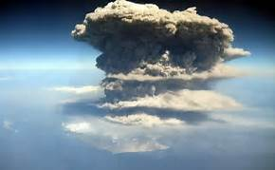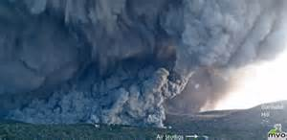
Similarly, an average normal person will have 0.065 ppm cadmium in their hair. Srila Prabhupada had about 250 times more than that, or an average of 15.75 ppm cadmium. This is a volcanic amount. Below we have one of our many expert opinions on the meaning of these levels. Please encourage everyone who will speak about the subject to be at least properly informed first.

(From Chapter 32, Book One: The Poisoning of Srila Prabhupada’s Body):
FIRST EXPERT OPINION: DR. PAGE HUDSON
FORENSIC PATHOLOGIST, NORTH CAROLINA

Immediately I thought of the former North Carolina Chief Medical Examiner, Dr. Page Hudson, Jr., M.D. A forensic pathologist, he taught at Eastern University of North Carolina and had already reviewed my first book, Someone Has Poisoned Me. He had specialized in studying and solving a series of heavy metal poison murders in North Carolina during the 1980’s and 1990’s. His work had been detailed in several popular books about these arsenic poisonings.
I prepared a brief summary of Srila Prabupada’s 1977 illness and symptoms and, including the test results on samples A and D, sent a letter to Dr. Hudson, asking for his insights and comments on Srila Prabhupada’s medical history and the cadmium toxicity. His reply:
“I suggest Medical Toxicology: Diagnosis and Treatment of Human Poisoning, by MJ Ellerhorn and DG Barceloux, 1988. It also has additional references. […] but they are remarkably few who possess expertise with this material.”
He then made some observations based on his professional and medical experience:
“One ppm is considered a rather hefty load of cadmium. About 20 ppm is distinctly abnormal. Wasting, kidney disease, and the spillage of sugar are certainly consistent with cadmium toxicity, but unfortunately are common with many other conditions and diseases… It appears to me that if the cadmium concentration is correct, the exposures to the material must have been small and over a period of months. To administer intentionally this poison in this fashion would call for amazing subtlety and patience.”
“I reasoned in a vague sort of way that a person reaching the high concentration the subject did would more likely have received multiple doses or had chronic exposure to reach the hair level he did – without having some clinically acute, dramatic episode marking the exposure. Perhaps Dr. Morris might find very irregular peaks in the cadmium concentrations if there were a serial analysis of the hair, measuring from the root.
But the cadmium may have done irrecoverable damage months before death and all subsequent hair growth may have been drawing from the body pool of cadmium – without new exposures.”
COMMENTS: Serial analysis of Srila Prabhupada’s hair would be difficult because his hair was cut every month, being less than 1 cm in length, insufficient for this type of testing, as was done with Napoleon’s case study with hair that was several inches long. Interesting points made by Dr. Hudson:
He surmised a case of multiple doses and chronic exposure, and an administering of cadmium with “amazing subtlety and patience.”
Cadmium poisoning results in symptoms very similar to many other conditions and diseases.
That 20 ppm is distinctly abnormal; even 1 ppm is a rather hefty load.
Dr. Page Hudson’s accomplishments and credentials are included in Appendix 7.
Below we can see how much cadmium Srila Prabhupada had in his hair and body; it was something like the Montserrat volcanic explosion or a huge elephant in a tiny closet!

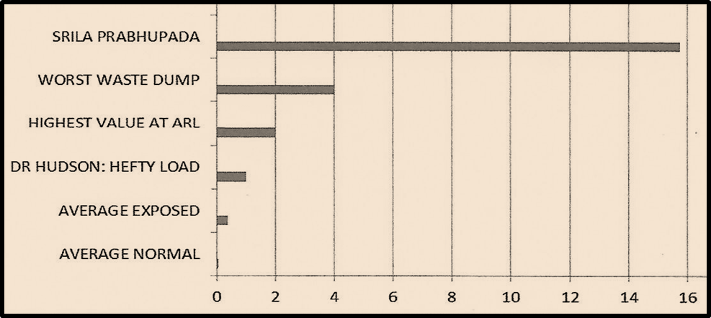
CADMIUM LEVELS: Comparison chart with amounts of Cadmium in ppm, from 0 to 16 ppm

- SRILA PRABHUPADA: Average of 15.75 ppm, about 250 X normal
- Worst waste dump in the USA: 4 ppm, 60 X normal
- Highest Value at ARL (commercial hair testing outfit): 2 ppm, 30 X normal
- Dr. Hudson, expert toxicologist, says this is a “hefty load”: 1 ppm, 15 X normal
- Average Exposed Industrial Worker: Average of 0.387 ppm, 6 X normal
- Average Normal Unexposed Person: Average of 0.065 ppm.

If anyone has any questions about this or any other evidence, please write to Nityananda das at: srigovinda@gmail.com The poisoning report will be out in June 2017 as a free downloadable E-book, titled Kill Guru, Become Guru: Book One: The Poisoning of Srila Prabhupada’s Body, 800 pages, 100 chapters. Also please see the YouTube video on how the forensic scientific breakthrough by the private investigation into Srila Prabhupada’s disappeance came about (6255 views in 30 days!)
https://www.youtube.com/watch?v=PIBqNBMbPvY

