What's Below the Earth?
BY: MAYESVARA DASA
Oct 25, 2017 — IRELAND (SUN) — Part One: The Subterranean Worlds
In previous papers we presented the Srimad Bhagavatam's description of the Earth (Bhu-mandala) as a four billion-mile circular disc. An introductory paper can be found here. We discussed the radical implications of this concept for the Hare Krishna movement, and particularly for the presentation of the Earth within the up-coming Temple of Vedic Planetarium, here.
The previous series of papers mostly dealt with the description of features on the surface of the great Earth circle such as the seven islands and oceans (sapta-dvipa) that cover hundreds of millions of miles along its vast plane. In the following series of papers we will add further details to this argument by looking at the descriptions of places below the surface of the Earth that are hundreds of thousands of miles deep—yes, that's hundreds of thousands of miles deep, not hundreds of thousands of feet.
These descriptions inform us once again that the massive Earth circle described in Srimad Bhagavatam is not a so-called globe in space; and thus why it should not be presented as such in the Mayapur Temple of Vedic Planetarium. We have discussed the issue of the Earth's depiction in the TOVP here.
Sukadeva Goswami describes four main categories that are below the Earth:
(1) The subterranean heavens (Bila-svarga)
(2) The root of Mount Meru
(3) The hells
(4) Ananta Sesha who is upon the Garbodaka Ocean and holding the great Earth circle on his hoods.
In this first part of four papers we will begin by looking at the subterranean worlds. Since our focus here is more concerned with the location and measurements of these places below the Earth, we will not be focusing on the otherwise fascinating description of the nature of the people and the environment within the seven subterranean heavens.

What Are Planets?
Srila Prabhupada spoke of the Earth's subterranean worlds as 'the seven lower planetary systems'
"...below the earth by 70,000 yojanas are the seven lower planetary systems called Atala, Vitala, Sutala, Talatala, Mahatala, Rasatala and Patala." (SB 5.23.9)
Again:
"The fourteen worlds are enumerated in Srimad Bhagavatam, Second Canto, Fifth Chapter. The upper planetary systems are (1) Bhu, (2) Bhuvar, (3) Svar, (4) Mahar, (5) Janas, (6) Tapas and (7) Satya. The seven lower planetary systems are (1) Tala, (2) Atala, (3) Vitala, (4) Nitala, (5) Talatala, (6) Mahatala and (7) Sutala." (Cc Ädi, 5.98)
This idea of 'seven lower planetary systems' may create the impression in a person's mind of seven layers of many globe-like planets orbiting in space somewhere below the assumed Earth globe. The term 'planetary systems' was Srila Prabhupada's choice of words, and it is a term that he used consistently, but our modern conception of what might constitute 'planetary systems' is wholly different from what is being described by Sukadeva Goswami as seven huge realms within the one vast Earth circle. From the very beginning of Srimad Bhagavatam, Srila Prabhupada was translating verses relating to the Bhu-mandala without even have a map or image of Bhu-mandala to help him conceptualize where each place is situated, and how each place is related to the other. The Fifth Canto especially presents a detailed description of the universal form that is very difficult to follow without a map, or depiction, or explanation of any kind. The commentaries by the acharyas are also full of seemingly endless measurements and calculations. By his own admission Srila Prabhupada said "I do not actually accommodate all this knowledge," and as ever, Srila Prabhupada gave the credit for the accomplishment of the translation of this difficult section to Krishna:
Prabhupada: And it was not possible for me to digest. (laughs) Somebody else helped me to... I am a layman. I do not know.
Tamala Krishna: How did you write it?
Prabhupada: That somebody, Krishna, helped me. That He manufactured...When I was writing, I was praying Krishna that "I do not actually accommodate all this knowledge. Please help me." Yes. That's all right.
(Room Conversation, June 18, 1977, Vrindavana)
When Srila Prabhupada said, "I do not actually accommodate all this knowledge," we should not think it was because Srila Prabhupada couldn't accommodate the knowledge of the Fifth Canto cosmology; rather, it was because (probably for want of time in trying to complete his Srimad Bhagavatam translation, and considering all the details involved in Vedic cosmology), he tactfully delegated the study of 'all this knowledge' to some of his disciples:
"Now our Ph.D.'s must collaborate and study the Fifth Canto to make a model for building the Vedic Planetarium... So now all you Ph.D.'s must carefully study the details of the Fifth Canto and make a working model of the universe. If we can explain the passing seasons, eclipses, phases of the moon, passing of day and night, etc., then it will be very powerful propaganda." (Letter from Srila Prabhupada to Svarupa Damodara dasa, April 27, 1976)
Prabhupada: Now you all together make this Vedic planetarium very nice, so that people will come and see. From the description of the Srimad Bhagavatam, you prepare this Vedic planetarium. (Room Conversation, June 15, 1976 Detroit)
"Regarding the scientists, we have entrusted our own three scientists namely Svarupa Damodara, Sadaputa, and Madhva and we leave the matter to them, we do not say anything ourselves, but are leaving it to them." (Dr. W.H. Wolf-Rottkay, 14 October, 1976)
We have discussed the issue in section 1.2 of this paper.
Without a map, or image, or explanation, the description of the virat-rupa (universal form) is very difficult to visualize. Srila Prabhupada invariably used the word 'planet' to cover the multitude of places mentioned by Sukadeva Goswami. However, one should be aware that many of the places that Srila Prabhupada refers to as 'planets,' are actually references to places upon the Bhu-mandala's vast landscape, or within the depths of the Bhu-mandala itself (the subterranean realms). They are not 'other planets' as we conceive them, but part of the Earth itself. As we shall see presently, the conception of seven layers of globe-like planets floating below the Earth is definitely not what is being described by Sukadeva Goswami. First, let us take a quick look at what is meant by the word 'planet.'
The Sanskrit word for planet is graha which means 'to seize,' 'to grab,' 'to hold.' The planets in Vedic cosmology are also known as grahas conveying a sense that the celestial bodies 'seize' or 'grab' or 'influence,' or 'lay hold of,' the destinies of men by awarding their karma in various ways. The grahas form the part of the universal body of Krishna that specifically award karma to the living entities:
"The unborn Lord has many incarnations. He has incarnated, as the nine (nava) grahasto bestow on the living beings the results due to their karmas . He isJanardana. He assumed the auspicious form of grahas to destroy the demons and sustain the divine beings." (Brhat Parasara hora-shastra 2.3-4)
The nine planets ( grahas ) are named as the Sun, Moon, Mars, Mercury, Jupiter, Venus, Saturn, Rahu, and Ketu. Graha is another name for the numeral nine. The Earth is not counted as one of the nine grahas , but is situated in it's own unique and separate category; indeed, most of Sukadeva Goswami's description of the universe focuses on the Earth because the Earth is actually the biggest feature in the universe with a diameter of 4 billion miles. The grahas move in the sky, unlike the massive fixed Earth below. Another Sanskrit name for the Earth is acala (not moving). The great Earth circle is held in it's immovable place by Ananta-sesha. The Lord's pastime of holding the Earth will form the subject of a later paper.
It's very interesting also that the Earth was not named as one of the planets by either the Greeks or Romans. Certainly both civilizations regarded the Earth (Gaia/Terra) as a Goddess, like the Moon planet (Selena/Luna) and Venus (Aphrodite); but they did not count the Earth as a planet like the others. The English word 'planet' derives from the Greek planan which means to wander. The idea is that the planets move or wander among the other stars that are fixed in constellations. In both ancient Western and Vedic astronomy, the planets were orbiting above a fixed flat-Earth. The Earth is the 'ground' or 'setting.'
This conception of the Earth as the fixed center of the universe was prominent in the West until the time of Copernicus (1473-1543). Thereafter, the Earth itself became to be regarded as a globe-like planet orbiting in space around the sun. This idea of the Earth moving around the sun has been refuted on many grounds and by many practical experiments, but like Darwin's theory which can also be refuted in many ways, the heliocentric model was just the idea that one the day. The Srimad Bhagavatam presents a completely different idea of the Earth and the planets that is a radical challenge to our contemporary world-view and sense of reality.
In chapters 16-20 of the Fifth Canto, the Earth with its prominent features is described as a 4 billion-mile disc that crosses the center of the universe and divides the universe into upper and lower divisions. In Sukadeva Goswami's description of the universe, the grahas (planets) and stars are above, not below the surface of the Earth. There is no description of grahas or stars floating in space below the Earth. Due to the massive 4 billion-mile diameter span of the Earth circle, the sunlight and light from other luminaries is blocked from the lower half of the universe which is otherwise filled with the water from the Garbodhaka Ocean. The Garbhodaka Ocean is 2 billion miles deep. On the surface of the Garbhodaka Ocean is Ananta-sesha who is holding the entire Earth circle (Bhu-gola or Bhu-mandala) on His hoods. Ananta-sesha is situated 240,000 miles below the bottom of the Earth. Thus the distance between the Garbhodaka Ocean and the bottom of the Earth is a mere 240,000 miles.
"Sri Sukadeva Gosvami said to Maharaja Pariksit: My dear King, approximately 240,000 miles beneath the planet Patala lives another incarnation of the Supreme Personality of Godhead. He is the expansion of Lord Visnu known as Lord Ananta or Lord Sankarshana." (SB 5.25.1)
This small distance of 240,000 between the surface of the Garbhodaka Ocean and the bottom of the Earth circle is certainly not a realm of endless dark space that we are led to believe from the images of an Earth globe with stars and planets seemingly stretching out to infinity. It is certainly not large enough to accommodate the idea of seven vast layers of innumerable planets orbiting somewhere below the Earth. As we shall hear presently, the seven subterranean worlds are, in fact, within the depths of the great Earth circle itself; they are not separate planets floating in space. The description of the location of the hells is vague, but we shall make an argument in a later paper that they are also within the depths of the Earth, and are situated just below Patala (the lowest subterranean realm). We stand to be corrected on the location of the hells, but, if the hells are also included to be within the depths of the Earth, then between the Garbhodaka Ocean and the bottom of the Earth there is only Ananta-sesha, who holds the great Earth circle on His head. In other words, there are no other stars or planets surrounding or below the Earth as depicted in the popular images of the Earth globe in space. This idea can be better understood by considering the division of the universe according to the three modes of nature (gunas ).

The Earth (Bhu-mandala) Crosses the Center of the Universe and Divides the Universe According to the Modes of Nature
The conception of the Earth (Bhu-mandala) as a great circular plane crossing the center of the universe may create some disconcertment or confusion in the readers mind as we are all used to seeing images of the so-called Earth globe floating in space with countless other stars and planets seemingly surrounding the Earth in all directions.

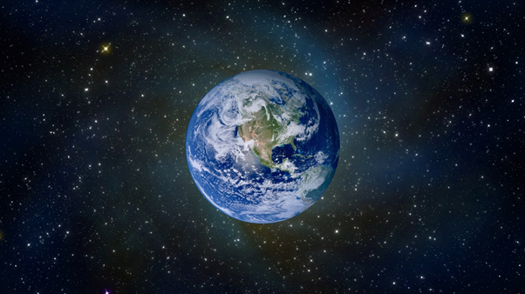

Examine closely! The above image of the so-called Earth globe has been created with computer animation; it is not a real image of the Earth taken from a so-called satellite in outer space—nor will you find such an authentic photo. When we see an image like this, we are naturally led to believe that the Earth is a globe in space and that there are millions of other planets below as well as above the so-called Earth planet. This is not the case—at least according to Srimad Bhagavatam.

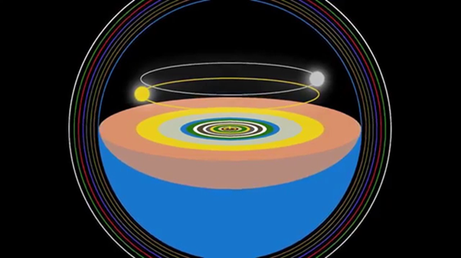

The above image is not to scale and omits many features. The idea here is just to show how the huge Bhu-mandala crosses the center of the universe, and divides it into upper and lower sections. The continents of our Earth are just a tiny part of this great landscape, indeed our own land and oceans are surrounded by other lands and oceans that continue for hundreds and millions of miles. The huge width of the Bhu-mandala blocks the light from the sun and moon from entering the lower part of the universe which is filled mostly with the Garbhodaka Ocean that has a depth of 2 billion miles. The Bhu-mandala is resting on Ananta-sesha and is about 240,000 miles above the Garbhodaka Ocean. Above the Earth's surface is the upper part of the universe which is a further 2 billion miles, making the universe 4 billion miles from top to bottom. The upper, middle, and lower parts of the universe are divided according to the three modes of material nature (gunas).
Above the great Earth circle are the stars and planets for those in the mode of goodness. Upon the great Earth circle of 4 billion-mile diameter are the seven islands (sapta-dvipa) for those in the mixed modes of nature. Within or below the surface of the Earth circle are the subterranean worlds for those in the modes of ignorance. Below that again are the hells. The division of the universe according to the three modes of nature is explained by Sukadeva Goswami to King Pariksit:
"King Pariksit inquired from Sukadeva Gosvami: My dear sir, why are the living entities put into different material situations? Kindly explain this to me." (SB 5.26.1)
"The great sage Sukadeva Gosvami said: My dear King, in this material world there are three kinds of activities—those in the mode of goodness, the mode of passion and the mode of ignorance. Because all people are influenced by the three modes of material nature, the results of their activities are also divided into three. One who acts in the mode of goodness is religious and happy, one who acts in passion achieves mixed misery and happiness, and one who acts under the influence of ignorance is always unhappy and lives like an animal. Because of the varying degrees to which the living entities are influenced by the different modes of nature, their destinations are also of different varieties." (SB 5.26.2)
"Just as by executing various pious activities one achieves different positions in heavenly life, by acting impiously one achieves different positions in hellish life. Those who are activated by the material mode of ignorance engage in impious activities, and according to the extent of their ignorance, they are placed in different grades of hellish life." (SB 5.26.3)
Krishna summarizes this in the Bhagavad-gita as follows:
"Those situated in the mode of goodness gradually go upward to the higher planets; those in the mode of passion live on the earthly planets; and those in the abominable mode of ignorance go down to the hellish worlds." (SB 14.18)
Again, in Srimad Bhagavatam Lord Krishna summaries this description in his instructions to Uddhava:
"Lord Brahma, the soul of the universe, being endowed with the mode of passion, performed great austerities by My mercy and thus created the three planetary divisions, called Bhur, Bhuvar and Svar, along with their presiding deities.
Heaven was established as the residence of the demigods, Bhuvarloka as that of the ghostly spirits, and the earth system as the place of human beings and other mortal creatures. Those mystics who strive for liberation are promoted beyond these three divisions.
Lord Brahma created the region below the earth for the demons and the Naga snakes. In this way the destinations of the three worlds were arranged as the corresponding reactions for different kinds of work performed within the three modes of nature." (SB 11.24.11-13)

Going Underground
Here Krishna says: adho 'suranam naganam bhumer: 'the region below the Earth is the abode of Nagas and asuras.' So what is to understood by the word adhah 'below'? Does it mean below the surface of the Earth like going into an underground station, or does it mean below the entire Earth itself?
Sukadeva Goswami says:
"My dear King, beneath this earth are seven other planets, known as Atala, Vitala, Sutala, Talatala, Mahatala, Rasatala and Patala. I have already explained the situation of the planetary systems of earth. The width and length of the seven lower planetary systems are calculated to be exactly the same as those of earth." (SB 5.24.7)
The Sanskrit text says:
avaner apy adhastat sapta bhu-vivara
We can understand here from the Sanskrit text that the subterranean realms are not separate planets but are part of the Earth itself (bhu-vivarah). Bhu, of course, means the Earth and vivara means a hole, an opening, a hollow, a chasm, a cave, etc. The idea of vivara meaning a hole can also be sensed from Prabhupada's translation of karna-vivaraih as 'through the holes (vivaraih) of the ears (karna)' (SB 3.9.5). It can also be applied to other apertures of the body. Vivara is another name for vagina. In its sense as an opening in the Earth, Prabhupada translates vivara as 'within the earth' regarding the well-known story of Sitadevi's entrance into the Earth:
"Being forsaken by her husband, Sitadevi entrusted her two sons to the care of Valmiki Muni. Then, meditating upon the lotus feet of Lord Ramacandra, she entered into the earth." (SB 9.11.15)
vivaram—within the earth; pravivesa—she entered
There is no indication that the word vivara relates to a planet in our contemporary sense of the word. The words bhu-vivara most definitely indicates an opening of some kind within or under the Earth itself. Thus, in describing the subterranean realms, when Srila Prabhupada translates the words vivara-ishvara as 'the leaders of the planets' (SB 5.24.9), we should understand that vivara is a reference to the subterranean realms wherein there are different ishvaras (leaders). The acharyas translate bhu-vivara as 'holes in the Earth' (see commentaries below). Srila Prabhupada actually translates the same word vivarah as 'holes' in a different verse describing the pastime of Vamanadeva's expansion throughout the universe:
"The unlimited Supreme Personality of Godhead, who had assumed the form of Vamana, then began increasing in size, acting in terms of the material energy, until everything in the universe was within His body, including the earth, the planetary systems, the sky, the directions, the various holes [vivarah] in the universe, the seas, the oceans, the birds, beasts, human beings, the demigods and the great saintly persons." (SB 8.20.21)
Here Srila Prabhupada translates the word vivarah as 'different holes of the universe.' This is not referring to some speculative idea like black holes, but to any kind of cave or hole that can be found throughout the varied landscapes of the universe; specifically to the subterranean realms of Bhu-mandala as they were described by Sukadeva Goswami to Maharaja Pariksit in his description of the universal form: adhastat sapta bhu-vivara (seven holes/caverns/realms within the Earth).
The word vivaran is used again in relation to Durvasa Muni when he was fleeing from the Sudarshana chakra:
"Just to protect himself, Durvasa Muni fled everywhere, in all directions—in the sky, on the surface of the earth, in caves (vivaran—within the holes), in the ocean, on different planets of the rulers of the three worlds, and even on the heavenly planets—but wherever he went he immediately saw following him the unbearable fire of the Sudarshana chakra." (SB 9.4.51)
Srila Prabhupada translates the Sanskrit synonyms to this verse as: ksmam—on the surface of the earth; vivaran—within the holes. The only holes described by Sukadeva Goswami are the amazing subterranean worlds below the surface of the Earth adhastat sapta bhu-vivara (SB 5.24.7). Although Srila Prabhupada has translated the words sapta bhu-vivara as 'seven other planets' below the Earth, they are literally described by Sukadeva Goswami as seven realms within or below the surface of the Earth. Thus 'holes in the Earth' is the most consistent translation of bhu-vivara, and is in line with Srila Prabhupada's other translations wherein the word vivara is translated as 'holes' not planets. This is also clearly the understanding presented by the acaryas. The word 'planet' was simply Srila Prabhupada's default word for describing anywhere outside our known Earth area. The true nature of the Bhu-mandala and our own place upon it hadn't been deciphered at this point. I'm not suggesting by any means that we should change the translation; I'm just recommending that we should try and understand from the description what is meant by adhastat sapta bhu-vivara.
In the above statement, adhastat sapta bhu-vivara (SB 5.24.7), the word adhastat('beneath'), tells us again that these seven (sapta) holes (vivarah) are beneath or below the surface of the Earth (bhu), not that there are seven layers of globe-like planets orbiting below a so-called Earth globe. Of course, the word adhastat can also mean 'below' in the sense that the planet Rahu is beneath the sun planet by 80,000 miles as in the statement: adhastät savitur yojanäyute svarbhänur (SB 5.24.1). However, the idea that adhastat means below or within the depths of the Earth itself is confirmed by a further statement from Sukadeva Goswami:
etesu hi bila-svargesu "In these subterranean heavens." (SB 5.24.7)
The Sanskrit word bila means a hole, cavity, hollow, opening, pit, etc. A bilayana, for example is an underground cave. It is another word used by Sukadeva Goswamito describe the first of these seven inhabited places underground or underneath the Earth:
"Bilayanam pravistam purusham" (SB 5.24.16)
"Bilayana means the abode in the form of holes" (Commentary by Srila Sridhara Swami)
"Now the holes are described individually, starting with Atala" (Commentary by Sri Bhagavatprasadacarya )
"Bilayana = the place of the hole" (Commentary by Yadavarya to SB 5.24.18)
(The above translations are from Danavir Goswami's edition to the Commentaries on 5th Canto Bhagavatam Cosmolgy by Vaisnava Acaryas.)
The word bila has correlative words and names connected to digging or burrowing. A mouse, for example, is called bilakarin because it lives in a hole. A snake or any animal that lives in an underground hole may be called bilavasin or bilamgama indicating it's habitat below the Earth. This is fitting because the great epics like Mahabharata depict the Nagas as mysterious beings with qualities that are both serpentine-like and human-like.

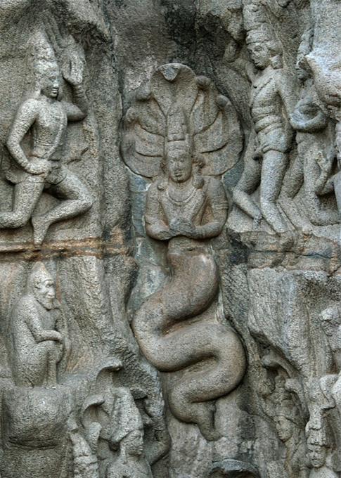

As in all walks of life, one can imagine that the nagas consist of both good and bad characters.



Images both ancient and modern depict the nagas as half-human half serpentine. Is this visualization something that emerges from the collective sub-conscious mind? Narada Muni says:
"Sometimes in a dream we see something never experienced or heard of in this life, but all these incidents have been experienced at different times, in different places and in different conditions." (SB 4.29.67)
"Therefore, my dear King, the living entity, who has a subtle mental covering, develops all kinds of thoughts and images because of his previous body. Take this from me as certain. There is no possibility of concocting anything mentally without having perceived it in the previous body." (4.29.65)
One may not take the idea of a serpentine/reptilian race living below the Earth as a serious proposition, but that is the statement of Srimad Bhagavatam, and one would be wise to take it seriously. The point of this information is to inform us of the different types of bodies and situations that the soul can enter according to one's association with the three modes of material nature. One who takes Krishna, seriously must take Srimad Bhagavatam seriously.
The bila-svargeshu are thus described as vast holes/caverns below (bila) the Earth' surface, not globe-like planets below the so-called Earth planet itself. This is quite clear. The bila-svargeshu, however, are not just any old holes; they are actually vast heavenly realms of inconceivable opulence. The word svarga means heavenly.
"Within the material universe there are three categories of heaven: divya-svarga, bhauma-svarga and bila-svarga." (purport SB 5.17.11)
The divya-svarga are in the upper realms of the universe, the bhauma-svarga are on the Earth circle and comprise eight of the nine varshas of Jambudvipa. Bharata-varsha is the ninth varsha or region of Jambudvipa (the central island of the great Earth circle) but is not regarded as a heavenly region. [Bharata-varsha has a different function. In Bharata-varsha the living entities create the karma that causes their future birth in either higher, middle, or lower regions of the universe. Bharata-varsha is also the area in the universe where the living entities can most easily achieve liberation from the cycle of birth and death. It is also most conducive for awakening love of Godhead]. Below the great Earth's surface is another category of heaven called bila-svarga where the asuras (demons) and Nagas (serpentine beings) enjoy great delight. The subterranean heavens are thus distinct from the hells that are usually associated with such entities:
"In these seven planetary systems, which are also known as the subterranean heavens [bila-svarga], there are very beautiful houses, gardens and places of sense enjoyment, which are even more opulent than those in the higher planets because the demons have a very high standard of sensual pleasure, wealth and influence. Most of the residents of these planets, who are known as Daityas, Danavas and Nagas, live as householders. Their wives, children, friends, and society are all fully engaged in illusory, material happiness. The sense enjoyment of the demigods is sometimes disturbed, but the residents of these planets enjoy life without disturbances. Thus they are understood to be very attached to illusory happiness." (SB 5.24.8)
Again, one should not take the wrong conception from Srila Prabhupada's English rendition of the Sanskrit words bila-svarga as 'seven planetary systems.' Our modern conception of what might constitute 'planetary systems' is wholly different from what is being described here by Sukadeva Goswami as seven huge realms within the one vast Earth circle. Srila Prabhupada actually qualifies the translation: "In these seven planetary systems, which are also known as the subterranean heavens [bila-svarga]." This is factually what is being described since bila-svarga literally means subterranean/underground (bila) heavens (svarga). The etymological dictionary explains the origin of the word 'subterranean' as follows: Subterranean (adj.) c. 1600, from Latin subterraneus "underground," from sub "under, beneath" + terra "earth, the ground"
The acaryas in their commentaries (see below) include the seven subterranean heavens as part of (within) the Bhu-mandala itself. The acaryas refer by to them as 'holes' within the Earth rather than seven layers of planetary systems orbiting below the so-called Earth planet.
So what are the subterranean realms? The best way to think of these is to think of going down into a subway or an underground base, except that the Earth is much, much deeper than what we've been told. What Srila Prabhupada called 'seven lower planetary systems' are actually seven underground realms below one's own feet. The Earth below our feet, however, is not a globe with a few thousand mile diameter. The great Earth circle has a diameter of four billion miles, and a depth of hundreds of thousands of miles:
"Parashara: The extent of the surface of the Earth has been thus described to you, Maitreya. Its depth below the surface is said to be seventy thousand yojanas (560,000 miles); each of the seven regions of Patala extending downwards ten thousand yojanas (80,000 miles)." (Vishnu Purana Book 2, chapter 5)
These figures are confirmed in Srimad Bhagavatam (see below). The subterranean realms are thus vast underground worlds where the nagas and asuras live. The Nagas and asuras enjoyan extraordinary underground civilization; much more beautiful than is depicted in the image below, although the idea of an underground world is conveyed:

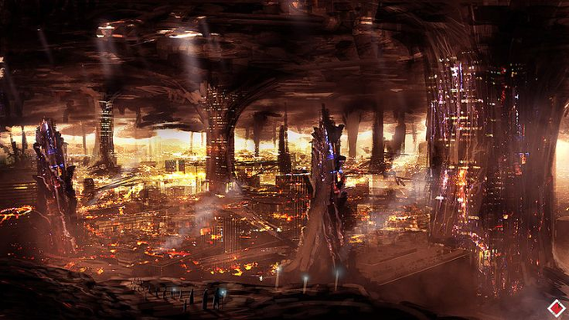

Regarding the size of the subterranean realms there appears to be mistake in the translation to SB 5.24.7. We shall repeat the translation again:
"My dear King, beneath this earth are seven other planets, known as Atala, Vitala, Sutala, Talatala, Mahatala, Rasatala and Patala. I have already explained the situation of the planetary systems of earth. The width and length of the seven lower planetary systems are calculated to be exactly the same as those of earth." (SB 5.24.7)
Here it says that 'the width and length of the seven lower planetary systems are calculated to be exactly the same as those of earth.' However, the measurement provided by Sukadeva Goswämé for each subterranean realm is yojana-ayuta which means 10,000 yojanas or 80,000 miles. This measurement, of course, is not the size of the Earth mentioned by Sukadeva Goswami (bhumeh—of the planet earth) which is otherwise described as 4 billion miles.
Regarding translations to the Fifth Canto in general, I'm not sure if Srila Prabhupada himself was doing all the translations, or if some of his disciples were engaged to help. In any case, the following conversation indicates Prabhupada's displeasure at the editors. In the conversation Prabhupada gives a blasting to those making unauthorized editorial changes to his books, and the following section may be relevant here:
Prabhupada: It is very risky to give to them for editorial direction. Little learning is dangerous. However proper Sanskrit scholar, little learning, dangerous. Immediately they become very big scholars, high salaried, and write all nonsense. Who they are? (pause) Then?
Tamala Krishna: "O sages, I have been..."
Prabhupada: No, they cannot be reliable. They can do more harm. Just see here the fun(?).
Tamala Krishna: Yeah. We're finding out in the Fifth Canto that there're words that are so off, the meaning is completely changed, completely changed. I mean, in the three chapters that we read, Bhakti-prema Maharaja made at least half a dozen corrections of serious corrections. They had changed the meaning.
Svarupa Damodara: Some of the mistakes in the numbers, the figures.
Tamala Krishna: Oh, yeah, they're all...
Prabhupada: So how they can be reliable…
Tamala Krishna: There was one verse in the Fifth Canto. From the way that they translated it, there was no way that anyone could possibly have understood what the verse meant. I mean, it was made unintelligible by the translation. So we were reading. Finally Bhakti-prema says, "Wait a minute. This translation is wrong. They have edited an extra statement here that is not there, and it makes it completely not understandable." Then suddenly, when he corrected the Sanskrit, it was easy to understand. It was very clear.
(Conversation: "Rascal Editors" - June 22, 1977, Vrindavana)
There also seems to be a mistake in Danavir Goswami's translation to the Commentaries on 5th Canto Bhagavatam Cosmolgy by Vaisnava Acaryas. The subterranean lokas are described as 10,000 yojanas each (80,000 miles) but the translation reads that they are 800,000 miles. This measurement needs to be confirmed or corrected by the editors. For the present, we will take as normal that a yojana is 8 miles making 10,000 yojanas equal to 80,000 miles, not 800,000 as has been translated. The words ayuta-yojana are consistently translated throughout Srimad Bhagavatam as 10,000 yojanas (80,000 miles) and this figure is confirmed in the Sanskrit dictionary. Sridhara Swami says the realms are all of equal width and height:
"Each one is 10,000 yojanas (80,000 miles high and wide. That is the expanse of the nether-worlds." (Commentary to SB 5.24.7)
Virarghava Acarya says:
"The Earth (entire Bhu-mandala) has been described above very elaborately. Now the author proceeds to explain the status of the lokas below the Earth. Below the earth are seven holes. Each of the lokas is 10,000 yojanas (80,000) miles high and equally broad and are placed one below the other." (Commentary by Viraraghava to SB 5.24.7)
Again:
"Adhastat = lower and lower. Atala and others are holes only and are 10,000 yojanas [80,000 miles] high and wide, placed one below the other." (Commentary by Vishvanatha Cakravarti Thakura to SB 5.24.7)
"Adhastat means in the lower and lower regions. Atala etc., are holes only. 10,000 yojanas [80,000] below the Earth is Atala, 10,000 yojanas [80,000 miles below Atala is Vitala and so on. Each of them is 10,000 yojanas [80,000 miles] high and wide"(Commentary by Vaàsidhara to SB 5.24.7)
These holes in the Earth go down for seven levels (one below the other). Each level is a vast size of ten thousand yojanas yojana-ayuta-antarena (eighty thousand miles). Altogether the seven realms go down into the Earth for 560,000 miles. Although massive in size, the subterranean realms are surprising small in comparison to the overall scale of Bhu-mandala. And, although these seven realms are small by comparison to the overall size of the Bhu-mandala, we should yet consider that they are each 80,000 miles in length, width, and breadth, and thus give us yet another example of the absolutely enormous massive size of the Earth itself.Once again, when Sukadeva Goswamé talks about adhastat sapta bhu-vivara, the Earth (bhu) that he is talking about is obviously not a small globe in space. Just one of these realms (vivara) that are below (adhastat) the surface of the Earth (bhu) is 80,000 miles in length and breadth (ayuta-yojana). 80,000 miles is 10 times the diameter of the so-called globe. Again, let us apply some logical deduction to the question—this description of realms within the bhu-gola is not a description of a so-called Earth Globe with a diameter of 8,000 miles. It is one's prerogative not to believe a word of what is being spoken, but now that it has been pointed out, one should at least be honest enough to accept what the speaker of Srimad Bhagavatam is describing about the Earth itself.
The details of this argument were never brought to Srila Prabhupada for his consideration. If the Earth described by Sukadeva Goswami has a depth of hundreds of thousands of miles, then on the basis of Srimad Bhagavatam we can question the presentation of the Earth as a small globe-shaped planet. My own research has revealed that the only images of the Earth are those created by artists, by computer animation, or by NASA's special effects department with a bunch of actors posing as astronauts in space. Anytime these so-called astronauts appear on the media, it is only to present some clown-like trick (created at a special effects studio) to distract the child-like viewer from asking any serious question about the authenticity of such so-called space travel:

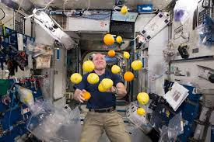

It's not such a difficult thing for special effects experts to make it look like an astronaut or a spaceship is floating in space above a so-called globe—movie-makers do it all the time! In fact the movie-makers do it better than NASA who are constantly being caught faking so-called flights in space. A little research reveals the whole as nothing but a hoax.

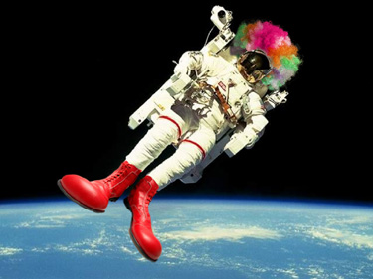

The images of the so-called round Earth are simply taken from high altitude planes which photograph or film the Earth's flat plane below; the curved effect is created either by the type of lens used, or added later using computer effects. We will write a paper later showing how these photos and videos of the Earth globe are created, although no such Earth globe actually exists. At the very least, Sukadeva Goswami's description of the Earth is surely the basis for the devotee community making a thorough investigation into the truth or falsity of images presented by NASA and other space agencies. The description of Bharata-varsha's position on the plane of Bhu-mandala certainly discounts the idea that Bharata-varsha is a planet in space; and the present description of the Earth's depth measuring hundreds of thousands of miles again tells us that the members of ISKCON need to reconsider the present paradigm that Earth is a globe in space.
As we have heard from the description, the subterranean heavenly realms are within the core or depths of the Earth circle, and are not separate planets. Since they are described as having equal length, height, and breadth, they do not taper to a point as depicted in the TOVP model below. This is a small but significant example of inattention to detail. The impression given below is of seven layers below the Bhu-mandala rather than seven layers within the Bhu-mandala itself.

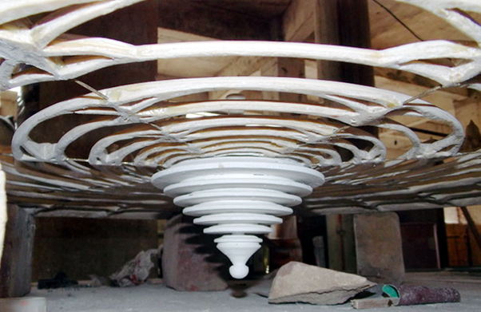

The above image depicts a model of the Bhu-mandala with a series of concentric circles, and seven layers tapering down below it. The Bhu-mandala's islands and oceans are rightly formed in a series of concentric circles, but let not the designers forget that they are in, fact, islands with real water and landscapes comprised of real Earth and water like our own. The above presentation is completely formless and gives no understanding whatsoever that the Bhu-mandala is one vast landscape made up of islands and oceans that spread out for hundreds and millions of miles across the center of the universe. The seven islands of Bhu-mandala are not a series of individual planets floating in space, but rather one landscape that is divided into seven massive islands with surrounding oceans. In the above image they have been wrongly depicted as circles of impersonal space.
How to depict the Earth's underground realms within the Bhu-mandala exhibition (so that they are visible to the visitors) may require some thinking, but what has to be avoided in any depiction is the mistaken idea that Sukadeva Goswami is describing seven layers of globe-like planets below a so-called Earth globe. The popular image below depicting the situation of the Earth, is used in practically all of ISKCON's exhibitions on Vedic cosmology—despite it being entirely wrong!

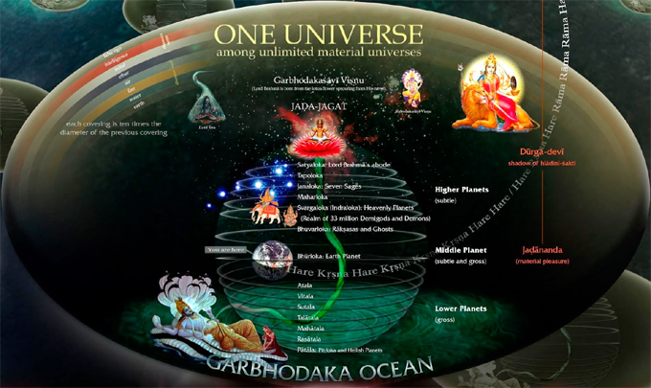

The first mistake is that the image depicts the Earth as a globe, when Srimad Bhagavatamitself describes the Earth as a 4 billion diameter disc that forms a massive landscape across the center of the universe. There is no so-called Earth-globe in Srimad Bhagavatam! Bharata-varsha is not described as a separate planet in space, but is described as being upon the Bhu-mandala landscape; to be precise, Bharata-varsha is on the southern side of Jambudwipa island (the central island of Bhu-mandala). Why then has the idea of the vast Bhu-mandala been omitted from the image above, and an Earth-globe been presented instead? Whatever one believes about the Earth, it should be understood and recognized that the above and similar images of the Earth are not accurate and reliable representations of the description given in Srimad Bhagavatam. Secondly, the subterranean realms are within the depths of the Bhu-mandala to a distance of 560,000 miles, and are not layers of planets that go down seemingly for billions of miles (as depicted in the image above). According to Srimad Bhagavatam, the universe is four billion miles from top to bottom, and the entire bottom half of the universe is filled with Garbhodaka Ocean to a depth of 2 billion miles. On the surface of the Garbodhaka Ocean is Ananta-sesha who is holding the Earth circle on His hoods which is a mere 240,000 miles above the surface of Garbhodaka Ocean. The seven subterranean worlds are within the massive depths of the Earth itself adhastat sapta bhu-vivara (SB 5.24.7). Above the Earth's surface are all the stars and planets orbiting around the fixed Earth below. Unfortunately, at this point we have no adequate images to convey all of this information; we look forward to an inspired computer designer who can help present the description of Bhu-mandala in a visual form.

