- The Gravity Hoax -
so-called law of gravitation is fake
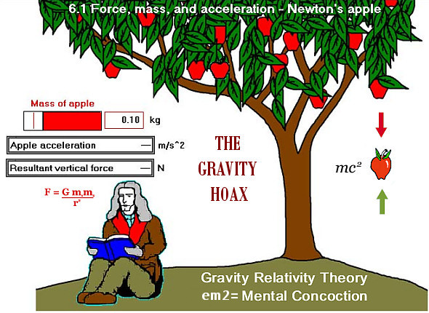
The Gravity Hoax - so-called law of gravitation is a fake
BY: PARIKSIT DAS
Gravitation-as-attraction (in short: 'gravity') is nothing but a Hoax! The so-called law of gravitation is a fake - it is nothing but a mental concoction, a theory propagated by Sir Isaac Newton. Newton's view of Gravity as Srila Prabhupada says is wrong.
Srila Prabhupada: The scientists, they say the law of gravitation... How far it is true...
Everyone can understand that this big airplane is floating in the sky because the pilot has entered within it. Similarly, if this planet is floating, then somebody, either you or somebody, God, has entered it. And that answer is there in the Bhagavad-gītā, that "I enter into these planets and therefore I keep them floating." That is our answer. And the scientists, they say the law of gravitation... How far it is true... (Iso Mantra 1 -- LA, April 29, 1970)

NASA's 45 Year Gravity Hoax EXPOSED
https://www.youtube.com/watch?v=d7eT2QpEtfU
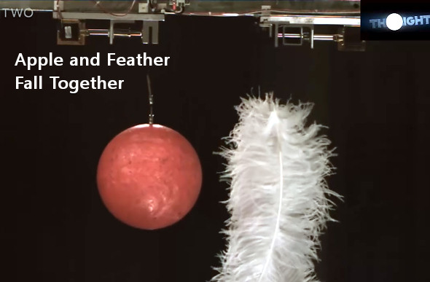
https://www.youtube.com/watch?v=d7eT2QpEtfU
The materialists try to explain that the planets are floating by the law of gravitation, but the so-called law of gravitation works under the control or direction of the Supreme Lord, who is situated even within the atoms. That is the version of Bhagavad-gītā (15.13) which confirms, by the Lord's statement, that behind the material laws or nature's laws and behind the growth, maintenance, production and evolution of all the planetary systems—behind everything—is the Lord's direction. The so-called law of gravitation which sustains the planets is described herein as the potency of the Lord.
Mahā-viṣṇu, enters. He lies within the Causal Ocean and breathes out innumerable universes, and into each universe the Lord again enters as Garbhodakaśāyī Viṣṇu. Each universe is in that way created. He still further manifests Himself as Kṣīrodakaśāyī Viṣṇu, and that Viṣṇu enters into everything—even into the minute atom. This fact is explained here. He enters into everything. BG 9.8, Purport
Kṛṣṇa says that the entire material world is maintained by His partial representation as Paramātmā. The Lord enters every universe as Garbhodakaśāyī Viṣṇu and then expands Himself as Kṣīrodakaśāyī Viṣṇu to enter the hearts of all living entities and even enter the atoms. Aṇḍāntara-stha-paramāṇu-cayāntara-stham (Bs. 5.35). Every universe is full of atoms, and the Lord is not only within the universe but also within the atoms. Thus within every atom the Supreme Lord exists in His Viṣṇu feature as Paramātmā, but all the viṣṇu-tattvas emanate from Kṛṣṇa. SB 8.3.17, Purport:

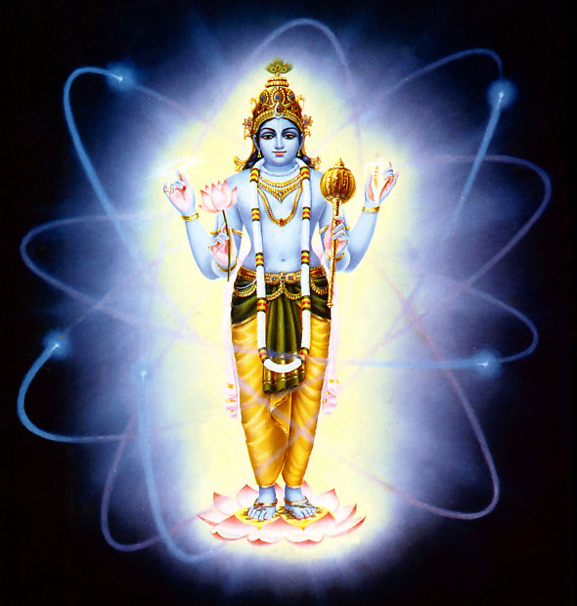
“I enter into each planet, and by My energy they stay in orbit.
I become the moon and thereby supply the juice of life to all vegetables.”
http://www.harekrsna.de/anti-material-world.htm

It is understood that all the planets are floating in the air only by the energy of the Lord. The Lord enters into every atom, every planet, and every living being.
That is discussed in the Brahmā-saṁhitā. It is said there that one plenary portion of the Supreme Personality of Godhead, Paramātmā, enters into the planets, the universe, the living entity, and even into the atom. So due to His entrance, everything is appropriately manifested. When the spirit soul is there, a living man can float on the water, but when the living spark is out of the body and the body is dead, it sinks. Of course when it is decomposed it floats just like straw and other things, but as soon as the man is dead, he at once sinks in the water. Similarly, all these planets are floating in space, and this is due to the entrance of the supreme energy of the Supreme Personality of Godhead. His energy is sustaining each planet, just like a handful of dust. If someone holds a handful of dust, there is no possibility of the dust falling, but if one throws it in the air, it will fall down. Similarly, these planets, which are floating in air, are actually held in the fist of the universal form of the Supreme Lord. By His strength and energy, all moving and unmoving things stay in their place. It is said that because of the Supreme Personality of Godhead, the sun is shining and the planets are steadily moving. Were it not for Him, all the planets would scatter, like dust in air, and perish. Similarly, it is due to the Supreme Personality of Godhead that the moon nourishes all vegetables. Due to the moon's influence, the vegetables become delicious. Without the moonshine, the vegetables can neither grow nor taste succulent. Human society is working, living comfortably and enjoying food due to the supply from the Supreme Lord. Otherwise, mankind could not survive. The word rasātmakaḥ is very significant. Everything becomes palatable by the agency of the Supreme Lord through the influence of the moon. (bg/15/13)

There is no question of law of gravity; it is the air
Srila Prabhupada - ''All these planets are moving only by the air. So the heavy land, heavy cloud is carried by the air. It is a question of adjustment of air, not the law of gravity. Now the whole universal planetary system are floating and rotating round the polestar. Is that law of gravity, rotating? It is the arrangement of the air. By the air it is up. Just like there is dust storm, so many are floating in the air. There is no question of law of gravity; it is the air. And the..., who is controlling the air?''

It is a question of adjustment of air, not the law of gravity.
Śrutakīrti: Just like they say the moon does not go away because the earth is attracting it.
Prabhupāda: Oh. What is earth? [laughs] All bogus.
Paramahaṁsa: But if we tell them that there is no law of gravity, they will say that why is it that if you throw up a ball, then it comes down?
Prabhupāda: It comes down, heavy, then it comes down, that's all. [laughs]
Śrutakīrti: But that heaviness, they say, is gravity.
Prabhupāda: You can call anything. [laughs] But if Kṛṣṇa desires, a football may not fall. Just like so many planets, they are carried up by the air. All these planets are moving only by the air. So the heavy land, heavy cloud is carried by the air. It is a question of adjustment of air, not the law of gravity. Now the whole universal planetary system are floating and rotating round the polestar. Is that law of gravity, rotating? It is the arrangement of the air. By the air it is up. Just like there is dust storm, so many are floating in the air. There is no question of law of gravity; it is the air. And the..., who is controlling the air? That is Supreme Personality. Just like in Darwin, the motor buses were floating by the air. It was a great storm there?"
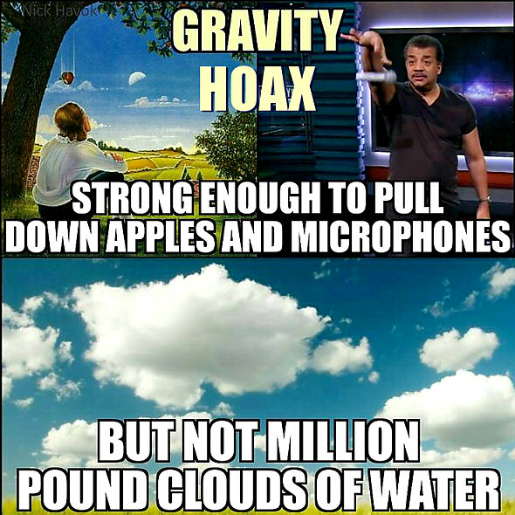
Big, big planets, there is no question of gravitation. That is nonsense. It is by His arrangement it is moving in the air. [solar-wind? cosmic rays?]
Prabhupāda: No. This is my interpretation. He is also creating; you are also creating. You can create a motorcar and He can create a huge, gigantic sun globe. The same process. As you are controlling the aeroplane by air condition or by controlling the air, similarly all these planets are there. It is by His plan it is moving with the air. Big, big planets, there is no question of gravitation. That is nonsense. It is by His arrangement it is moving in the air. Just like big, big cloud containing millions of tons of water floating in the air. How it is being done? Eh? Millions of tons of water are floating in the air. That we see daily. So similarly, all these planets are floating by His arrangement. Not only floating. Making center that polestar, all the planets are moving around it, even the sun. So it is by His arrangement. Morning Walk -- May 17, 1975, Perth:
Planets and stars are enabled to float by manipulations of the air. This has nothing to do with gravity or any other imaginary laws created by the material scientists. (sb/5/23/3)
When bulls are yoked together and tied to a central post to thresh rice, they tread around that pivot without deviating from their proper positions—one bull being closest to the post, another in the middle, and a third on the outside. Similarly, all the planets and all the hundreds and thousands of stars revolve around the polestar, the planet of MahārājaDhruva, in their respective orbits, some higher and some lower. Fastened by the Supreme Personality of Godhead to the machine of material nature according to the results of their fruitive acts, they are driven around the polestar by the wind and will continue to be so until the end of creation. These planets float in the air within the vast sky, just as clouds with hundreds of tons of water float in the air or as the great śyenaeagles, due to the results of past activities, fly high in the sky and have no chance of falling to the ground.

PURPORT: According to the description of this verse, the hundreds and thousands of stars and the great planets such as the sun, the moon, Venus, Mercury, Mars and Jupiter are not clustered together because of the law of gravity or any similar idea of the modern scientists. These planets and stars are all servants of the Supreme Personality of Godhead, Govinda or Kṛṣṇa, and according to His order they sit in their chariots and travel in their respective orbits. The orbits in which they move are compared to machines given by material nature to the operating deities of the stars and planets, who carry out the orders of the Supreme Personality of Godhead by revolving around Dhruvaloka, which is occupied by the great devotee Mahārāja Dhruva. This is confirmed in the Brahma-saṁhitā (5.52) as follows:
yac-cakṣur eṣa savitā sakala-grahāṇāṁ
rājā samasta-sura-mūrtir aśeṣa-tejāḥ
yasyājñayā bhramati sambhṛta-kāla-cakro
govindam ādi-puruṣaṁ tam ahaṁ bhajāmi
“I worship Govinda, the primeval Lord, the Supreme Personality of Godhead, under whose control even the sun, which is considered to be the eye of the Lord, rotates within the fixed orbit of eternal time. The sun is the king of all planetary systems and has unlimited potency in heat and light.” This verse from Brahma-saṁhitā confirms that even the largest and most powerful planet, the sun, rotates within a fixed orbit, or kāla-cakra, in obedience to the order of the Supreme Personality of Godhead. This has nothing to do with gravity or any other imaginary laws created by the material scientists. Material scientists want to avoid the ruling government of the Supreme Personality of Godhead, and therefore they imagine different conditions under which they suppose the planets move. The only condition, however, is the order of the Supreme Personality of Godhead. All the various predominating deities of the planets are persons, and the Supreme Personality of Godhead is also a person. The Supreme Personality orders the subordinate persons, the demigods of various names, to carry out His supreme will. This fact is also confirmed in Bhagavad-gītā (9.10), wherein Kṛṣṇa says:
mayādhyakṣeṇa prakṛtiḥ / sūyate sa-carācaram
hetunānena kaunteya / jagad viparivartate
“This material nature is working under My direction, O son of Kuntī, and it is producing all moving and unmoving beings. By its rule this manifestation is created and annihilated again and again.” The orbits of the planets resemble the bodies in which all living entities are seated because they are both machines controlled by the Supreme Personality of Godhead. As Kṛṣṇa says in Bhagavad-gītā (18.61):
īśvaraḥ sarva-bhūtānāṁ / hṛd-deśe ’rjuna tiṣṭhati
bhrāmayan sarva-bhūtāni / yantrārūḍhāni māyayā
“The Supreme Lord is situated in everyone’s heart, O Arjuna, and is directing the wanderings of all living entities, who are seated as on a machine, made of the material energy.” The machine given by material nature—whether the machine of the body or the machine of the orbit, or kāla-cakra—works according to the orders given by the Supreme Personality of Godhead. The Supreme Personality of Godhead and material nature work together to maintain this great universe, and not only this universe but also the millions of other universes beyond this one.
The question of how the planets and stars are floating is also answered in this verse. It is not because of the laws of gravity. Rather, the planets and stars are enabled to float by manipulations of the air. It is due to such manipulations that big, heavy clouds float and big eagles fly in the sky. Modern airplanes like the 747 jet aircraft work in a similar way: by controlling the air, they float high in the sky, resisting the tendency to fall to earth. Such adjustments of the air are all made possible by the cooperation of the principles of puruṣa (male) and prakṛti (female). By the cooperation of material nature, which is considered to be prakṛti, and the Supreme Personality of Godhead, who is considered the puruṣa, all the affairs of the universe are going on nicely in their proper order. prakṛti, material nature, is also described in the Brahma-saṁhitā (5.44) as follows:
sṛṣṭi-sthiti-pralaya-sādhana-śaktir ekā
chāyeva yasya bhuvanāni bibharti durgā
icchānurūpam api yasya ca ceṣṭate sā
govindam ādi-puruṣaṁ tam ahaṁ bhajāmi
“The external potency, māyā, who is of the nature of the shadow of the cit [spiritual] potency, is worshiped by all people as Durgā, the creating, preserving and destroying agency of this mundane world. I adore the primeval Lord Govinda, in accordance with whose will Durgā conducts herself.” Material nature, the external energy of the Supreme Lord, is also known as Durgā, or the female energy that protects the great fort of this universe. The word Durgā also means fort. This universe is just like a great fort in which all the conditioned souls are kept, and they cannot leave it unless they are liberated by the mercy of the Supreme Personality of Godhead. The Lord Himself declares in Bhagavad-gītā (4.9):
janma karma ca me divyam / evaṁ yo vetti tattvataḥ
tyaktvā dehaṁ punar janma / naiti mām eti so ’rjuna
“One who knows the transcendental nature of My appearance and activities does not, upon leaving the body, take his birth again in this material world, but attains My eternal abode, O Arjuna.” Thus simply by Kṛṣṇa consciousness, by the mercy of the Supreme Personality of Godhead, one can be liberated, or, in other words, one can be released from the great fort of this universe and go outside it to the spiritual world.
It is also significant that the predominating deities of even the greatest planets have been offered their exalted posts because of the very valuable pious activities they performed in previous births. This is indicated herein by the words karma-nirmita-gatayaḥ. For example, as we have previously discussed, the moon is called jīva,which means that he is a living entity like us, but because of his pious activities he has been appointed to his post as the moon-god. Similarly, all the demigods are living entities who have been appointed to their various posts as the masters of the moon, the earth, Venus and so on because of their great service and pious acts. Only the predominating deity of the sun, Sūrya Nārāyaṇa, is an incarnation of the Supreme Personality of Godhead. Mahārāja Dhruva, the predominating deity of Dhruvaloka, is also a living entity. Thus there are two kinds of entities—the supreme entity, the Supreme Personality of Godhead, and the ordinary living entity, the jīva (nityo nityānāṁ cetanaś cetanānām). All the demigods are engaged in the service of the Lord, and only by such an arrangement are the affairs of the universe going on.
Regarding the great eagles mentioned in this verse, it is understood that there are eagles so big that they can prey on big elephants. They fly so high that they can travel from one planet to another. They start flying in one planet and land in another, and while in flight they lay eggs that hatch into other birds while falling through the air. In Sanskrit such eagles are called śyena. Under the present circumstances, of course, we cannot see such huge birds, but at least we know of eagles that can capture monkeys and then throw them down to kill and eat them. Similarly, it is understood that there are gigantic birds that can carry off elephants, kill them and eat them.
The two examples of the eagle and the cloud are sufficient to prove that flying and floating can be made possible through adjustments of the air. The planets, in a similar way, are floating because material nature adjusts the air according to the orders of the Supreme Lord. It could be said that these adjustments constitute the law of gravity, but in any case, one must accept that these laws are made by the Supreme Personality of Godhead. The so-called scientists have no control over them. The scientists can falsely, improperly declare that there is no God, but this is not a fact.

How is it that so-called gravity is strong enough to pull down
newtonian apples but not million pound of rain clouds ???
These planets float in the air within the vast sky, just as clouds with hundreds of tons of water float in the air or as the great shena eagles, due to the results of past activities, fly high in the sky and have no chance of falling to the ground ((sb/5/23/3))."

Here it says that the past good karma (karma-nirmita) of the living entities (who form the stars and planets), along with the controlling power of vayu (vayu-vasah), under the direction of the Supreme Personality of Godhead (purusha) keeps the planets (graha-adayah) and other luminaries (jyotih-ganah) in their respective orbit, so that they do not fall to the Earth (bhuvi—on the ground; na—not; patanti—fall down). The grahas thus traverse in their orbits and revolve in the sky like clouds that are moved by the wind (kramanti—revolve all around; nabhasi—in the sky; yatha—exactly like; meghah—heavy clouds; syena-adayah—birds such as the big eagle; vayu-vasah—controlled by the air).
The planets are thus held not by gravity, but by vayu or the manipulation of air (avalambya—taking support of; vayuna—by the wind; udiryamanah—being propelled). Srila Prabhupada thus disputes the gravity theory in a very important purport to this verse.
This verse and purport will be one of the foundational statements for our spiritual scientists to defeat the globe theory which practically rests on the idea of gravity. According to the scientists, space is a vacuum with no air present; but here we learn that cosmic winds operate in space and are both holding and moving the planets in their orbits. [Incidentally, in the years 1969-72, the American government presented to the world that their astronauts made successive trips through the vacuum of space and landed on the surface of the moon. For followers of Srimad Bhagavatam, this one verse proves that the whole presentation was fake (as Srila Prabhupada consistently argued). We will later write a paper on this whole issue of the Moon Landing Hoax, but, for the moment, let everyone take note that Srimad Bhagavatam does not present space as a vacuum. Cosmic winds operate in space under the direction of Vayu and keep the planets afloat and in their respective orbits].
The acharyas comment on the above verse as follows:
"Oxen tied to a thrashing pole with a three stringed rope, move in circles around the central pole—some of them tied from inside and others tied from outside. In the same manner, the celestial bodies which are tied to the kala-chakra from inside and outside move in circles around Druva, propelled by their karma and the forces of pravaha Vayu. They resemble birds in the sky and do not fall. The karma of jivas and the properties of matter such as the wind are manifold and wonderful and are responsible for holding these bodies in the sky (Commentary by Viraraghava to SB 5.23.3)

Just as oxen tied to the central pole of the threshing floor move in their respective positions, so do the stars and planets fixed by Ishvara [the controller] in the proper positions within the kala-cakra move by their own karma [the results of fruitive activities] and propelled by Vayu [wind or the demigod of wind, Vayu] (Commentary by Vishvanatha Cakravarti Thakura to SB 5.23.3)

The same idea is further clarified. As oxen tied to a pole do not violate their path and position, so do the stars and planets move around Dhruva, driven by Vayu and assisted by their own karma. They are attached to the kala-chakra by ropes of wind from inside and outside and they do not fall because of these reasons. The same thing is further elaborated. The association of prakrti (matter) and purusa (the living entity) is so complex that it produces wonderful events. This is one of the reasons for their not falling." (Commentary by Sri Bhagavatacharya 5.23.3)
Here we learn about a very personal aspect of the universe—that the stars and planets all have personal existence behind them, and karma is one of the factors that enable these luminaries to orbit in the celestial regions.
"They do not fall like us because they have done excellent deeds in the form of the worship of Vishnu. As a result of these, they are endowed with extraordinary powers" (Commentary by Yadavarya to SB 5.23.3)
Ii is doubtful that modern astronomers would factor karma as one of the reasons why planets stay in orbit.

DIFFERENT KINDS OF AIR [VĀYU]
The vedic scriptures describe the air (vāyu) to be of different kinds (gross and subtle), according to the function it performs. A yogi, for example, is advised to control the different airs, for attaining mystic perfections or travelling to other planets. There are the controlling of different airs passing within this body, such as Apāna-vāyu, prāṇa-vāyu, vyāna-vāyu etc. The apāna-vāyu goes downwards, vyāna-vāyu acts to shrink and expand, samāna-vāyu adjusts equilibrium, udāna-vāyu goes upwards—and when one is enlightened, one engages all these in searching for self-realization.
Modern scientist, analysing the planetary movements, speak of solar-winds, cosmic rays and magnetic storms. The Vayu-Purana states that all the celestial bodies are tied to Dhruva with ropes of cosmic winds. Vayu at the level of the solar system is responsible for the movement and revolution of the planets. The Sun itself has its solar wind or solar Vayu, or as scientists would say, its electromagnetic forces that hold the solar system together.
The suns movement is due to the dakṣiṇāvarta wind
The living entities residing on Sumeru Mountain are always very warm, as at midday, because for them the sun is always overhead. Although the sun moves counterclockwise, facing the constellations, with SumeruMountain on its left, it also moves clockwise and appears to have the mountain on its right because it is influenced by the dakṣiṇāvarta wind. People living in countries at points diametrically opposite to where the sun is first seen rising will see the sun setting, and if a straight line were drawn from a point where the sun is at midday, the people in countries at the opposite end of the line would be experiencing midnight. Similarly, if people residing where the sun is setting were to go to countries diametrically opposite, they would not see the sun in the same condition.
Srila Sridhara Swami in his commentary on SB 5.21.8-9 remarks: "Although leftward movement, facing the constellations, is their own motion [svagatya], the luminaries [sun, moon, etc.] move around Meru to the right daily,being blown by the pravaha wind, due to the power of the kala-cakra."
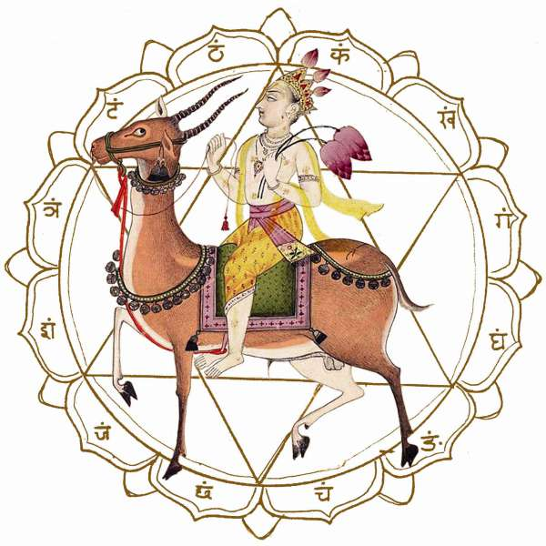
Vāyu Devata
Controlling the vāyu, the air within the body - prāṇāyāma -
The yoga system is controlling the vāyu, the air within the body. That is called prāṇāyāma, prāṇa, prāṇa, vāyu, control the prāṇa-vāyu. So perfect yogi, they control the prāṇa-vāyu in such a way that by their sweet will they can transfer themselves through the prāṇa-vāyu in different planets. They can do that when they are fixed up, that "Now I am completely able to transfer myself," so they can transfer to any planet, or if he wants, he can transfer himself to the spiritual world. That is the perfection. We have given this picture in our Perfection of Yogabook: a yogi is transferring himself to another planet. So if you want to go to the planets of the demigods... They are trying to go to the moon planet, but by yogasystem, you can transfer yourself to any planet by yoga practice perfection. Therefore we have written that book Easy Journey to Other Planets. You can go to any other planet by bhakti-yoga or the aṣṭāṅga-yoga. Aṣṭāṅga-yoga, by practicing and becoming perfect, you can transfer to any planet yourself within this material world.
Prabhupāda: So this verse [SB 1.15.41] describes in the manner of yogic practice. The yogic practice means controlling five kinds of air within the body: prāṇa, apāna, vyāna, like that. That is breathing exercise, yoga practice. (classes/LA/19/1973) So the Patañjali system is explained in the purport that controlling the inner different kinds of air, vāyu.
There are five kinds of air passing within our body: prāṇa, apāna, vyāna, udāna... There are different names of the air. So controlling them, prāṇāpānau samau kṛtvā and nāsābhyantara-cāriṇau. They are coming, breathing control. These are the process. Those who are have practiced this yoga process, they can know.

THE AIR OF LIFE
The activity of consciousness is performed through the air of life, which is of ten divisions. The airs of life are called prāṇa, apāna, udāna, vyāna and samāna and are also differently qualified as em>nāga, kūrma, kṛkara, devadatta and dhanañjaya. Consciousness is the sign of the living entity, or the soul. The existence of the soul is manifest in the form of consciousness, called jñāna-śakti. The total consciousness is that of the gigantic virāṭ-rūpa, and the same consciousness is exhibited in individual persons. The consciousness of the soul becomes polluted by the material atmosphere, and thus various activities are exhibited in the false ego of bodily identification. (sb/3/6/7)

THE TEN KINDS OF AIR WITHIN THE BODY
The movements of the body are first generated from the heart, and all the activities of the body are made possible by the senses, powered by the ten kinds of air within the body. The ten kinds of air are described as follows: The main air passing through the nose in breathing is called prāṇa. The air which passes through the rectum as evacuated bodily air is called apāna. The air which adjusts the foodstuff within the stomach and which sometimes sounds as belching is called samāna. The air which passes through the throat and the stoppage of which constitutes suffocation is called the udāna air. Aid the total air which circulates throughout the entire body is called the vyāna air. Subtler than these five airs, there are others also. That which facilitates the opening of the eyes, mouth, etc., is called nāga air. The air which increases appetite is called kṛkara air. The air which helps contraction is called kūrma air. The air which helps relaxation by opening the mouth wide (in yawning) is called devadatta air, and the air which helps sustenance is called dhanañjaya air.
All these airs are generated from the center of the heart, which is one only. This central energy is superior energy of the Lord, who is seated within the heart with the soul of the body, who acts under the guidance of the Lord. (sb/3/6/9). The life air is surrounded by five kinds of air, known as prāṇa, apāna, vyāna, udāna and samāna. When the body is inactive, the prāṇa, or the life air, is active. There is prāṇa, apāna, udāna, vyāna and samāna, and because the life air functions in this fivefold way,

THE ATOMIC SOUL IS FLOATING IN FIVE KINDS OF AIR
"The soul is atomic in size and can be perceived by perfect intelligence. This atomic soul is floating in the five kinds of air (prāṇa, apāna, vyāna, samāna and udāna), is situated within the heart, and spreads its influence all over the body of the embodied living entities. When the soul is purified from the contamination of the five kinds of material air, its spiritual influence is exhibited."
The haṭha-yoga system is meant for controlling the five kinds of air encircling the pure soul by different kinds of sitting postures—not for any material profit, but for liberation of the minute soul from the entanglement of the material atmosphere.
So the constitution of the atomic soul is admitted in all Vedic literatures, and it is also actually felt in the practical experience of any sane man. Only the insane man can think of this atomic soul as all-pervading viṣṇu-tattva.
The influence of the atomic soul can be spread all over a particular body. According to the Muṇḍaka Upaniṣad, this atomic soul is situated in the heart of every living entity, and because the measurement of the atomic soul is beyond the power of appreciation of the material scientists, some of them assert foolishly that there is no soul. The individual atomic soul is definitely there in the heart along with the Supersoul, and thus all the energies of bodily movement are emanating from this part of the body. The corpuscles which carry the oxygen from the lungs gather energy from the soul. When the soul passes away from this position, the activity of the blood, generating fusion, ceases. Medical science accepts the importance of the red corpuscles, but it cannot ascertain that the source of the energy is the soul. Medical science, however, does admit that the heart is the seat of all energies of the body.
Such atomic particles of the spirit whole are compared to the sunshine molecules. In the sunshine there are innumerable radiant molecules. Similarly, the fragmental parts of the Supreme Lord are atomic sparks of the rays of the Supreme Lord, called by the name prabhā, or superior energy. So whether one follows Vedic knowledge or modern science, one cannot deny the existence of the spirit soul in the body, and the science of the soul is explicitly described in the Bhagavad-gītā by the Personality of Godhead Himself. (bg/2/17)
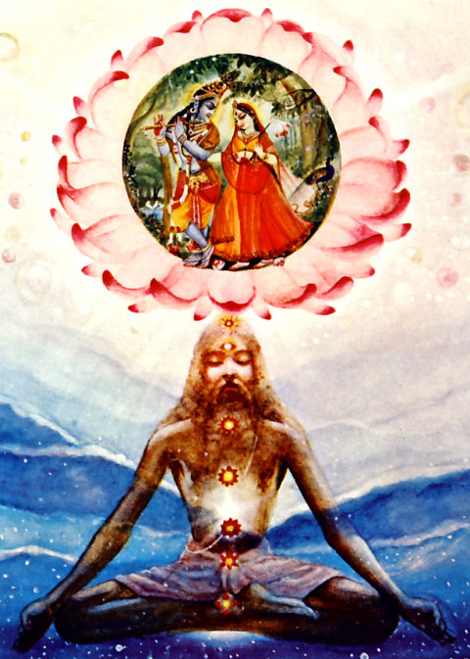
The yogis who have perfectly controlled their mystic powers can give up their material bodies at will at some opportune moment, and thus are able to enter the antimaterial world through a specific thoroughfare which connects the material and antimaterial. Such yogis are able to do this only in accordance with the prescribed method given in The Bhagavad Gita as follows:
Those who know the Supreme Brahman pass away from this world during the influence of the fiery god, in the light, at an auspicious moment, during the fortnight of the moon and the six months when the sun travels in the north.
The different deities are powerful directing officers appointed to the administration of cosmic affairs. Foolish people who are unable to perceive the intricacies of cosmic management deny the concept of personal control over fire, air, electricity, day, night, etc. But the perfect yogis know how to satisfy the unseen administrators of such affairs of the material world. Such yogis take advantage of these administrations and leave their material bodies at will at opportune moments, so that they can enter the antimaterial world, or else travel to the higher planets of the material world.
On the higher planets of the material world one can enjoy a more comfortable and pleasant life for thousands of millions of years, but all the same, life on those higher planets is not eternal. Those who desire eternal life enter into the antimaterial world by their yogic or mystic powers at opportune moments which are arranged by the administrators of cosmic affairs, beings unseen by the gross materialists of this planet earth. (BTG)
Śrīmad-Bhāgavatam also describes how yogīs can travel to all the planets in the universe. When the vital force is lifted to the cerebellum, there is every chance that this force will burst out from the eyes, nose, ears, etc., as these are places that are known as the seventh orbit of the vital force. But the yogīs can block these holes by complete suspension of air. The yogī then concentrates the vital force in the middle position, that is, between the eyebrows. At this position, the yogī can think of the planet to which he wants to go after leaving the body. He can then decide whether he wants to go to the abode of Kṛṣṇa in the transcendental Vaikuṇṭhas, from which he will not be required to descend into the material world, or to travel to higher planets in the material universe. The perfect yogī is at liberty to do either.
For the perfect yogī who has attained success in the method of leaving his body in perfect consciousness, transferring from one planet to another is as easy as an ordinary man's walking to the grocery store. As already discussed, the material body is just a covering of the spiritual soul. Mind and intelligence are the undercoverings, and the gross body of earth, water, air and so on is the overcoating of the soul. As such, any advanced soul who has realized himself by the yogic process, who knows the relationship between matter and spirit, can leave the gross dress of the soul in perfect order and as he desires. By the grace of God, we have complete freedom. Because the Lord is kind to us, we can live anywhere—either in the spiritual sky or in the material sky, upon whichever planet we desire.

