The Mistake in Mayesa dasa’s Calculation
BY: MAYESVARA DASA
Jan 06, 2017 — IRELAND (SUN) —
The following is a reply to Mayesa dasa's article, It Takes Math. Although we both share a variation of the same name, we obviously differ on our conception of the Earth. I do not personally know Mayesa dasa, but I offer my obeisances to a Vaisnava and a disciple of Srila Prabhupada.
"The thoughts of My pure devotees dwell in Me, their lives are fully devoted to My service, and they derive great satisfaction and bliss from always enlightening one another and conversing about Me." (Bhagavad-gita 10.9)
In the spirit of Bhagavad-gita (10.9), and not to be seemingly finding fault, I would like to point out some texts from Srimad Bhagavatam that present the actual description of the Earth, specifically to our own Earth area known as Bharata-varsha. Sukadeva Goswami's description of Bharata-varsha's location on the Bhu-mandala (Earth circle), is quite different from the globe version presented in the video by Mayesa dasa.
There may be many wondering about all the fuss over the current discussion regarding the shape and location of the Earth. A question may be raised: since the universe is so vast, is a seemingly small detail like the shape of the Earth really of any significance? What harm is there if we stick a globe-shaped Earth into the Vedic planetarium?
The Bhu-mandala (Earth), however, is not a small detail, as it is actually the biggest feature in the Vedic universe. And our perception of the Earth as either a small insignificant planet in dark lifeless space, or as a vast and continuous Earth plane filled with other lands and teeming with other life has profound psychological and spiritual effects on who we are, where we are, and our sense of purpose within the universal scheme of things. Is such a small detail in such a vast universe really of any significance? Yes it is! Since the Earth of Srimad Bhagavatam is described as a vast cosmic circle, and not a small globe in space, the obvious inference is that we are not being told the truth about the Earth we live on.
We will continue to present the case against the globe paradigm in a series of articles called "Applying Spiritual Science to the Question of the Earth's Shape and Location". Part 1 and Part 2 can be found here.
For the moment we would like to address an argument made by Mayesa dasa in his video presentation, It Takes Math, wherein he states:
"…this doesn't mean that the Earth is on Jambudwipa, nor that the sun is directly on top of Manosattara Mountain. The sun is above Manosattara Mountain; that indicates that the Earth is above Jambudwipa."
For those unfamiliar with the name Jambudwipa and its relevance to the Earth, first of all we would should point out that the only Earth described in Srimad Bhagavatam is called Bhu-mandala (Earth circle) and measures at 4 billion miles diameter. Bhu-mandala crosses the center of the universe, dividing the universe into higher and lower realms. The higher part of the universe is for those in the mode of goodness; the lower part of the universe is for those in the mode of ignorance; and the middle part of the universe (Bhu-mandala) is for those who are a mixture of the modes of goodness, passion, and ignorance.
Bhu-mandala is one continual landscape that forms a vast circle across the center of the universe, dividing the universe into higher and lower realms. It's important to grasp the idea of Bhu-mandala as a landscape, not space. Bhu-mandala is the Earth plane, and therefore this vast landscape is a continuation of the same 'earthiness' as our own Earth area, with varieties of land, rivers, oceans, etc. In other words, our own Earth continues into a much greater Earth area with other lands and people. Earth is not an isolated globe floating in space, but just part of a vast continual Earth plane. These other lands surrounding the continents of our known Earth area are described in the fifth canto of Srimad Bhagavatam.
The central area of Bhu-mandala is formed of seven islands and oceans called sapta-dwipa. These islands and oceans form a unique and amazing series of concentric circles that expand for a distance of 202,800,000 miles. Unfortunately, we are short of suitable images to depict this landscape and are relying on other people's images. The problem with these images is that they do not convey the idea of a habitat where people live. Although this diagram looks like any other geometrical form, please try to think of it in terms of a representation of the Bhu-mandala's landscape, rather than a diagram of some lifeless, impersonal conception:

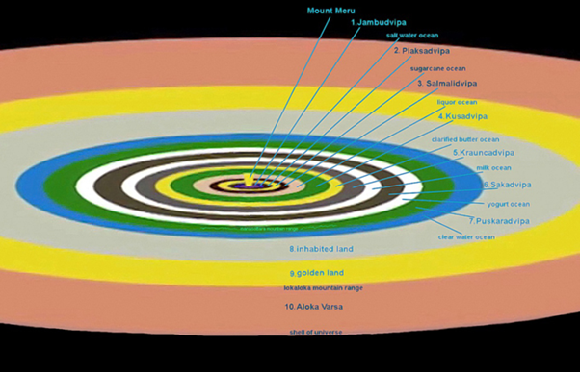

There are other features on the Bhu-mandala that are not depicted here, but these seven circular islands are where most of the inhabitants on the Earth plane live. Our own area of the Earth plane is called Bharata-varsha and is situated at the southern side of the central island of Bhu-mandala called Jambudwipa. Jambudwipa is in the center of Bhu-mandala as depicted in the image below:

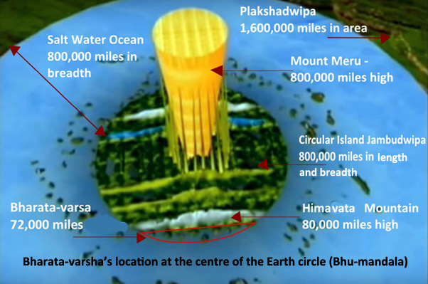

Now let's get back to Mayesa dasa. Mayesa dasa's argument is that we on the Earth are not on Jambudwipa itself, as described by Sukadeva Goswami in the Srimad Bhagavatam, but rather the Earth is above Jambudwipa somewhere in space.
When Mayesa dasa talks about 'Earth' in the above video link, it is the assumed Earth globe that we are all familiar with. Just to repeat here he says:
"…this doesn't mean that the Earth is on Jambudwipa, nor that the sun is directly on top of Manosattara Mountain. The sun is above Manosattara Mountain; that indicates that the Earth is above Jambudwipa."
Mayesa dasa then presents an argument on why the movement of the Sun around the Earth creates day and night and the seasons, and deduces from this that the Earth must be above Mount Meru and not on the same level as the rest of Jambudwipa.
Sukadeva Goswami, however, gives a complete list of planets that are above the one and only Earth plane that is described (the Bhu-mandala). The planets (grahas) above the Earth plane include the Sun, Moon, Venus, Mercury, Mars, etc. There is no mention in this list of a second Earth planet above the Earth plane itself (Bhu-mandala). A second Earth planet has mysteriously appeared above Jambudwipa in Mayesa dasa's diagram. Sukadeva Goswami does not mention such an entity, nor do the acharyas in their commentaries on the fifth canto ever mention another Earth planet above Jambudwipa.
The Earth that Mayesa dasa is obviously referring to is our own area of Bharata-varsha which is plainly described as being at the southern side of Jambudwipa, not hundreds of thousands of miles above it:
"Similarly, south of Ilavrta-varṣa and extending from east to west are three great mountains named (from north to south) Nisadha, Hemakuta and Himalaya. Each of them is 10,000 yojanas [80,000 miles] high. They mark the boundaries of the three varshas named Hari-varsha, Kimpurusha-varsha and Bharata-varsha [India]." (SB 5.16.9)
[Note here, that the translation says that Bharata-varsha is India, but Bharata-varsha is elsewhere described as being 72,000 miles (SB 5.16.6) and is thus obviously a much greater area than India alone. Bharata-varsha is actually 9 times larger than the diameter of our known Earth area].
The translation says that Bharata-varsha is south of Ilavrta-varsha, not above Mount Meru, as Mayesa dasa wants us to believe. Ilavrta-varsha is in the center of Jambudwipa as described by Sukadeva Goswami. Going in the southern direction from Ilavrta varsha, one crosses several other varshas until coming to Bharata-varsha. This is all part of a continual plane:
"In Jambudvipa there are nine divisions of land, each with a length of 9,000 yojanas [72,000 miles]. There are eight mountains that mark the boundaries of these divisions and separate them nicely" (SB 5.16.6)
"Amidst these divisions, or varṣas, is the varṣa named Ilavrta, which is situated in the middle of the whorl of the lotus. Within Ilavrta-varṣa is Sumeru Mountain, which is made of gold. Sumeru Mountain is like the pericarp of the lotuslike Bhu-mandala planetary system". (SB 5.16.7)

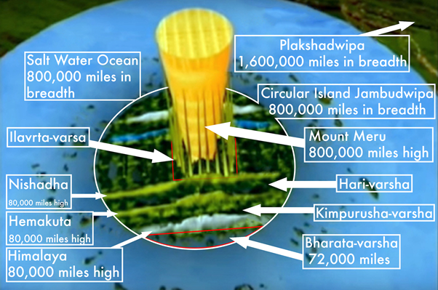

So if Sukadeva Goswami Goswami locates Bharata-varsha at the southern end of Jambudwipa, who are we to say it must be part of an Earth planet floating above Jambudwipa? Bharata varsha is part of the vast Earth plane, not that it is part of a small Earth planet. Let us please strictly adhere to the description provided by Sukadeva Goswami, and not invent new planets in order to prove a preconceived idea about the Earth. Mayesa dasa writes:
"In the matter of deciphering the information of the 5th canto of Srimad Bhagavatam, I undertook the challenge of searching for a meaning in the texts not subject to speculation. This led to 10 years of 7 day weeks, 365 days a year of intensive research in every work I could find. I also had to learn mathematics and begin testing formulas which might expose a definite meaning.
My guiding principles were 2:
1) My spiritual master said that the distances to the planets are revealed in Srimad Bhagavatam
2) Sukadeva Gosvami's words contain these distances"
Sukadeva Goswami says: bhu-golaka-vishesham nama-rupa-mana-lakshanato vyakhyasyamah (SB 5.16.4). O King, I shall nevertheless try to explain to you the principal regions, such as Bhuloka, with their names, forms, measurements and various symptoms. Sukadeva Goswami provides a detailed description of the 'names,' 'measurements,' and 'characteristics' of the Earth circle, as well as the subterranean realms below its surface, and the planets above its surface. Unfortunately for globe advocates like Mayesa dasa, Sukadeva Goswami does not provide any description of another Earth globe, or of its supposed distance from the plane of Bhu-mandala to somewhere in space above Mount Meru. On the contrary, Sukadeva Goswami describes the location and measurements of Bharata-varsha as being south of Ilavrta-varsha which is in the center of Jambudwipa. Just as a traveler going south of Germany will eventually go to Italy, so a traveler going south of Ilavrta-varsha will eventually come to Bharata-varsha. It's that simple! Bhaktivinoda Thakura says:
"One should understand and explain the straight forward, direct meaning of a text – too much analysis and extrapolation only lead to misconception." (Jaiva Dharma translated by Sarvabhavana dasa, Brhat Mrdanga Press, 2004, p328)
The idea of Bharata-varsha's location on an Earth globe above Mount Meru is an obvious misconception that departs from the straightforward reading of the text. Bharata-varsha is described as being south of Ilavrta varsha, not in outer space. The mistake in Mayesa's dasa's calculation is in working from the false premise that the Earth is a globe, and that a globe concept must somehow be made to fit within Srimad Bhagavatam's description of Earth as a circular plane. One is reminded of the story: A man walks in the woods and sees in every tree an arrow stuck right in the bulls eye. Then he sees the man with the bow and arrow and says, ''you're a great shot.'' The man with the bow says, "Well not really. I shoot the arrows into the trees and paint a bulls eye around each arrow'.'
In a similar manner, Mayesa dasa has simply assumed the existence of a globe within the pages of Srimad Bhagavatam, and then created mathematical arguments that supposedly proves the existence of the assumed Vedic globe. What may look like hitting the bulls eye is really just painting bulls eyes around a false premise. The assumption of a globe is unfounded because there is no Earth globe in the Vedic cosmos as described by Sukadeva Goswami. Sukadeva Goswami describes one vast Earth plane and we are situated on that plane. It's not that we are above the Earth plane on a separate Earth globe floating in outer space. This does not conform to the description of shastra as Mayesa dasa claims, nor is it confirmed or even mentioned by any of the acharyas in their commentaries on the fifth canto cosmology.
One point to note: since Bharata-varsha is south of Jambudwipa, then the rest of Jambudwipa is obviously to the north of our known Earth area. Sukadeva Goswami's description of a vast area of land beyond our northern-most points informs us that we are part of a greater Earth plane, and not part of a globe in space. In other words we have not been told the truth about the Earth we live on. The appearance of Srimad Bhagavatam reveals the actual facts. A supporting science that will confirm the Srimad Bhagavatam's description of a continual Earth plane will soon emerge from those thoughtful members of the International Society for Krishna Consciousness who can grasp this concept. The current series of articles on Sampradaya Sun called "Applying Spiritual Science to the Question of the Earth's Shape and Location" is our small attempt to present the shastric basis of this concept to the devotee community.
Please bear in mind that the modern presentation of the Earth as a globe began with Copernicus, Galileo, Kepler, etc, and makes absolutely no reference to, or has any similarity with the Vedic conception. The two diagrams below show the difference. The heliocentric model has a small Earth globe orbiting the sun, with an even smaller moon orbiting the Earth as in the following depiction:

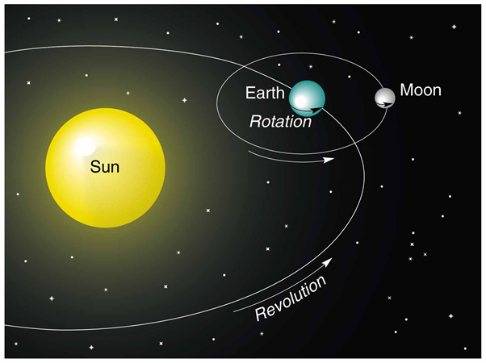

In complete opposition to this conception, the Srimad Bhagavatam describes the Sun and Moon both circling at a vertical distance above the stationary Earth plane of Bhu-mandala. These images are not to scale:

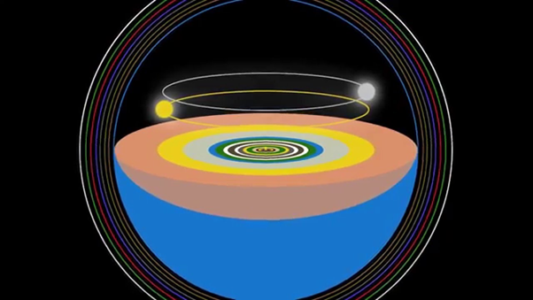

In the modern conception, the Earth is a small globe with a diameter of 24,900 miles. The Srimad Bhagavatam, by contrast, describes Earth as a circular disc with a diameter of 4 billion miles. By comparing these two systems, a follower of Srimad Bhagavatam can quickly conclude that the idea of a small Earth globe and its supposed motions around the Sun are nothing but a product of the speculations of Copernicus, Galileo, etc, and have nothing whatsoever to do with the original description in Srimad Bhagavatam of the movements of the Sun and Moon above the vast stationary Earth plane. The ideas of the western scientists in regards to their conception of how day and night, seasons, etc, are created, will obviously have a contaminating influence on those devotees who favour a globe conception of the Earth. Srila Prabhupada wanted his disciples to study the fifth canto in order to produce a model for the TOVP that would explain 'the passing seasons, eclipses, phases of the moon, passing of day and night, etc.' Unfortunately, the devotees involved at the TOVP are at present working on the model of the Earth as a globe in space, despite the fact that such a conception is not even mentioned by Sukadeva Goswami.
In order to conform to the Srimad Bhagavatam's geocentric (Earth-centered) model, the current TOVP thinking is to present the idea that the Sun goes around the Earth, and not vice versa. However, no matter what speculations emerge to reconcile the idea that the Sun is circling around an Earth globe (and thus causing day and night, seasons, and eclipses in a particular way), these explanations can only be made in complete disregard of Sukadeva's Goswami's original description that the Sun circles at a vertical distance above and parallel to the vast Earth plane, not that it rotates around a small Earth globe (as In Mayesa dasa's explanation).
The members of ISKCON working on providing explanations for such phenomenon as day and night, seasons, etc., will not be able to give a true explanation of this phenomena because their model of the Earth is wrong to begin with.
Sukadeva Goswami begins his description of the Earth by starting with its central island of Jambudwipa, and from there he goes on to describe a fabulous cosmic landscape that crosses the universe and bears absolutely no resemblance to the so-called Earth globe. Since the Sun circles overhead around this vast and stationary Earth circle, any science employed to explain day and night, etc., must be with reference to this model. I believe Danavir Goswami was on the right track in his video called "Vedic Cosmos", which shows the movement of the Sun around the Bhu-mandala below, which creates light (day) and darkness (night) on the flat Earth plane below.

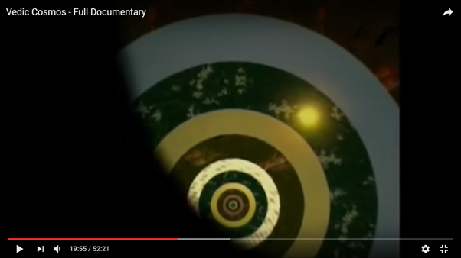

Unfortunately Danavir Goswami departed from this original description, and resorted back to using the globe model as an explanation for this phenomenon. However, since no Earth globe is ever mentioned in Srimad Bhagavatam, and since Bharata-varsha is clearly described as being situated on the same horizontal plane as the rest of Bhu-mandala, any explanation for day and night, time zones, seasons, etc., must be consistent with this model of Earth as a horizontal plane, not a globe in space.

