Perception of the Earth According to the Three Modes of Nature
BY: MAYESVARA DASA
Jan 11, 2018 —IRELAND (SUN) —
The Vedic description of the Earth (Bhu-mandala) can be found in chapters 16-26 of Srimad Bhagavatam's fifth canto. The description of Bhu-mandala is that of a massive Earth circle with amazing, fantastic, and colossal features; it is certainly not a description of a small Earth globe floating in space, nor does the description of our own area of the Earth (in Bharata-varsha) in any way conform to such an idea. In this paper we would like to discuss the various possible reactions from devotees to the Srimad Bhagavatam's description of the Earth. We will consider these possible reactions from the perspective of Lord Kapila's analysis of devotional service within the three modes of material nature.
Simply reading Sukadeva Goswami's description of the Earth does not mean that everyone will arrive at the same understanding of the Earth at the same time; one's realization of any subject in Srimad Bhagavatam is personal and dependent on various factors. Srila Prabhupada presented Srimad Bhagavatam as the answer to all questions. However, Krishna in His own time will reveal the answers to all questions one by one (depending on the attitude and other circumstances of the individual devotee, as well as circumstances in the world in general). The answer to a particular question is personal; and not everyone will have the same question, nor share the same answer at the same time. One may therefore read the description of the Earth in Srimad Bhagavatam, and despite showing an ability to understand what is being described, one may still not accept or believe it to be true.
Srimad Bhagavatam describes an objective universe that can be understood with reference to the standard method of measurement and observation; indeed when Sukadeva Goswami begins his description of the Earth he does just that when he says: bhu-golaka-vishesham nama-rupa-mana-lakshanato vyakhyasyamah—O King, I shall nevertheless try to explain to you the principal regions, such as Bhuloka, with their names, forms, measurements and various symptoms (SB 5.16.4). Although Sukadeva Goswami gives an objective description of the Earth with measurements and characteristics, it is not that everyone will accept the Earth as he has described it; nor will those devotees who are engaged to study and represent Bhu-mandala be necessarily willing to present it as it described. This is because of the intervention of the three modes of material nature as we shall see below.
The Bhu-mandala is non-different from Krishna being part of Krishna's expansion as the virat-rupa or universal form. When we look at the universe around us, we are actually just looking at a form of Krishna (virat-rupa). We obviously can't see all of that form from our relative position, so we have to understand what the complete form looks like by seeing through ‘the eyes of shastra'.
"kavibhih shastra-cakshusa, 'learned authorities see through the eye of scripture" (SB 10.84.36)
Although the universal form is vast, Sukadeva Goswami describes the principal features in chapters 16-26 of the fifth canto. These principal features can be presented in a depiction which then gives us some idea of the size, shape, and characteristic features of Krishna's expansion as virat-rupa. This virat-rupa of Lord Krishna will form the major exhibition with the Temple of Vedic Planetarium. The Temple of Vedic Planetarium is called a temple because it will house not only the deity of Sri-Sri Radha-Krishna, but also the deity of virat-rupa. Upon completion, the pilgrims entering the TOVP can respectfully offer obeisances not only to the forms of Sri-Sri Radha-Krishna on the altar, but also (hoping the TOVP management get it right) to the Lord's gigantic expansion as virat-rupa which will be on display in the main dome of the planetarium. We have pointed out some mistakes in the current TOVP models of Bhu-mandala in two papers that can be found here and here.
The Earth (Bhu-mandala) is the center-piece of the virat-rupa. The greatness, magnificence, and absolute splendor of the Bhu-mandala may arouse hatred in the minds of the envious, who wish to continue living in the illusion of a very different kind of Earth. This is due to the contamination of the material modes of nature, which creates an agenda to exploit the material nature, and thus one is obliged to remain in illusion concerning the Earth's actual feature and purpose. Devotees of Krishna are also affected by the modes of nature as explained by Lord Kapila in the third canto of Srimad Bhagavatam:
"Devotional service executed by a person who is envious, proud, violent and angry, and who is a separatist, is considered to be in the mode of darkness. The worship of Deities in the temple by a separatist, with a motive for material enjoyment, fame, and opulence, is devotion in the mode of passion. When a devotee worships the Supreme Personality of Godhead and offers the results of his activities in order to free himself from the inebrieties of fruitive activities, his devotion is in the mode of goodness. The manifestation of unadulterated devotional service is exhibited when one's mind is at once attracted to hearing the transcendental name and qualities of the Supreme Personality of Godhead, who is residing in everyone's heart." (SB 3.29.8-12)
A devotee should be immediately attracted to hear about Krishna's wonderful expansion as the universal form (which includes, of course, the form of the Earth or Bhu-mandala), but unfortunately the modes of nature intervene and create speculation in the mind. Krishna says in the Bhagavad-gita:
"There is no being existing, either here or among the demigods in the higher planetary systems, which is freed from these three modes born of material nature." (Bg 18.40)
According to the predominance a certain guna in a devotee's conditioned nature, one will respond differently to people, ideas, events, etc. We can, therefore, take Kapiladeva's analysis of devotional service in the 3 modes of material nature and apply it to the possible reactions of devotees to the Bhu-mandala concept.
The mode of passion is particularly relevant here. Considering the prestige that will be associated with the adbhuta mandira (the ‘astounding temple' or Temple of Vedic Planetarium), both individual devotees and the society in general may be allured by the potential fame (yasha—fame/honour), sense objects (vishayan), and opulence (aishvaryam) that inevitably accompany such a massive and prestigious project. The false ego knows that any challenge to the belief that the Earth is a globe will obviously invite disbelief, disapproval, ridicule, and scorn from the world's scientists and governments, as well as practically everyone else. Therefore, an individual devotee (as well as ISKCON's leadership in general), may fear the possible rejection of those they deem to be important people in the world. Taking Lord Kapila's analysis of devotional service within the modes of nature and applying it to a devotee's understanding of Bhu-mandala, it is not unrealistic that a devotee (or movement) in the mode of passion (rajasah), despite worshiping the Deity (arca-adau), will actually turn out to have a separatist mentality (prthag-bhavah), because of compromising with the forces of materialism and scientism, being allured by fame and desire for honour (yasha) as well as sense objects (vishayan), and opulence (aishvaryam) as mentioned in the above verse. (SB 3.29.9) Srila Prabhupada once chastised one of his disciples for creating misunderstanding in a newspaper report in relation to the Vedic Planetarium. Srila Prabhupada detected the source of the problem was his disciple's desire for fame:
"Everything is spoiled. They have given so much coverage, and everything has been farce. Because, don't mind, you wanted to become famous—that is the intention-therefore it has become a farce. The inner intention was that you want to be famous. Frankly. Therefore it has become farce. Everything ludicrous, farce." (Conversation, April, 19,1977, Bombay)
In SB 3.29.8 cited above, Lord Kapila says that a devotee of Krishna who is in the mode of ignorance is characterized by himsam (violence), dambham (pride) matsaryam (envy), and samrambhi (anger). Due to one's desire to remain in illusion (tamasah—ignorance) a devotee becomes envious of others, including Krishna Himself. Thus Lord Kapila says: bhinna-drg bhavam mayi kuryat sa tamasah—"one in the mode of ignorance has separate vision from Me." The envious will thus refuse to accept the vision or sight (drg) of the Earth as it is described by Sukadeva Goswami. They will literally have a separate vision (bhinna-drg) of the Earth due to a desire to be in illusion. They will not accept Bharata-varsha's location on the plane of Bhu-mandala as their true location. A devotee in the mode of ignorance may become angry and even violent upon hearing this conception of the Earth presented above their cherished Earth-globe idea. We have personally been subject to such angry exchanges. Thankfully, most devotees have been inquisitive, appreciative, and surprisingly receptive to the research and arguments presented.
Lord Kapila says that pride is one of the characteristics of a devotee in the mode of ignorance. A devotee subject to pride may not accept that they could possibly be wrong in their understanding of the Earth, or that they could possibly be subject to such a great deception regarding the presentation of the Earth as a globe in space. They may envy others who are closer to the truth. They may hate others who point out the nature of their illusion. We should point out here that the mode of ignorance does not necessarily manifest on account of someone having a poor education. One may have a high education, but still be subject to violence, pride, envy, and anger and other symptoms of the tama-guna; indeed such symptoms are the direct outcome of the type of scientism taught in the best universities throughout the world.
We should briefly mention here that Srila Prabhupada was not against science in the true sense of the word; Srila Prabhupada was against the speculations of atheistic materialism that operates under the name of science. We refer to this atheistic materialism as ‘scientism'. Otherwise, Srila Prabhupada stated that a true scientist will prove the existence of God:
Prabhupada: If you are actually scientist, then prove that there is God. That is your success of education. Idam hi pumsas tapasah srutasya va svishtasya suktasya ca buddhi-dattayoh avicyuto 'rthah kavibhir nirupito... [SB 1.5.22]. Your education has meaning when by your education, by your scientific knowledge, you'll prove that there is God, He is so glorified. Then you are welcome. Then you are really scientist. (Room Conversation, July 7, 1977, Baltimore)
However, science and scientism are two different things and the devotees in ISKCON are not immune to the nefarious education of the latter. This is particularly true for those who are incapable of even questioning the idea that the Earth could be anything other than a globe-shaped planet floating in space.
Srila Prabhupada himself often admonished his disciples for their lack of faith Vedic authority, and in their almost unquestioned acceptance of scientism which has at its very basis the idea that there is no God and no soul:
Prabhupada: Unless one understands this very first instruction, eternity of life, so-called scientists, philosophers—all nonsense. All rascals. Animal...The so-called scientists, they are no better than the animals. That's all. They cannot understand the very simple thing. Animals cannot know. Otherwise any sane man can understand...I am the consciousness. Vasamsi jirnani... They never try to understand this. What is their advance? You are supporting these rascals. That means you do not understand about the soul. Do they not?
Shatadhanya: Yes. Nobody.
Prabhupada: Still in doubt. The brain is not clear. Your background is that rascal civilization. (indistinct) If you understand Bhagavad-gita, you cannot support all this...
Satadhanya: You are not moved by the scientists.
Prabhupada: You should be firmly convinced about our philosophy. Otherwise where is that firm...? How you can support these rascal scientists? That is your rascaldom. Take it for granted. One who cannot understand this fact, that soul is immortal, body is... He is no more human; he is animal.
(Morning Walk, June 19, 1977, Vrindavana)
Again:
Prabhupada: Simply rascals. And because we have become rascals, we accept them, "Oh, here is scientist."
Gurukrpa: They find it convenient to accept what these scientists say.
Prabhupada: No, accept, we accept, but we accept the real scientist, Krishna. Therefore we are triumphant. We understand.
(Morning Walk, February 1, 1977, Bhuvaneshvara)
Again:
"…But first of all we must know also what is the position. If we also become enamored by the so-called scientists, politicians, philosophers, then we cannot preach. We must definitely be convinced that they're all rascals. As a gentleman, I can give him some respect. That is another thing. But he's a rascal. You must know that "I am talking with a rascal number one." So I... He cannot deviate me from my position. But I can talk in a nice way, gentlemanly. That is another thing. That is courtesy. But I know that these rascals, number fools, number one fools, they have no idea."
(Room Conversation, April 13, 1977, Bombay)
Srila Prabhupada's advice was to scrutinize everything:
"So you should have depth of knowledge, otherwise you will be carried away by these rascals. We cannot be carried away by these rascals. We never so easily believed that they are going to the moon planet. You see? We have to scrutinize everything. Yes. That is brahminical qualification. A brahmana will not accept anything simply because it is said by some rascal. A sudra will accept because he has no intelligence. That is the difference between brahmana and sudra. …Kalau sudra-sambhavau. "In this age, Kali-yuga, all sudras." Therefore they accept everything cheaply and at once, the sudras." (Room Conversation, April 1 1972 Sydney)
Considering the Srimad Bhagavatam's description of the Earth as a circular plane, those who claim to be such, must likewise apply the brahminical scrutiny to the current idea that Earth is a globe in space.
In SB 3.29.10, Kapiladeva says that a devotee in the mode of goodness offers the results of their activities to Krishna, the Supreme Personality of Godhead in order to get free from the bondage of fruitive activities or karmic reactions (karma-nirharam uddisya). Although a devotee in the mode of goodness (sa sattvikah) dutifully worships the Lord (yajet) and offers the results of activities to Him (tat-arpanam), they do so with a material motivation (karma-nirharam uddisya), and thus still retain a separatist mentality (prthak-bhavah). Such a devotee will go on doing what is required of them, and whether the Earth is a round globe or a circular plane makes not the slightest difference; they are not attached to either idea. However, being influenced by the quality of sattva they may take some time to study the right and wrong of the idea.
Once the description of Bhu-mandala is understood, a devotee with full faith in Srimad Bhagavatam will accept the description as it is delivered by Sukadeva Goswami. Kapiladeva says such devotees are attracted to hearing of my qualities: mad-guna-sruti (SB 3.29.11-12). One should accept and re-present the description of Bhu-mandala as it was delivered by Sukadeva Goswami to Maharaja Pariksit; otherwise, on account of the contamination of the modes of nature many speculations arise in the name of Vedic cosmology. Devotees like Pariksit Maharaja are eager to hear of this amazing virat form of the Lord:
"My dear Lord, the rolling wheels of Maharaja Priyavrata's chariot created seven ditches, in which the seven oceans came into existence. Because of these seven oceans, Bhu-mandala is divided into seven islands. You have given a very general description of their measurement, names and characteristics. Now I wish to know of them in detail. Kindly fulfill my desire.
When the mind is fixed upon the Supreme Personality of Godhead in His external feature made of the material modes of nature—the gross universal form—it is brought to the platform of pure goodness. In that transcendental position, one can understand the Supreme Personality of Godhead, Vasudeva, who in His subtler form is self-effulgent and beyond the modes of nature. O my lord, please describe vividly how that form, which covers the entire universe, is perceived." (SB 5.16.2-3)
We have previously raised the question as to why Pariksit Maharaja in his preparation for death would ask about the measurements of the Earth. It hardly seems a suitable topic for one preparing to leave the body. Interestingly, the question leads into the subject of the simultaneous oneness and difference of Krishna and the universe itself — an essential realization for anyone in Krishna consciousness. The paper can be found here.
Just as persons are affected by different modes of nature and different levels of spiritual consciousness, so too are nations. The sages of India were hearing about and discussing the Bhu-mandala 5,000 years ago—a concept that we are now only now beginning to hear about in the Western world. Srila Prabhupada wanted to introduce the rest of the world to the Srimad Bhagavatam's essential cosmological teachings. In a nutshell, Srila Prabhupada preached that there is a material and spiritual world, that there are other forms of life throughout the material universe in various types of environments, and that we reincarnate according to our karma into what Srila Prabhupada called ‘the heavenly planets,' or ‘the hellish planets' and even the other ‘Earthly planets.' All of this seems more or less acceptable to the followers of Srila Prabhupada; indeed, they are concepts that are regularly discussed at ISKCON centers. However, the idea of reincarnation and transmigration to life on other planets does not necessarily challenge our present concept of the Earth. Such topics are always interesting, but not too much of a challenge for anyone with a general interest in spiritual subject matter. What about something closer to home? What about this idea of Bhu-mandala? What if our own Earth is not a planet floating in space at all, but just part of this bigger Earth circle? Suddenly the Srimad Bhagavatam presents a very immediate challenge to our faith in the Vedas versus our attachment to so-called scientific ideas regarding the nature of the Earth. When push comes to shove how will followers of Srimad Bhagavatam feel about this idea? Will the GBC disown this idea as heretical—as if such a body actually has the authority to go against Krishna's own method of education for self-realization:
"Thus I have explained to you knowledge still more confidential. Deliberate on this fully, and then do what you wish to do" (Bg 18.63)
Is the world in general and the Hare Krishna movement in particular, mentally and spiritually ready to enter the Srimad Bhagavatam's paradigm of reality regarding the true shape and size of the Earth? Since the TOVP is now rising, it would seem obvious that Krishna's desire is to manifest the truth of the Earth through the medium of the TOVP. But what is the truth of the Earth? Members of ISKCON may feel uncertain about the answer because: (1) they don't understand the description of Bhu-mandala; (2) Srila Prabhupada spoke as if the Earth is a globe (3) they are unfamiliar with Srila Prabhupada's discussions revolving around the disparity between the two world-views; (4) they are unfamiliar with Srila Prabhupada's emphatic insistence to depict Bhu-mandala in the TOVP ‘exactly' as it described. We have made a reply to these various questions and objections in the previous paper that can be found here.
We will continue to address these questions and objections in forthcoming papers.
Once the Srimad Bhagavatam's description of the Earth is understood there should be no objection to preaching the actual nature of the Earth as described in Srimad Bhagavatam. The presentation of Srimad Bhagavatam fifth canto as it is, is essentially what Srila Prabhupada asked us to do:
Prabhupada: We have to simply present Srimad-Bhagavatam as it is. That's all. Whether it is right, wrong, we are not concerned. Sarvam etad ritam manye yad vadasi kesava [Bg. 10.14]. This is our position. You know this verse?
Patita-pavana: This verse I don't know. I don't know this verse. Sarva...?
Prabhupada: Find out. Sarvam etad ritam manye yad vadasi kesava [Bg. 10.14]. Find out. Bhagavad-gita.
Giriraja: "Whatever You say, I accept in toto."
Prabhupada: That's all... What Krishna says and Vyasadeva says, that's all. We haven't got to manufacture. And as soon as you manufacture, fall down. Evam parampara-praptam imam rajarshayah... [Bg. 4.2]. This manufacturing idea is very, very dangerous in spiritual life. Whatever little success is there for me, I did not manufacture any idea.
(Conversation, April 20 1977, Bombay)
Srila Prabhupada's faith in the Srimad Bhagavatam is expressed in his statement that ‘whether it is right or wrong', ‘we have to simply present Srimad Bhagavatam as it is'. Of course, Srila Prabhupada does not think that Srimad Bhagavatam is wrong, but perhaps for the sake of those disciples who may think it is wrong, Srila Prabhupada's insistence is to present it as it is: ‘Whether it is right, wrong, we are not concerned'. Again, Srila Prabhupada gives a sharp warning not to manufacture ideas: "This manufacturing idea is very, very dangerous in spiritual life. Whatever little success is there for me, I did not manufacture any idea".
"We are teaching Bhagavad-gita and Srimad-Bhagavatam as it is spoken by the authorities. We don't add anything or subtract anything." (SB 1.2.6, Delhi, November 12 1973)
For the TOVP management to present Bharata-varsha as part of a globe-shaped planet floating in space certainly counts as an ‘addition' to the original description that is not warranted. Bharata-varsha is described by Sukadeva Goswami as an area of land resting on the surface of Bhu-mandala, and surrounded by other inhabited areas of the greater Earth circle; it is certainly not described as a small separate planet floating in space. Sukadeva Goswami presents a conception of the Earth that is very different from our own.

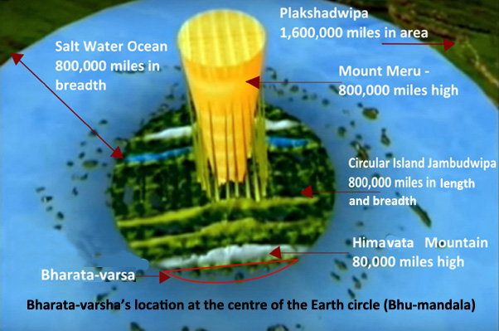

One may or may not agree with it, but the original description by Sukadeva Goswami is the one that has to be presented in the TOVP. From any point of view, the original work of the author has to be clearly represented. The TOVP has a mandate to depict the reality of the Earth as it is described by Sukadeva Goswami. If those responsible for the TOVP are unable to understand this reality, or are unwillingly to present and defend Bhu-mandala as it is described, then they should not take a position in the TOVP simply to propagate the conventional understanding of the Earth as a globe in space—a concept that that mis-represents and undermines the revolution in consciousness that Srimad Bhagavatam has manifested to bring about.
It is not just the exhibition of the Bhu-mandala itself within the TOVP that is is important; the most important thing is the nature of the preaching that accompanies it. Srila Prabhupada says in the conversation below: "not only simply showing museum, but educating people to that idea."
Prabhupada: …We shall show the Vedic conception of planetary system within this material world and above the material world. [break] We are going to exhibit the Vedic culture throughout the whole world, and they'll come here…
Jayapataka: There can be a model of that temple in every temple all over the world.
Prabhupada: Yes.
Jayapataka: So then people can... Then advertising, "Come here."
Prabhupada: Oh, yes. Actually it will be an unique thing in the world. There is no such thing all over the world. That we shall do. And not only simply showing museum, but educating people to that idea.
(Morning Walk, Feb 27, 1976, Mayapur)
Srila Prabhupada makes the point here that the purpose of the TOVP is ‘not only simply showing museum' but ‘educating people to that idea.' What idea? Srila Prabhupada is referring to the idea of the universe as it is described by Sukadeva Goswami! Since Sukadeva Goswami describes Bharata-varsha's location as being on the plane of Bhu-mandala, then the idea that we live on a globe floating in space is obviously false. The cause and nature of the falsity must therefore be pointed out and argued, thus ‘educating people to that idea'. This means taking on the official version of the Earth as propagated by governments and science through-out the world. The concept of Bhu-mandala is not a quaint but hopelessly ridiculous idea from ancient India. It is a weapon of war against the illusions created by scientism, and what bigger illusion to bust than the idea that we live on a globe floating in space.
The first photographic images of the so-called Earth globe came via NASA's great moon landing hoax:

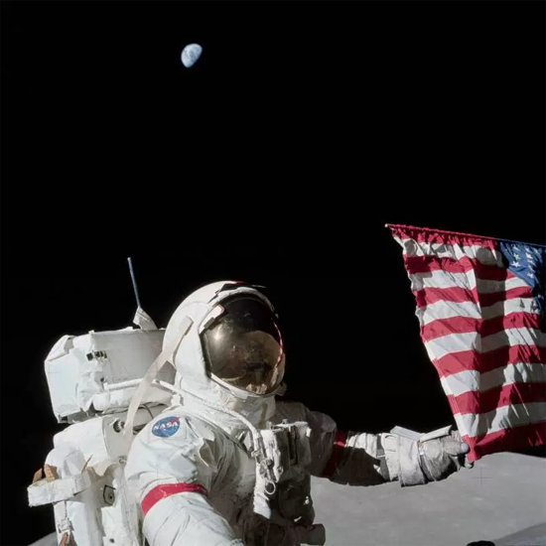

Prabhupada: And they are going to moon. They are going nowhere, simply taking laboratory photo, studio photo, and cheating. Why this cheating can go on? You do not know. That's all. (June 28, 1977, Vrindavana)
Despite Srila Prabhupada's absolute rejection of scientism, and its various propaganda agencies such as NASA (aka moon-landing hoax), his movement, unfortunately, has went the way of everyone else in the modern world, particularly in regards to falling for NASA's so-called space program. As predicted by Srila Prabhupada, having staged the moon landing hoax, NASA would be obliged to continue the deception:
Prabhupada: If they simply follow strictly this moon expedition and they admit they have not gone, then the whole civilization will change. All wrong conclusion. But they will have to admit now. Now they are serious, and they will have to say that they've never gone to the moon. And they will have to continue this. Otherwise they will be farce before the world. They will have to continue it. Now they are in such a position. (Morning Walk, May 16 1975, Perth)
It's not difficult to discern, therefore, that the more recent images of astronauts over the so-called Earth globe are just a continuation of the same deception. Certainly it was Srila Prabhupada's mood that we should not accept any of the propaganda:
Prabhupada: Why if one is settled up that he's a rascal, we should not hear anything. And why not? He has not gone to the moon. They are insisting, "Yes, we have gone," by false propaganda. Why the one who makes false propaganda and one who says nonsense, we have to believe? Immediately, whatever he says, reject. There's no argument. You have proved yourself rascal so we don't accept any statement. (Conversation about Bhu-mandala, July 5, 1977, Vrindavana)
The truth is that NASA's images of astronauts floating in space over the so-called Earth globe below are no different from those found in movies such as the spectacular images in Gravity:

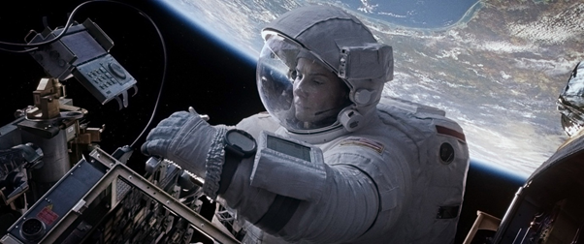
Actress Sandra Bullock high above the Earth in Gravity (Warner Brothers 2013)

Prabhupada: And they are going to moon. They are going nowhere, simply taking laboratory photo, studio photo, and cheating. Why this cheating can go on? You do not know. That's all. (June 28, 1977, Vrindavana)

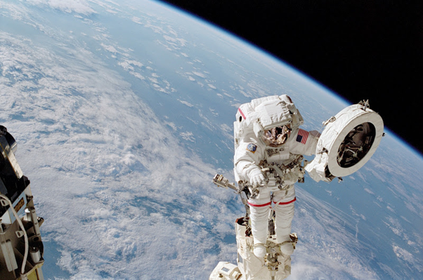
Astro-not Chang Diaz in High Above the Earth Globe (NASA 2002)

Now here is something for everyone to consider: when we see actor Brandon Routh as Superman flying around the globe-shaped Earth, or actress Sandra Bullock as Dr Ryan Stone fixing her space station high above the Earth globe, does anyone think that these actors actually were above the Earth, or that the producers of the film actually took a rocket into outer space in order to get realistic film footage of the so-called Earth planet? I don't think so! So how do the movie makers create such realistic looking images of the Earth globe? Obviously the image is created in a special effects studio!
What about NASA, how do they get their image of the globe-shaped Earth? It's simple! You take an airplane and fly at high-altitude and film the surface of the Earth below which looks like this:

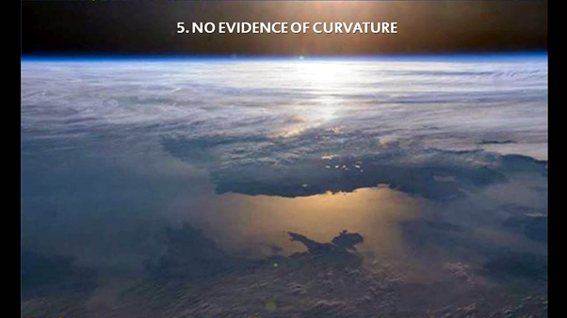

Since there is no evidence of curvature, you have to go back to your computer and add a curve like this:

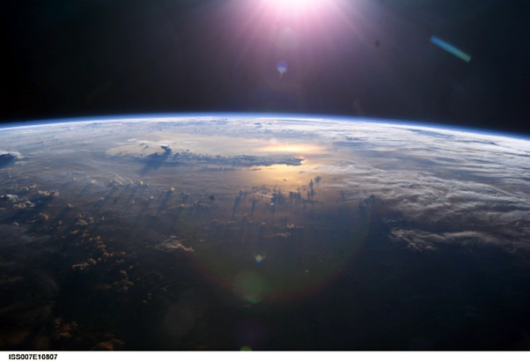

Then you just have to convince everyone that you were on the International Space Station by releasing the following information accompanying the image of the so-called curve of the Earth:
ISS007-E-10807 (21 July 2003). This view of Earth's horizon as the sunsets over the Pacific Ocean was taken by an Expedition 7 crewmember onboard the International Space Station (ISS). Anvil tops of thunderclouds are also visible.
Of course, a mock-up of a space station makes the whole thing look a lot more realistic and not forgetting an astro-not looking at the Earth to add a sentimental touch:

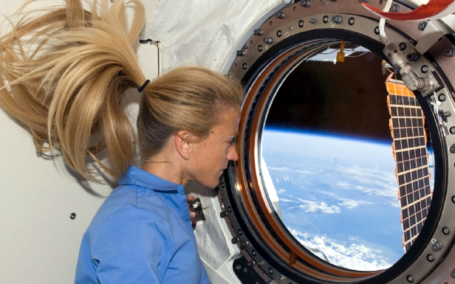
Astro-not Karen Nyberg looks upon the Earth from the International Space station in 2008]

Of course, certain philosophers and scientists have believed that the Earth was a globe hundreds of years before NASA, but such speculative ideas were only supposedly 'proven' once and for all by the first photographic images of the globe Earth taken from outer space at the time of the 1969-1972 moon landings, as well as all subsequent space travel propaganda images and video. Since the media is controlled by the same small elite who control everything else in the world, no one asks any questions, and everyone goes along with the flow because that is what one is paid to do—follow orders; not think! That's why, unlike images of the Earth seen in movies, everyone just believes that NASA's pictures must be real—because no one would, or could, lie to us on this scale and get away with it. Isn't that right?And anyway, what about the motive? Why would they do such a thing? And how could they possibly cover the whole thing up? Conclusion: the Earth globe must obviously be true because NASA and your government say so; and, of course, good old science ‘proves it.'
But, how many of us have personally ever checked the science that supposedly ‘proves' the Earth is a globe? And how many of us can say for sure that what NASA presents are real images of the Earth? How many of us have ever seen the Earth with our own eyes? We have only seen images of the Earth that have been presented by other people. There are actually very few "official" images of the Earth that have been presented by NASA. Although these images of the Earth are no more than paintings, models, or computer animation, we have all been convinced that they are authentic images of a globe-shaped planet Earth. All the other millions of images of the globe that saturate our culture are either reproductions of NASA's 'official images' or simply products of graphic designers that follow the official version of reality presented by NASA and other bogus space agencies.


Astro-not Karen Nyberg looks upon the Earth from the International Space station in 2008]

The cultural saturation just convinces everyone that the Earth globe is true because everyone else believes so; but what is our collective belief based upon?
It would seem a very simple thing to demonstrate and measure curvature on the Earth, or provide some evidence that the Earth is actually moving; but all empirical experiments prove the contrary by establishing that the Earth is a stationary horizontal plane, not a globe-shaped planet that is moving. This will take time to establish, so please bear with me. A globe denier is like someone constantly interrupting you at the movies to remind you that it's not real. Most people don't care that the movie is not real, they just want to enjoy the show; and so here we are enjoying the show that we live on a globe flying through space. But does anyone feel like they are moving?
Having looked at the cheating practices employed in NASA's official videos of so called astronauts in space, and basing my sense of reality on Srimad Bhagavatam's description of the Earth, my personal conclusion is that the images of international astronauts hovering over the so-called Earth globe below are just another movie made in studios on Earth. The special effects are there just to convince the public that all this space travel requires untold billions of tax-payers money. It's a con job on a massive scale. But so special are the effects of NASA's special effects that the world is now deep in love with their Earth globe icon (courtesy of NASA), and can't see through the farce. Of course, people have believed the world was round since the time of the Copernican revolution, and long before NASA, but it was only in the 1960's that we got the first so-called photo of the Earth globe that supposedly proved the fact. But are the images real? Will we allow only scientism to create our sense of reality?
Harikesha: They have taken pictures from the moon taken of the earth. Prabhupada: Pictures? First of all you see. Then take picture. You cannot see.
(Morning Walk, June 1975, Honolulu)
Srila Prabhupada exposed the real agenda of the so-called adventures in space:
"Because they are very, very sinful, duskrtina. Mischievous, miscreants, simply wasting money. They're taking huge salary, huge research fees from the government, and simply misleading persons. That is their business. Miscreants. Actually, they want money, but to take the money he has to bluff. Without bluffing, how he can take money? Then they will present themselves: "I am great scientist, I am great philosopher, so give me money, millions of dollars. I'll go to the moon planet, I'll go to the Mars," and taking money and wasting. And because we are rascals, we are also: "Oh, they are making so much advancement, yes." Andha yathandhair upaniyamanah [SB 7.5.31]. We are following blind leaders. Because we are blind, we do not know. This is the position. Andha yathandhair upaniyamanah. So we have to open our eyes." (SB 1.2.25, August 28 1972, Los Angeles)
Note what Srila Prabhupada says here: "Because we are rascals, we are thinking also: "Oh, they are making so much advancement...We are following blind leaders. Because we are blind, we do not know...so we have to open our eyes." So let's open our eyes! Let's not follow blind leaders! If one has any faith in Srila Prabhupada, then follow his direction. Srila Prabhupada's instruction is to follow the authority of shastra. On the basis of Srimad Bhagavatam description of the Earth, a devotee has to sooner or later understand the very Earth itself is also up for question.
Taking our analysis of the three modes of material nature to the above presentation, the reaction of a devotee in the mode of ignorance would be to immediately become angry that their Earth globe construct of reality is challenged in this way. The anger is based on the false pride that they could possibly be subject to such a deception. It also based on the desire to be in ignorance (illusion) regarding the nature of the world as described by Srimad Bhagavatam. In order to continue exploiting the material world one must voluntarily desire to remain in illusion regrading the Earth's true feature and purpose. Therefore, a devotee in the mode of ignorance must necessarily believe that the illusory Earth (presented by NASA) is real, and the real Earth (presented by Srimad Bhagavatam) is illusion. However, by engaging in the process of bhakti-yoga, a devotee of Krishna will eventually become purified of the tamo-guna that creates distortion in one's perception of the transcendental reality.
A devotee in the mode of passion will likewise reject the above idea that the Earth globe is a false construct of reality created by a combination of pseudo-science (Galileo, etc), and charlatan agencies such as NASA. The reason being is that any challenge to the prevailing construct of reality propagated by governments and so-called scientists would jeopardize such a devotees desire for acceptance (fame/honour, etc) from these same forces of materialism. As Lord Kapila says, a devotee in the mode of passion (rajasah), despite worshiping the Deity (arca-adau), has a separatist mentality (prthag-bhavah), because of compromising with the forces of materialism, being allured by fame and desire for honour (yasha) as well as sense objects (vishayan), and opulence (aishvaryam) as mentioned in the above verse (SB 3.29.9).
A devotee in the mode of goodness is not attached to any particular idea regarding the shape of the world, and goes on with their service regardless—the shape and size of the Earth is not a burning question for them. However, being conducted by sattva (which has knowledge as an attribute), the devotee in goodness may take the time to consider various arguments in order to ascertain the truth of the matter.
A devotee with full faith in Srimad Bhagavatam will see through the eyes of shastra and be blessed to see the world as it is. So lets all try and understand the Earth with full faith in the description of Srimad Bhagavatam. For the pleasure of Srila Prabhupada and the benefit of the world, let us present the Earth as it is described in Srimad Bhagavatam:
Prabhupada: Now you all together make this Vedic planetarium very nice, so that people will come and see. From the description of the Srimad Bhagavatam, you prepare this Vedic planetarium. (Room Conversation, June 15, 1976 Detroit)

